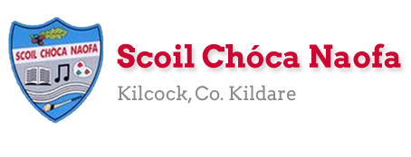
Work for 6th class : Week of Monday 25th May 2020
***School Magazine. This week we would like you to design the FRONT COVER and the BACK COVER of the school magazine. Have a look on the school website at last year’s magazine for ideas. We will hold a competition. You never know...your cover might be chosen to go on this year’s magazine. The magazine needs to be finished this week to allow sufficient time to print it and post it to all the girls before the end of June. Please send us an article if you have not done this already. See below for ideas.
Ms Conboy’s and Ms Tone’s work is attached to the end of this plan. This can be worked through at your child’s own pace. On days you decide to do some of the work they have set please do so instead of something the teacher has set. It is not extra work.
Remember our email addresses are below if you need any help. Have a great week!
msdiggin@scoilchoca.ie mssoden@scoilchoca.ie
Monday | English | - Spellbound Week 34 Exercise 1 *Learn to spell 7 difficult words  - Read At Home Week 30 Day 1 – Imagine you have to phone 112 to report an emergency. Write the dialogue between you and the emergency service operator.  - Starlight Unit 15a – p 170-172 Look up the meaning of the BOLD words
 | Maths | - Maths Matters p 152. Use your calculator.  - Mathletics ( focus on Decimals) or Maths Challenge One test
 | Gaeilge | - Watch TG4 @ 10:00-10:30 Cúla 4 ar Scoil  - Sin É lch 154 Éist leis an CD  - Sin É lch 155 Ceisteanna 1-8
 | P.E. | - Go outside and be active for at least 30 minutes  - Have a look at Scoilnet Beyond the Classroom. Links below  - https://vimeo.com/403344557 Throwing Home Activity C  - https://vimeo.com/403344817 Ag Caitheamh (Throwing as gaeilge)
 | Other | School Magazine: See Information Box below  Cow Parsley: Have a read of the page on Cow Parsley attached below  Pick out 5 interesting/key facts and write them into your SESE copy  Title: Cow Parsley. Date 25/05/20.

Tuesday | English | - Spellbound Week 34 Exercise 2 * Learn to spell 7 difficult words  - Read At Home Week 30 Day 2 – Read aloud with expression. Send an audio recording to your teacher if you like reading a short paragraph.  - Starlight Unit 15a – p 173 C, p 174 D
 | Maths | - Mathletics or Maths Challenge One test  - Maths Matters p 153 Use your calculator
 | Gaeilge | - Watch TG4 @ 10:00-10:30 Cúla 4 ar Scoil  - Sin É lch 157 Thuas, thíos, suas, síos
 | P.E. | Go outside and be active for at least 30 minutes  Have a look at Scoilnet Beyond the Classroom. Links below  - https://vimeo.com/404412589 Running Home Activity C  - https://vimeo.com/404412677 Ag rith (Running as Gaeilge)
 | Other | School Magazine: See Information Box below  Cow Parsley: Do a sketch of the cow parsley plant onto the page that contains your facts.  Go for a walk and see can you spot any cow parsley. If you get a chance to pick a sample, why not press it between the pages of a book for a week or two and then stick it onto your page?

Wednesday | English | - Spellbound Week 34 Exercise 3 * Learn to spell 7 difficult words  - Read At Home Week 30 Day 3 – Answer Q 1-5  - Startlight p 173 A and A*
 | Maths | - Mathletics or Maths Challenge One test  - Maths Matters p 154 Use your calculator.
 | Gaeilge | - Watch TG4 @ 10:00-10:30 Cúla 4 ar Scoil  - Sin É lch 159 Comhair agus meaitseáil  - Sin É lch 159 Críochnaigh na habairtí
 | P.E. | - Go outside and be active for 30 minutes  - Look up look up 30 Days of Yoga with Adrienne  - https://www.youtube.com/playlist?list=PLui6Eyny-UzwxbWCWDbTzEwsZnnROBTIL  - Choose a day and complete lesson
 | Other | School Magazine: See Information Box below  Art: Collect some petals, strands of grass, leaves and seeds that you can find outside. Create a piece of art using them. See below for a few ideas/inspiration.  Don’t take too many flowers or the bees will be annoyed!

Thursday | English | - Spellbound Week 34 Exercise 4 * Revise spellings  - Read At Home Week 30 Day 4 –Write a poem called “HERO”- be imaginative  - Starlight p– 173 B and B*
 | Maths | - Mathletics or Maths Challenge One test  - Maths Matters p 155. Use your calculator.
 | Gaeilge | - Watch TG4 @ 10:00-10:30 Cúla 4 ar Scoil  - Sin É lch 160. Éist leis an CD  - Sin É lch 160/161 Ceisteanna 1-6
 | P.E. | - Go outside and be active for at least 30 minutes  - Have a look at Scoilnet Beyond the Classroom. Links below.  - https://vimeo.com/412282658 Catching Home Activity C  - https://vimeo.com/412283472 Gabháil (Catching as Gaeilge)
 | Other | School Magazine: See Information Box below  SPHE: Listen to and follow along with this podcast. It involves a grounding meditation. https://app.kidslisten.org/ep/Peace-Out-Time-to-Pause-Tuesday#/

Friday | English | - Spellbound Week 34 Test  - Starlight p 174 E Grammar
 | Maths | - Mathletics or Maths Challenge One test  - Maths Assessment Book Mental Assessment Part One p23/p24(1-30)  ** Please send your teacher a photo of p23/24 when finished
 | Gaeilge | - Watch TG4 @ 10:00-10:30 Cúla 4 ar Scoil  - Sin É lch 161 Líon na Bearnaí
 | P.E. | - Go outside and be active for at least 30 minutes  - Have a look at Scoilnet Beyond the Classroom. Links below  - https://vimeo.com/409589781Balancing Home Activity C
 | Other | School Magazine: See Information Box below
School Magazine
Front Cover: A4 page, deep strong colours, clear writing “Scoil Chóca Naofa 2020”. Don’t draw too near the edges of the page.
Back Cover: A4 page, no title needed, deep strong colours. Don’t draw too near the edges of the page.
Article: If you decide to write an article for the school magazine please use the following guidelines.
- Portrait Orientation
- Typed is best on a Word document
- Title: Make sure the title is centered and in Bold Type. Underline the title. Use Calibri Font Size 22.
- Content: Write one page. Include photos, clip art or images if you like. Use Calibri font size 14.
Memory: Please email your teacher “My Favourite Memory from Primary School”. This is to be one sentence. In total we will have 56 sentences – one from each girl!
Article Ideas: My Favourite School Tour. My First Holy Communion. My First Day at School. Sports Day. Maths Week. My trip to the BTYS. Science Week. Storm Ophelia. The day I woke up late for school. The Colour Run. The Marathon. My Funniest Memory. Covid – 19 Lockdown. My Best Friend(s).
Photos: If you have any school photos please send them to us and we might include them in the magazine.

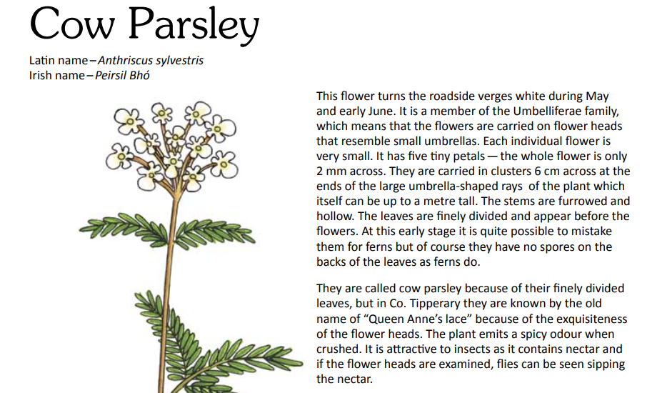
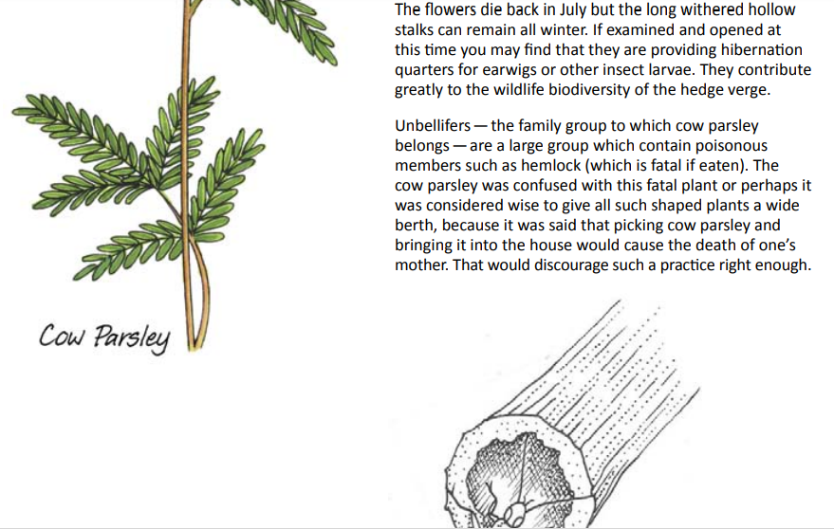

Art Inspiration
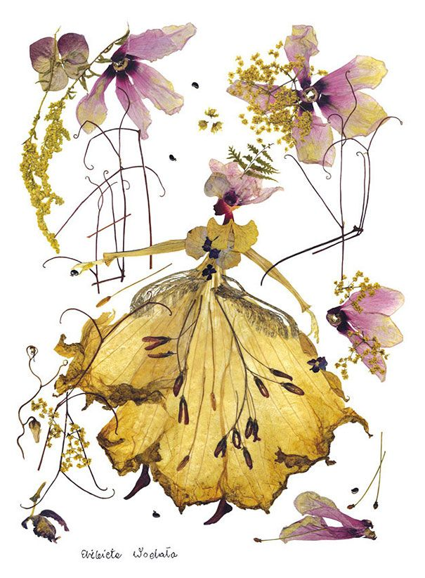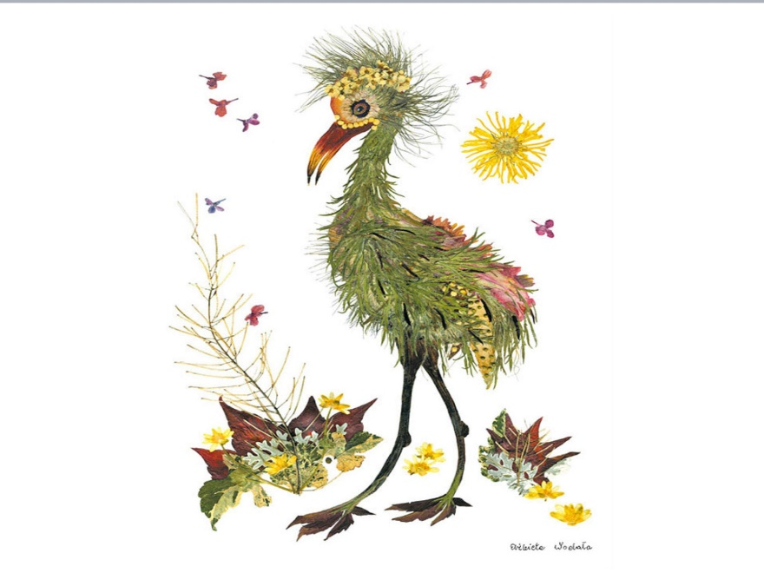
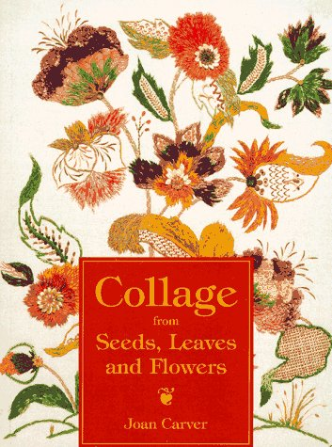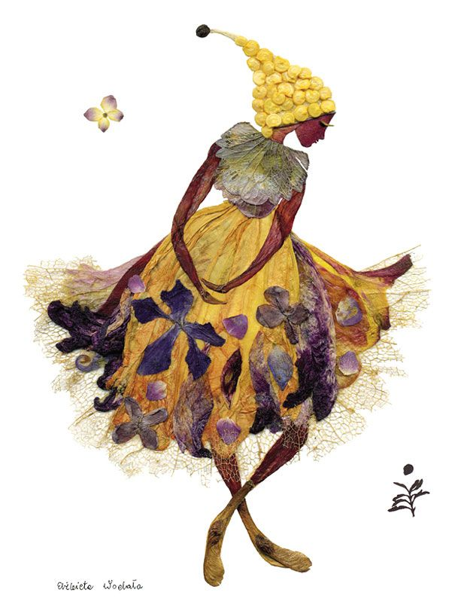

SEN work
Teacher: Ms. Conboy
Note: SEN teachers have added work on to the teachers’ plan. Children can decide to do this work instead of something the teacher has assigned. It is not extra work. Also, I would be delighted if you could email on a picture of something that your child has done and is proud of so I can see their lovely work again!
Speech and Language | If you look in your basket, I have put a pack that includes nearly 20 different speech and language activities. Do 2-3 activities each week. You will need an adult to help you.
Literacy | Read the story from the starlight to an adult. (Unit 15A)  Choose 2 words from the story to explain under the following headings:  Definition (the meaning), synonym (another word that means the same) and sentence. Also, try to draw a picture to represent the word. Please send me one of the words.
Exemption | Instead of doing the Irish work your teacher has assigned you can read page 38 of the “A Way with Words” textbook I put in your basket. Please do Exercise A Q1-7 and exercise B Q1-3 on page 25 answering in full sentences.  Cloze procedure: Antarctica (Contact me for the answers to the previous one)  Continue your SNIP (dont forget your Friday revision) and ‘Item missing’  Please remember to do some TTRS also, I will send your details by email.
Numeracy | Follow the above work from your teacher. If your child is in my maths class and is having difficulty doing the work please contact me.
Computer class | Design a powerpoint presentation on a topic of your choice. Make sure to include:  Transitions, pictures, animations and text on each slide. Email me the end result.
Contact SEN Teacher: msconboy@scoilchoca.ie

EAL work
Teacher: Ms Tone /Ms Clancy
Note: SEN teachers have added work on to the teachers’ plan. Children can decide to do this work instead of something the teacher has assigned. It is not extra work. Also, we would be delighted if you could email on a picture of something that your child has done and is proud of so we can see their lovely work again!
EAL | The local and wider community  • Look at the worksheet below.

Contact SEN Teacher: mstone@scoilchoca.ie
Kilcock
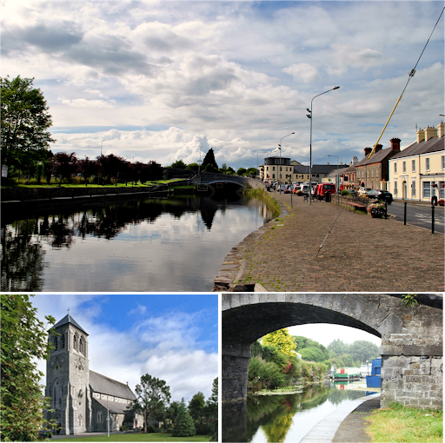
- What places do you like to visit in Kilcock? E.g. canal, square.
_______________________________________________
- What do you do there?
______________________________________________________________________________________________
- Why do you like to go there?
__________________________________________________________________________________________________

- Write five sentences about Kilcock.
What shops does it have?
Where can you go to eat?
What sports can you play?
Does it have a library / police station / factory?
- Draw a picture.

______________________________________________________________________________________________________________________________________________________________________________________________________________________________________
______________________________________________

