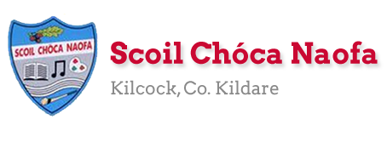
Work for First Class (D. Shanley) Tuesday 2nd.June 2020
Well done everyone. You’re all doing great work. Keep sending it on to me. Always get the reading done first. If you can’t do the full page of any book perhaps you could do half a page. Don’t worry if you don’t get everything done. Just do what you can. Monday is a Bank Holiday so no work on that day and the work on Tuesday is optional. The Stay Safe is finished and this week there is some work included from The R.S.E. Programme. Just to remind everyone that Sport’s Week is on from June 8th– 12th. Please look at the website from 9am on Fri.5th. June to see a message from a famous Sport’s Star! There will also be two more videos live on the website on Sun. night 7th June. Also Zoom meetings will be starting next week, more to follow on that.
Have a great week.

Monday | No work today.
Tuesday | Work today is optional.  English: Write a story about ‘Things I Like to do at Home’ and draw some pictures to illustrate.  Art: Make something from a cereal box (get some help to turn it inside out first) and send me a photo of it.  cosmickids.com – watch video -under 10 mins – Super Yoga/Cosmic Jungle
Wednesday | English: Read at Home: p.94  Maths: Cracking Maths p. 139 (Spatial Awareness)  Irish: Oral work- see Bua na Cainte p. 72 Feicim le mo shúilín rud éigin a thosaíonn le p. Feicim ____.  (péint, pram, puisín, puimcín, práta, peann luaidhe srl.)  Do Bua na Cainte p.72  R.S.E. Theme: The Wonder of New Life p.59  Please go to www.pdst.ie/primary/healthwellbeing/RSE  and click on 1st and 2nd RSE Resource Book
Thursday | English: R. at H. p.95  Maths: Cracking Maths p.144 (problems involving money)  Irish: Oral work same as Wed. Do Bua na Cainte p.73  R.S.E. Theme: How my Body Works p. 67  Please go to www.pdst.ie/primary/healthwellbeing/RSE  and click on 1st and 2nd RSE Resource Book
Friday  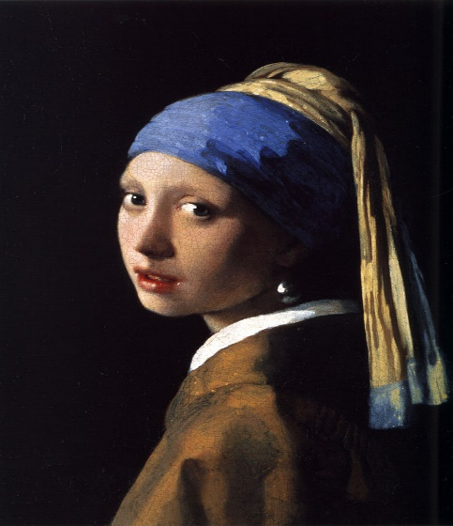 | English: R. at H. p.96  Go With The Flow p. 45  Maths: next test at back of Master your Maths  Irish: Oral work same as Wed.  Art : Do your own version of the ‘Girl with a Pearl Earring’ by Vermeer (1665) in your sketchbook or on a large sheet of paper.
Useful Websites for self-directed work:
Extra Reading- CJFallon (ebooks available now for free) –Starways – Stage 2 - Jill’s New Rollerblades
Extra Maths- CJFallon – Busy at Maths 1 (Shadow Book) - p.41, 45, 46, 47, 52.
Go to mathplayground.com for some fun maths games.
Extra Irish:www.tg4.ie/en/player/categories/childrens-tv-show/ Go to Kid E Cats
WriteReader.com - to help you write your own book. Pick your own topic.
dkfindout.com, twinkl.ie, scoilnet.ie – for project work ie. write down some family recipes
Don’t forget to watch School Hub on R.T.E. everyday at 11am. if you get a chance.
Contact : msshanley@scoilchoca.ie, mssheil@scoilchoca.ie, msheffernan@scoilchoca.ie

SEN/EAL work -Teacher: Ms.Sheil
Note: SEN teachers have added work on to the teachers’ plan. Children can decide to do this work instead of something the teacher has assigned. It is not extra work. Also, we would be delighted if you could email on a picture of something that your child has done and is proud of so we can see their lovely work again!
EAL –Summer.
Working in the Garden.See below.

Literacy | This is a short week so you need only complete two comprehension stories  Shopping and Gardening
Numeracy  Contact SEN Teacher:mssheil@scoilchoca.ie Useful Websites for this week: ixl maths | This is a short week and so you need only complete half the page of addition .  Remember to add the units first.  TU  25  + 18  ----------
