Work for First Class (D. Shanley) -Monday 18th. May 2020
Keep up the good work everyone. Always get the reading done first If you can’t do the full page of any book perhaps you could do half a page. This week we’re starting the Stay Safe Programme. Go into staysafe.ie and click on Stay Safe Lessons 1st./2nd. Click on Stay Safe Teacher’s Resources underneath that to access the resources to go with each lesson. These are called TR 1,2, 3 etc. Best of luck with it. Don’t worry if you don’t get everything done. Just do your best. To revise addition of tens and units with regrouping I’ve given you 4 extra sums each day to do if possible. See below. Have a great week.

Monday | English: Starlight: read p. 42 and do p. 43  Read at Home: p.84 (answer questions orally each day )  If I gave you a list of words to learn/revise please keep working on these everyday if possible.  Maths: Cracking Maths – Weight p.152  and addition of t u-see below  Oral Maths to do each day if time :- the doubles ie. 8+8=, near doubles ie. 7+8=_ and 9+8=_,  revision of 5+ tables, (see: www.theschoolhub.ie/sample.php for tables game)  Talk about an hour earlier/ later than ie. 5 o’clock  Talk about heavier/ lighter/ weighs the same.  Subtraction Problems ie. I had 17 marbles and I lost 11 of them How many had I left?  Irish: ( Do oral Irish everyday if possible)  Dia duit. Dia’s Muire duit.  Cén lá atá ann inniu? Inniu an _. (an Luan, an Mháirt, an Chéadaoin, an Déardaoin, an Aoine, an Satharn, an Domhnach)  Cad atá ar an mbord? Tá _ ar an mbord. (scian, forc, spúnóg, pláta, cupán, bainne etc.)  An bhfuil peata (pet) agat? Tá/ Níl peata agam. Tá _ agam. (cearc, capall, bó, cat, madra, luch, iasc, éan etc.)  Cé a thug an madra duit?  Thug Daidí an madra dom. Do Bua na Cainte p. 64  P.E: Joe Wicks 5 mins. kids workout  Stay Safe Topic 1: Lesson 1- Feelings are Important p.20 (TR1- go to Teacher’s Resources for this)  Lesson 2- Sometimes I feel Safe, Sometimes I feel unsafe p.22 Tr.2
Tuesday | English: Starlight: read p. 42 and do p.44  R. at H. p.85  Maths: Cracking Maths Weight – p.153  and addition of t u- see below  Irish: same as Mon.  P.E: Joe Wicks  Stay Safe: Lesson 3: What do I do if I feel unsafe? P.24 Tr. 3 and 4 (Go to Teacher’s Resources for this)
Wednesday | English: Starlight - read p. 42 and do p. 45  Read at Home: p.86  Maths: Cracking Maths - Weight p.154  and addition of t u – see below  Irish: same as Mon. and do Bua na Cainte p.65  P.E: Joe Wicks (as above)  Stay Safe: Topic 2-Lesson 1:- Friendship p.35  TR.5  Lesson 2: What is Bullying p.37 TR. 6, 7, 8.
Thursday | English: Just Phonics p. 62 and 63  R. a H. p.87  Maths: Cracking Maths – Weight p. 155  and addition of t u – see below  Irish: same as Mon.  P.E: Joe Wicks (as above)  Stay Safe: Lesson 3- Exclusion p.39 TR. 9, 10, 11, 12.
Friday | English: R. at H. p.88  Maths: next test at back of Master your Maths and addition of t u – see below  P.E: Joe Wicks (as above)  Stay Safe: Lesson 4: The Effects of Bullying p.41 TR. 13, 14, 15.  Art: We’re going again to the Tata Modern and looking at the work of Georgia O’Keeffe. After watching the video do your own close-up of a flower. Have fun!  www.tate.org.uk/kids/explore/kids-view/explore-georgia-okeeffe
If looking for extra work you could do writing/ drawing in your S.E.S.E. copy about the Stay Safe topic you did.
Useful Websites for self-directed work:
Extra Reading- CJFallon (ebooks available now for free) –Wonderland – Stage 2 ( Book 3) -Dance Shoes for GG
Extra Maths- CJFallon – Busy at Maths 1 (Shadow Book) - p.13, 20, 30, 31 and 35
Go to mathplayground.com for some fun maths games.
Extra Irish:www.tg4.ie/en/player/categories/childrens-tv-show/ Go to PJ Masks
WriteReader.com - to help you write your own book. Pick your own topic.
dkfindout.com, twinkl.ie, scoilnet.ie – for project work ie. Wild Flowers
Don’t forget to watch School Hub on R.T.E. everyday at 11am. if you get a chance.
Contact : msshanley@scoilchoca.ie, mssheil@scoilchoca.ie, msheffernan@scoilchoca.ie

Please do the following Maths everyday this week as revision if possible.
Don’t forget to add the units first.
Monday | t u t u t u t u  2 6 1 8 3 5 1 9  + 1 6 +2 3 +1 5 +3 4  _____ _____ _____ _____
Tuesday | t u t u t u t u  2 7 1 9 3 6 1 4  + 2 4 + 2 3 +1 8 +3 8  _____ _____ _____ _____
Wednesday | t u t u t u t u  4 6 1 8 3 9 1 9  + 1 6 +5 7 +1 5 + 6 4  _____ _____ _____ _____
Thursday | t u t u t u t u  2 6 5 8 4 5 1 9  + 1 9 +2 6 +1 9 + 3 9  _____ _____ _____ _____
Friday | t u t u t u t u  2 6 1 8 7 5 1 9  + 5 6 +7 3 +1 5 +3 7  _____ _____ _____ _____
SEN/EAL work Teacher: Ms.Sheil
Note: SEN teachers have added work on to the teachers’ plan. Children can decide to do this work instead of something the teacher has assigned. It is not extra work. Also, we would be delighted if you could email on a picture of something that your child has done and is proud of so we can see their lovely work again!
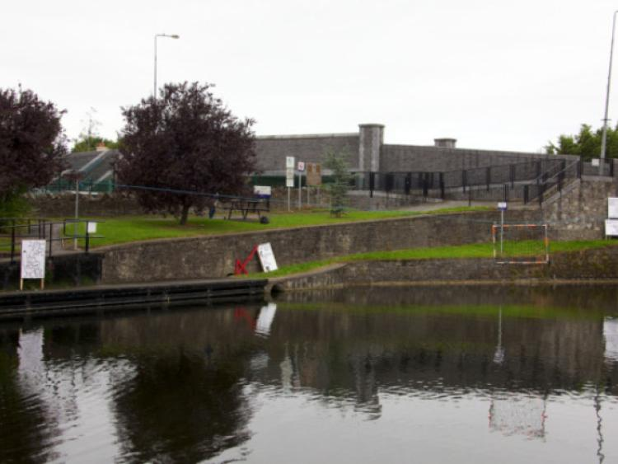 | Fill the Blank Spaces.Write out or print.  This is the -------- ----------.  People can------ and --------- in the canal.  Long ago horses used to pull-------called barges along the canal.  Before lorries ,this was how shops got their goods.  fish Royal Canal swim boats
This is-------- ----------- Church.
It was built about one hundred and
sixty ---------- ago.St. Coca ------- in Kilcock long-----.

lived years St. Coca’s ago

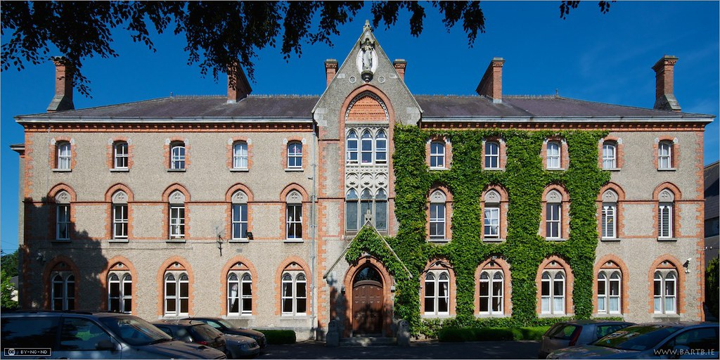 | This is the -----------.  It is ---------- the church.  Lots of ------ used to live --------.  They used to be---------- in Scoil Choca.  beside-- convent—there---nuns--teachers

Literacy | Pupils with Wonderland books,please revise both of the readers you were given and all the sight words.  Please complete, Feeding the Horse,Cleaning the Stable and Picking Apples ,in the Comprehension workbook.If you have a Phonics Workbook ,please revise all the word sheets.Try to read the words without sounding them out.
Numeracy | Continue with the work I sent and try to get most of it finished.I will be sending you some more next week.It will be revision so you will be able to do it quickly.  Keep up the good work!
Contact SEN Teacher:mssheil@scoilchoca.ie Useful Websites for this week: ixl maths

