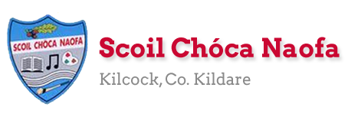
Work for First Class : Monday 1st June 2020
Dear Parents: We will be finishing the ‘Stay Safe Programme’ this week. There are very sensitive lessons this week which you might like to read before covering them with your child. Please see Ms Daly’s email regarding the ‘Stay Safe’ Website.
Please look at school website on Friday 5th June from 9.00am to see a message from a famous sports star in preparation for ‘Active Week’ starting Monday June 8th.
Two more videos will go live on Sunday (night) 7th June one similar to the our last staff one and the second one from famous sports stars again wishing us luck for ‘Active Week’. The children will love them!
We hope the overall scheme of work below is manageable for you and your child. As always prioritise the reading. Please only do as much as your child can manage. If you have any queries or questions don’t hesitate to email us.
See work from Ms. Sheil & Ms. Ní Dhalaigh
Monday | Bank Holiday – No school work today  Enjoy!
Tuesday | Today’s work is optional.  SPHE: Make a book : All About Me in 2020:  Fold sheets of paper and staple together in book format. Write one sentence with a picture on each page. Here are some ideas for your book:  My name is _____. I am ___ years old. I am in First Class. My school is closed because of Covid 19. I am doing all my school work at home. My favourite food is ____. My favourite hobby is ____.  You could write more sentences if you like.  This book could be your own history book for 2020 and you could keep it in a memory box for the future.  Enjoy Dublin Zoo:  https://www.dublinzoo.ie/virtual-tours-2/  P.E: Choose an activity from gonoodle games @ https://www.gonoodle.com/blog/gonoodle-games-movement-app-for-kids/  Take a break! 5 Minute Move video @  https://www.youtube.com/watch?v=d3LPrhI0v-w
Wednesday | English: Continue Read at Home book  Starlight: Read Pg. 46: Underline and talk about new words. Say them in another sentence to help with understanding.  Starlight: Do pg. 41 Revise – Doing words are called verbs and describing words are called adjectives.  Maths: Master Your Maths: Do the next two tests.  Cracking Maths: Children will enjoy the topic this week: Capacity: Please note you will need a 1 litre container for Maths on Friday.  As an introduction to this topic, show your child different containers and ask them which one holds the most/least? Words to ask your child the meaning of: least, capacity.  Do pg. 145: How many egg cups does it take to fill each container? If you do not have an egg cup you could use a small cup, large spoon…. or substitute any of the other containers too. Just ensure your child estimates beforehand and to emphasise the estimate doesn’t have to be right!! Discuss which container is best for filling the bucket and why?  Gaeilge: Do Pg. 74 Complete An Nuacht (The News). Inniu an __ (Today is.. Chéadaoin = Wednesday), Inné an ___ (Yesterday was.. = Mháirt Tuesday ), Amárach an ___(Tomorrow is.. Déardaoin= Thursday) Tá an lá __ (Today is __ . Choose a weather word), Chonaic mé ____ ar an teilifís.( I saw___ on the television. Pick a word: sorcas (circus, cartún (cartoon)…)  PE. Go outside for a walk/play. You could also practise ball skills: throwing, catching, kicking  SPHE: The Stay Safe Programme for First Class:  In order to gain access to the lessons see Ms Daly’s email regarding the ‘Stay Safe’ website. It might make life easier to open two tabs/pages of the website: Lessons on one and Teacher’s Resources on the other, so you can flick forward and back more easily  Topic 3: Touches : Lesson 1 & 2: Different Type of Touches & Dealing with Inappropriate Touch  Lesson 1: Different Type of Touches: Pg 52  Key Messages:  Pupils should be enabled to:  1. Understand and appreciate the value of normal affection  2. Identify touches they like, touches they don’t like and touches that confuse them  3. Identify the feelings they associate with different touches - Learn how to deal with touches they don’t like, don’t want or that they find confusing.  Open TR16 & TR17 in the teacher’s resources section of the website.  Lesson 2: Dealing with Inappropriate Touch Pg. 55  Key Messages:  Children should be enabled to:  - Identify and name the private parts of their bodies  - Understand that they should never keep secrets about touches and that if anyone touches them on their private parts without good reason (even if they say they are just playing or teasing), they must tell an adult  - Develop the skills, confidence and strategies to say No to inappropriate touches  Open TR18, TR19 & TR20 in the teacher’s resources section of the website.
Thursday | English: Continue Read at Home book  Starlight: Read Pg. 46 again: Revise ‘Focus words’ at the end of the page. Ask your child meanings of the words: sprinkle, grated, dough, mixture, timer  Starlight Do Pg. 47  Maths: Master Your Maths: Do the next two tests  Cracking Maths: Do Pg. 146 Revise what ‘capacity, least’ mean.  Gaeilge: Pg. 75 Téigh siar ar na focail (Go over the words) lampa(lamp), pictiúr( picture) seomra leapa (bedroom) Mamaí coinín(Mammy Rabbit) cathaoir(chair), leabhar(book), cófra(press), leaba(bed), babóg(doll), liathróid(ball) Babaí Coinín( Baby Rabbit) Dathaigh an pictiúr(Colour the picture)  P.E: Tennis Ball game @ https://www.eenymeeny.net/games/ball%20games/Sevens.html  SPHE: The Stay Safe Programme for First Class:  Topic 4: Secrets and Telling Lesson Pg.65  Key messages:  Pupils should be enabled to learn:  1.To distinguish between good and bad secrets  2. How to tell effectively - About the difficulty of telling when there are bribes or threats involved.  Open TR 21 in the teacher’s resources section of the website.
Friday | English:  The Broken Sleigh Pg. 40 & 41  Starlight: Do pg. 44  Go With the Flow Do 1 or 2 pages, you decide!  Maths: Master Your Maths : Do the next two tests.  Cracking Maths: Do Pg. 147 and 148 Explain that the litre is the measurement used for capacity. Find one litre containers in your kitchen or google them and show how 1 litre is recorded on them.  Gaeilge: Pg. 76: Bí ag Léamh (Read) Is fearr liom an carr( I prefer the car) Is fearr liom an bád (the boat) ….  Pg 77: Do 1 - 4  P.E: Go Noodle games as on Tuesday.  The Stay Safe Programme for First Class:  Topic 5: Strangers Lesson Pg.74  Key Messages:  Pupils should be enabled to:  1. Understand the concept of a stranger  2. Learn safety strategies for dealing appropriately with strangers  3. Understand that most strangers are good people we should not fear or be anxious about.  Open TR22 &TR23 in the teacher’s resources section of the website  Art: You were reading about how to make a pizza this week. Draw a pizza using Art for Kids Hub on youtube.
Useful Website for this week: RTE Home School hub continues at www.rte.ie/learn/
- Contact Teacher: msgoggin@scoilchoca.ie
SEN/EAL work
Teacher: Ms. Sheil
Note: SEN teachers have added work on to the teachers’ plan. Children can decide to do this work instead of something the teacher has assigned. It is not extra work. Also, we would be delighted if you could email on a picture of something that your child has done and is proud of so we can see their lovely work again! Also ,try to watch the School Hub daily on RTE at 11.00 am...it is very good!

Literacy | This is a short week and so I only want you to complete two comprehension stories-Shopping and Gardening.Continue with the sight words I sent last week.
Numeracy | This week I would like you to complete half of the page on addition.Remember to add the units first.  TU  15  + 18  ---------

Contact SEN Teacher: mssheil@scoilchoca.ie
SEN Teacher 2 Ms. Ní Dhálaigh
EAL  This week is a short week, all about Summer. | 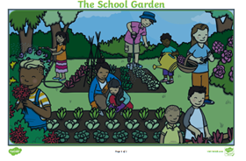
See questions on the next page
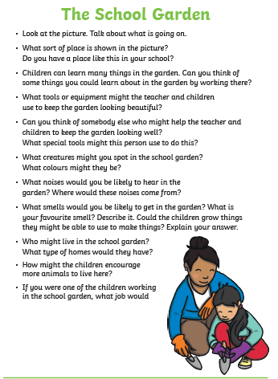
Contact SEN Teacher: msnidhalaigh@scoilchoca.ie

