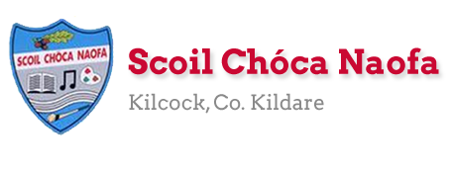
Work for First Class : Monday 18th May 2020
Dear Parents: We are starting the ‘Stay Safe Programme’ this week. These lessons need to be covered with a parent. Please see Ms Daly’s email regarding the ‘Stay Safe’ Website. We would not recommend free access for your child to this website as there are some sensitive lessons and so need supervision. We hope the overall scheme of work below is manageable for you and your child. As always prioritise the reading. Please only do as much as your child can manage. If you have any queries or questions don’t hesitate to email us.
See work from Ms. Sheil & Ms. Ní Dhalaigh
Monday | English: Continue Read at Home book  The Broken Sleigh Read Pg. 26, 27, 28  Write 5 lines of ‘Our News’.  Maths: Master Your Maths Week 29 Mon  Cracking Maths: Pg. 74 & 75 Check that you child understands ‘More than, less than’: Is 16 more than or less than 18? Practise a few of these.  I am bigger than 16 but less than 20. What three numbers could I be? Discuss the options.  This is a fun Maths Game for two people called ‘More than’: Make number cards 1 – 20. Place them upside down on the table. Mix them up so you don’t know the order. Two people pick up one card each at the same time. The person who turned over the card with the biggest number keeps the card. The person who has the most cards at the end wins. You can play the game again as ‘less than’.  Gaeilge: Lch 67: Learn new words : seomra suí (sitting room) clog (clock) teilifís (television) cartún (cartoon) bord (table) lampa (lamp) tolg (sofa) bláthanna( flowers) raidió (radio) ríomhaire (computer) leabhair (books) Colour the picture on Tuesday.  P.E: Go outside for a walk/play. You could also practise ball skills: throwing, catching, kicking….  SPHE: The Stay Safe Programme for First Class  In order to gain access to the lessons see Ms Daly’s email regarding the ‘Stay Safe’ website.  Lesson 1: Feelings are important Pg. 20 Teacher’s Resource: TR1.  When you are reading through the lesson you will come across TR1: ‘Feelings Faces’ then go back to the main menu, click on ‘Stay Safe 1st and 2nd Class Teacher’s Resources’ and then on TR1.  We have identified feelings during our ‘Wellbeing Week’ but we have not covered the key messages below from Lesson 1.  Key Messages: To enable your child to learn:  1. All feelings, even ones we don’t like, are important.  2. Feelings are like messages that tell us how we are inside.  3. It is important to recognise our feelings so we can keep ourselves safe.  Following the lesson, draw 6 different faces each showing these feelings: pleased, excited, frightened, sorry and angry.  Finish these two sentences and write them in your copy:  When we are sad or upset we _____. ( laugh/ cry)  When I am nervous or excited I might get butterflies in my _______. (back/tummy)
Tuesday | English: Continue Read at Home book  The Broken Sleigh Read Pg. 29,30,  Starlight: Read back over Pg. 34 from last week and do Pg. 35  Maths: Master Your Maths Week 29 Tues  Cracking Maths: Pg. 76 More work on ‘More than, less than’  Play Monday’s game again but this time make number cards 50 – 70.  Cracking Maths: Pg. 77 Numbers 51 – 100 Make sure your child follows the trail correctly and not automatically go to the beginning of each line. I have found some children make this mistake. After filling in the numbers, here are some activities to do:  - Ask your child to identify some numbers on the lily pads.  - Cover a number and ask to identify the number.  - Pick out two numbers and ask which is the biggest/smallest.  - Pick a number and ask what number comes before or after it. Let your child look at the lily pads for the answer the first time and if he/she knows it challenge them by not looking at it the second time…. Do a few of these.  Some children find identifying what number comes before another number difficult.  Gaeilge: Lch 67 : Téigh siar ar na focail. (Go over new words) Dathaigh an pictiúr (Colour the picture)  Cuir ceist ( Ask a question):  Cad atá sa seomra suí? (What is in the sitting room?) Tá clog sa seomra suí. (There’s a clock in the sitting room.) Tá tolg sa seomra suite. (There’s a sofa in the sitting room.) Tá lampa/bord/ bláthanna /teilifís…. sa seomra suite. ( There’s a lamp/table/flowers/television…. in the sitting room.)  Cad atá ar siúl ag Daidí agus Mamaí (What are daddy and Mammy doing?) Tá Daidí agus Mamaí ag féachaint ar an teilifís. (Daddy and Mammy are watching the television.)  P.E: Tennis Ball game @ https://www.eenymeeny.net/games/ball%20games/Sevens.html  SPHE: The Stay Safe Programme for First Class  In order to gain access to the lessons see Ms Daly’s email regarding the ‘Stay Safe’ website.  Lesson 2: Sometimes I feel safe, Sometimes I feel unsafe Pg. 22 Teacher’s Resource:TR2  When you are reading through the lesson you will come across ‘TR2: Sammy’s Story’ then as you did on Monday go back to main menu and click on ‘Stay Safe 1st and 2nd Class Teacher’s Resources’ and then on TR2.  Key Messages of Lesson 2:  To enable your child to learn:  1. To identify situations in which they feel safe and unsafe.  2. To anticipate situations that may be unsafe or dangerous.  3. That they should always tell an adult if they feel unsafe, threatened or in danger.  Discuss ‘Sammy’s Story’ and talk about what your child would do if he/she got lost in the park or at the shops.  If you would like draw a picture of a time you felt safe. Write ‘I felt safe when…’ underneath your picture.
Wednesday | English: Continue Read at Home book  The Broken Sleigh Read Pg. 31,32,33  Writing: The Broken Sleigh: Unjumble the sentences:  - wobbled Emma the out door  - to see I don’t want sausage another  - all spaghetti Emma the gobbled  Starlight: Do Pg. 36  Maths: Master Your Maths Week 29 Wednesday  Cracking Maths Pg. 78 Numbers 80 – 100: Same activities as on Tuesday.  I am thinking of a number bigger than 81 but less than 86. What four numbers could I be? Discuss options.  Cracking Maths: Pg.79 Identify the rows and columns.  Discuss patterns: Rows: 20’s (beginning with 2) 30’s (beginning with 3) and so on. Columns: For example to find the number 32 – this has 2 units, so I go down the 2 column to find it… Challenge your child to find numbers on the 100 sq. Find 65 – go to the 60’s row or go down the 5 column…Practise a few of these.  Gaeilge: Bí ag léamh (Read) lch.68: Chuala mé asal (I heard a donkey) Chuala mé bó ( I heard a cow) Chuala mé capall (I heard a horse)….  Gaeilge: Lch 69: Scríobh( Write) 1- 4 Chuala mé madra. (I heard a dog.)….  P.E. Go outside for a walk/play. You could also practise ball skills: throwing, catching , kicking….  SPHE: The Stay Safe Programme for First Class  Lesson 3: What to do if I feel unsafe Pg.24 Teacher’s Resources: TR3: Safe/Unsafe Music Clips & TR4: The Stay Safe Song  Pupils should be enabled to:  1. Develop a clear understanding of situations where they feel safe and unsafe  2. Identify adults that they could talk to if they feel unsafe, threatened or in danger  3. Learn other safety strategies they can use when they feel unsafe or are in potentially dangerous or threatening situations.
Thursday | English: Continue Read at Home book  Starlight Read Pg. 38 Underline and talk about new words. Say them in another sentence to help with understanding.  Starlight: Do pg. 33 but instead of writing a report about spring write about summer instead. Don’t forget to cross out the word ‘spring’ and write summer in its place.  Maths: Master Your Maths Week 29 Thursday  Cracking Maths: Pg. 80 Revise quick ways of finding numbers on the 100sq.  Cracking Maths: Pg. 81 The 100 sq. The 100 square puzzles in No. 2 can be tricky. Your child may need help with these.  Gaeilge: Lch. 69 Write( Scríobh) 5 - 7  P.E: Tennis Ball game @ https://www.eenymeeny.net/games/ball%20games/Sevens.html  SPHE: The Stay Safe Programme for First Class:  Revise Lesson 3: What to do if I feel unsafe Pg.24 Teacher’s Resources: TR3: Safe/Unsafe Music Clips & TR4: The Stay Safe Song  Reassure your child that we can all feel frightened from time to time and remind them that feelings are like messages. We should listen to those messages, try to get away from the situation and always tell an adult we can trust, whenever we feel unsafe, scared or frightened.  The Stay Safe rules are Say No, Get Away and Tell, and remember to keep telling until someone listens to you.  Write down the name of 3 – 4 adults who you would talk to if you felt unsafe or in danger. Remember they must be adults you know and trust in your life. Draw two of them.
Friday | English: Starlight Read Pg. 38 again, revise new words and their meanings.  You’ve just read a recipe for a ‘Hippopotamus Sandwich’ on pg. 38. Can you write your own recipe for a ‘Hippopotamus Sandwich’. Remember they are hungry animals! Name 5 ingredients (or more if you like) and remember to go onto a new line for each ingredient. Draw a picture of it.  Go With the Flow Do 1 page, or 2 if you like.  Maths: Do the first two Maths tests at the back of ‘Master your Maths’.  Gaeilge: Do pg. 70: Cad a fheiceann tú? (What do you see?) Feicim rón. (I see a seal.) Feicim bó. (I see a cow.)……  P.E: Go Noodle games  Religion: May is the month of Mary: Look at the photo below of a May Altar. You could draw one in your copy or even make one of your own.  If you like you could say the Hail Mary with your family.
Useful Website for this week: RTE Home School hub continues at www.rte.ie/learn/
- Contact Teacher: msgoggin@gmail.com

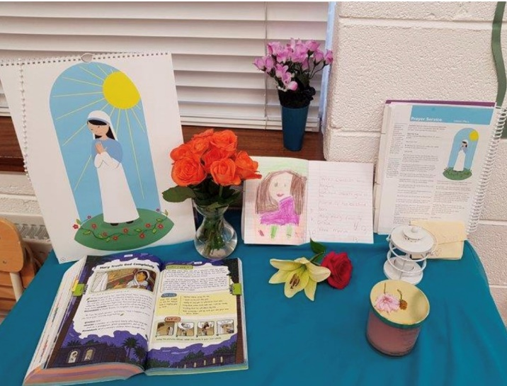

SEN/EAL work Teacher: Ms. Sheil
Note: SEN teachers have added work on to the teachers’ plan. Children can decide to do this work instead of something the teacher has assigned. It is not extra work. Also, we would be delighted if you could email on a picture of something that your child has done and is proud of so we can see their lovely work again! Also ,try to watch the School Hub daily on RTE at 11.00 am...it is very good!
Literacy | All pupils who have story workbooks please complete’ Feeding the Horse,Cleaning the Stable and Picking Apples.  Follow the instructions that I gave you last week!  Also go back to your phonics workbook and try to read the pages of words.Try to read them without sounding them out!
Numeracy | Keep working on the maths workbook that I sent.I will check next week if you are nearly finished, and if you are I will send you another workbook.  It is good to keep revising all the time!!!!!!!
Contact SEN Teacher: mssheil@scoilchoca.ie
SEN Teacher 2 Ms. Ní Dhálaigh
EAL  This work is taking a walk near the canal and take a photo | Transport in my local community  1. Stand at Shaw bridge (opposite Clearys hardware shop) Look towards Maynooth. Can you name 3 modes of transport (air/water/land???) Name the 3 ways you could travel from Kilcock.  2. Go down to the train station, Name the train company, name 2 other routes you could travel on, not Dublin.  3. Go to the square in the town, can you name the bus company and the number of the route.  4. Now you should be able to do this. Match up these words that go together: train,115,barge,Sligo,lock, canal, rail, greenway, Irish Rail, road, car, Bus Eireann ,Please send me your picture at some of these places via email if you can!!
Contact SEN Teacher: msnidhalaigh@scoilchoca.ie

