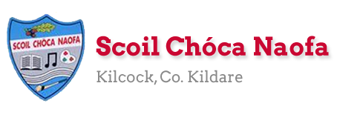
Work for First Class : Monday 25th May 2020
Dear Parents: We are continuing the ‘Stay Safe Programme’ this week. These lessons need parental guidance. Please see Ms Daly’s email regarding the ‘Stay Safe’ Website.
Tip for using Stay Safe Website: It might be helpful to have two separate tabs open on your laptop/phone to flick between the lesson section and the teacher’s resources.
We hope the overall scheme of work below is manageable for you and your child. As always prioritise the reading. Please only do as much as your child can manage. If you have any queries or questions don’t hesitate to email us.
See work from Ms. Sheil & Ms. Ní Dhalaigh
Monday | English: Continue Read at Home book  Write 5 lines of ‘Our News’  The Broken Sleigh: Read Pg. 34,35  Maths: Master Your Maths Week 30 Mon  Cracking Maths: Do Pg. 82 - The Hundred Square continued  Optional Maths game for practising 10 more/10 less on 100 square https://www.topmarks.co.uk/learning-to-count/helicopter-rescue Select ‘Chopper Squad’ at bottom of screen. Under Ten More/Ten Less select 1 to 100  Gaeilge: Pg. 71: Scéal/Story: Bhí sorcas ar an teilifís (There was a circus on TV), Chonaic na páistí leon (The children saw a lion), Bhéic an leon (The lion roared), Bhí eagla ar Bran (Bran was afraid), Rith sé faoin mbord (He ran under the table). Colour the picture.  P.E: Choose an activity from gonoodle games @ https://www.gonoodle.com/blog/gonoodle-games-movement-app-for-kids/  SPHE: The Stay Safe Programme for First Class  To access to the lessons see Ms Daly’s email regarding the ‘Stay Safe’ website. Again, it might make life easier to open two tabs/pages of the website: Lessons on one and Teacher’s Resources on the other, so you can flick forward and back more easily  Topic 2: Friendship and Bullying/Lesson 1: Friendship  Key Messages of Lesson 1:  To enable the child to:  1. Understand the value of friendship  2. Explore how to make and keep friends  3. Understand the importance of treating one another with respect and dignity  In the Teacher’s Resources section select TR5 – this song will be a nice surprise for our class!  Talk about: Who is your friend? What things do you like to do with your friend? What makes you a good friend? Optional: write answers and draw a picture of you and your friend(s).
Tuesday | English: Continue Read at Home book  The Broken Sleigh Read Pg. 36,37  Starlight: Do Pg. 39A and B  Maths: Master Your Maths Week 30 Tues  Cracking Maths: Do Pg. 83 Last day on the Hundred Square, you will need your coloured pencils. Remember TU so for example: 95 is made from 9 Tens and 5 Units  Play Maths game from yesterday if you didn’t get a chance to or have another go if you liked it!  Gaeilge: Pg. 72: Faigh (Get) Faigh péint (Get paint) Do no. 1-4  P.E: Take a break! 5 Minute Move video @ https://www.youtube.com/watch?v=d3LPrhI0v-w  SPHE: The Stay Safe Programme for First Class  In order to gain access to the lessons see Ms Daly’s email regarding the ‘Stay Safe’ website.  Topic 2: Friendship and Bullying/Lesson 2: What is Bullying?  Key Messages of Lesson 2: Children should be enabled to understand:  1. What bullying is  2. Why bullying behaviour is totally unacceptable  3. Some of the ways bullying can hurt us  Open TR6 Storyboard ‘Basketball’ in the teacher’s resources section of the website Tip: It might be helpful to have two separate tabs open on your laptop/phone to flick between the lesson and the resources – it is hard to navigate!! We know!  Look at the pictures. Discuss the suggested questions (on the Lessons section Pink & White Pg. 37) about the Basketball Storyboard (TR6), use right arrow on TR6 to go to TR7 where will you read and discuss the definition of bullying and click right again to TR8 to read about the ways in which bullying hurts us  Write the 3 ways bullying can hurt us in your copy and draw a picture
Wednesday | English: Continue Read at Home book  The Broken Sleigh Read Pg. 38,39  Starlight: Do Pg. 40. ‘There’ is a place, like ‘here and there’. There’ even has the word here in it! Their with an ‘i’ is belonging to them, their coats, their books, their homes..  Maths: Master Your Maths Week 30 Wednesday  Cracking Maths: Do Pg. 142 Money: now that we have practised adding 10s we will spend a few days on Money. Remember on No. 2 the circles represent real coins. We usually use real money to develop understanding here so get your purse out!!  Gaeilge: Pg. 72: Faigh (Get) - Faigh pláta (Get a plate) Do no. 5-8  P.E. Go outside for a walk/play. You could also practise ball skills: throwing, catching, kicking  SPHE: The Stay Safe Programme for First Class  Topic 2: Friendship and Bullying/Lesson 3: Exclusion  Key Messages of Lesson 3: Children should be enabled to:  1. Understand that exclusion is bullying  2. Develop strategies to prevent and manage bullying  3. Understand the role of the bystander  It is not telling tales to tell about bullying. It is telling to be safe. We all have a right to feel safe at home, at school and at play. We should also try to make sure that other people feel safe too.  TR9 ‘An Unhappy Day for Molly’ (TR9) is a video of a child experiencing exclusion. TR10 is the ‘Tell Song’ TR11 reinforces the message of telling. TR11 is a follow-on video called ‘A Happier Day for Molly’
Thursday | English: Continue Read at Home book  Starlight: Read Pg. 42: ‘Waiter, There’s a Dog in My Soup’ (First 3 verses) Underline and talk about new words. Say them in another sentence to help with understanding.  Starlight Do Pg. 43A Q 1-4 (full sentences)  Maths: Master Your Maths Week 30 Thursday  Cracking Maths: Do Pg. 143. Calculate the change you would get from 50c. The book shows the children the method of counting on with real coins to 50c to calculate change. The circles represent coins, the boxes the total you get when you add on each coin. See example in photo below this plan. This is a difficult concept and we would normally spend a week working on Money. Playing with Money is the best way to learn about it.  Gaeilge: Pg. 73 No 1-3 Put a circle around the correct word and write the word  P.E: Tennis Ball game @ https://www.eenymeeny.net/games/ball%20games/Sevens.html  SPHE: The Stay Safe Programme for First Class:  Topic 2: Friendship and Bullying Lesson 4: The Effects of Bullying  Key Messages of Lesson 4: Children should be enabled to understand:  1. How bullying makes others feel and that it is wrong to use bullying behaviour  2. The importance of telling to help yourself or others to be safe  TR13A shows an image of a child being tripped up.TR13B shows a child being excluded. The lessons section has some guide questions you could ask (pink and white pg 41/42) These questions usually bring about a lot of class discussion about feelings and personal experience. Focus on the role of the bystander too: Should you tell? Why should you? Why would you be afraid to? It’s not always easy to tell. Reinforce the Say No, Get Away, Tell message.. ‘If you know that someone else is being bullied, you should tell an adult about it. You are not a tell-tale if you tell about bullying - it is telling to keep someone else safe... But remember the best way to stop bullying is to tell an adult who can help.’
Friday | English:  Starlight: Read Pg. 42: ‘Waiter, There’s a Dog in My Soup’ (Last 2 verses) Underline and talk about new words. Say them in another sentence to help with understanding.  Starlight: Do Pg. 43A Q 5 and 6 and Part B  Go With the Flow Do 1 or 2 pages, you decide!  Maths: Do the next two tests in Master Your Maths  Cracking Maths: Do Pg. 144. Some of these are more difficult than others. You may want to leave harder ones and use real money to solve a few problems e.g. Show me the coins you would need to buy a banana for 25c. I only have a 50c coin to buy the banana. How much change would I get?  Gaeilge: Pg. 73 No 4-6 Put a circle around the correct word and write the word  P.E: Go Noodle games as Monday  Art: Draw a picture of a hippopotamus. Use Art for Kids Hub on youtube as a guide if you wish. Give him/her a name!
Useful Website for this week: RTE Home School hub continues at www.rte.ie/learn/
- Contact Teacher: msquinn@scoilchoca.ie

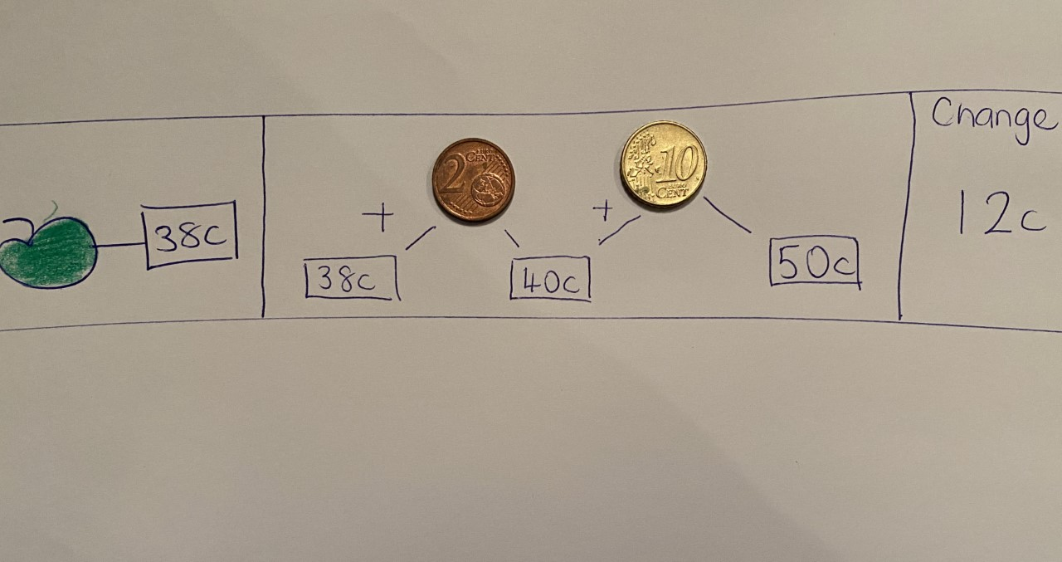
Counting on to Calculate Change Example
SEN/EAL work
Teacher: Ms. Sheil
Note: SEN teachers have added work on to the teachers’ plan. Children can decide to do this work instead of something the teacher has assigned. It is not extra work. Also, we would be delighted if you could email on a picture of something that your child has done and is proud of so we can see their lovely work again! Also ,try to watch the School Hub daily on RTE at 11.00 am...it is very good!

Literacy | This week I would like you to complete- Cleaning the Stable,Picking Apples and Playing Conkers.  I am sending two lists of words ,the First 100 words for two weeks.These words are revision of words that you will have met during the year.You could revise 10 words each day.
Numeracy | I am sending some maths sheets.I would like you to complete the sheet on Time and Money this week and test 31 on the other sheet.

Contact SEN Teacher: mssheil@scoilchoca.ie
SEN Teacher 2 Ms. Ní Dhálaigh
EAL groups This week is like a little quiz of all you learned. Maybe walk around the canal and train station with your parent if you forget some of the answers | 1.Name the hardware store opposite Shaw Bridge.  2. Name the boats you see on the canal.  3. Name the train company in Irish and English if you can.  4.How many km is it from Kilcock to Maynooth along the greenway , beside the canal.  5.Name the street beside the canal (name is near the coffee shop)  6. Name the butcher shop and the flower shop near the canal (not books and gifts!)  7.Name what used to be in the yellow building near the end of this street.

Contact SEN Teacher: msnidhalaigh@scoilchoca.ie

