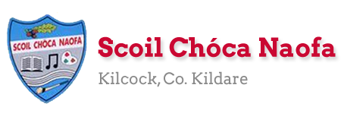
Dear 4th Class,
We are blessed with beautiful weather, I hope you are enjoying the sunshine at home and that your family are safe and well. I know everyone is trying their best with the activities on the lesson plans. You are not expected to complete everything.
Ask an adult to send 3-6 pictures of your work per email, if possible. Your parent/guardian can email me more than once throughout the week if they wish to do so - whatever suits your family. Email: mssmith@scoilchoca.ie
You are familiar with the Bua na Cainte programme. If possible ask an adult to follow the instructions below to download the programme. If your family are not able to do so please let me know as this is a trial run. I understand if this isn’t possible. Try not to rush ahead through the interactive material as I hope to allocate certain activities to match book work. Spend time looking back on the material we have covered so far on this interactive Irish programme.
Take care,
Ms. Smith
Wishing a belated Happy Birthday to the following girls:
Megan Nolan, Aoibheann August, Molly McGrath and Lucy O’Sullivan

Work for Ms. Smith’s 4th Class : Week 5 Starting 27.04.2020 – 01.05.2020
Monday | English:  - Read at Home pg 105  - Starlight 14a ‘Miss Trunchbull’ Complete A Comprehension: Fact Finding and B Comprehension: Read Between the lines in copy pg 161  - Use your dictionary to look up any new words  - Practise saying some tricky tongue twisters (2 per day) refer to Appendix 6.  Maths:  - Maths Matters pg 134 Q1 and Q2 in book (Refer to Appendix 1)  - Use a calculator to correct your answers.  - Count up and down in multiples from 2-20, 3-30, 4-40  Irish:  - Bua na Cainte lch 123- Answer in your copy.  - Watch Cúla4 ar scoil on TG4 at 10 a.m.  - If possible, download Bua na Cainte App to a computuer. Refer to Appendix 2 for instructions.  - Click An Aimsir. Click An tEarrach. Click ceacht 1. Cick Tasc Éisteachta-Listen to the cartoon conversation. Click the game icon. Click Tuisceana. Play game. If you are unable to download this material, please let me know.  - Abair an dán/Say the poem: ‘Crann’ lch 125 (This poem can be found on the Bua na Cainte programme – the girls will know how to locate the songs/poem section.  Science:  - Scavenger Hunt. (refer to Appendix 3 below)
Tuesday | English:  - Read at Home pg 107  - Starlight 14a ‘Miss Trunchbull’ Complete C Vocabulary in copy pg 161  Maths:  - Maths Matters pg 134 Q3 in book  - Correct your answers using a calculator  - Count up and down in multiples from 5-50, 6-60  Irish:  - Bua na Cainte lch 124-fill in the blanks and if you don’t have enough room in book, write it out in copy.  - Click An Aimsir. Click An tEarrach. Click ceacht 2. Cick Tasc Éisteachta-Listen to the cartoon conversation. Click the game icon. Play any game from that section.  - Abair an dán/Say the poem: ‘Crann’ lch 125  - Watch Cúla4 ar scoil on TG4 at 10 a.m.  Science:  - Minibeasts hunt and leaf hunt: Go explore outside and see if you can find any minibeasts/leaves. (refer to Appendix 7) You could draw and label the animals and leaves you find in your copy.  - Using the back of your copy, write a diary entry.
Wednesday | English:  - Read at Home pg 107  - Starlight 14a ‘Miss Trunchbull’ Complete D Vocabulary in copy pg 162  Maths:  - Maths Matters pg 135 (all) and pg 136 Q2 in book  - Count up and down in multiplies from 7-70, 8-80  Irish:  - Bua na Cainte lch 125. Scríobh an dán agus tarraing pictiúr (Write the poem and draw a picture in your copy).  - Abair an dán/Say the poem: ‘Crann’ lch 125  Science/English:  - Adjective hunt (Refer to Appendix 4)
Thursday | English:  - Read at Home pg 108  - Starlight 14a ‘Miss Trunchbull’ Complete E Grammar pg 162  Maths:  - Maths Matters pg 137 in book  - Count up and down in multiples from 9-90, 10-100  Irish:  - Leabhar Litrithe lch 36 (ceacht 1 section)  - Abair an dán/Say the poem: ‘Crann’ lch 125  - Watch Cúla4 ar scoil on TG4 at 10 a.m.  Visual Arts:  - Using the back of your copy, write a diary entry.  - Design your own treasure island. (Refer to Appendix 8).
Friday | English:  - Read at Home pg 109  - Starlight 14a ‘Miss Trunchbull’ Complete F Writing Skills pg 163  Maths:  - Maths Trail (refer to Appendix 5)  - Count up and down in multiples from 11-110, 12-120  Irish:  - Leabhar Litrithe lch 36 (ceacht 2 section)  - Abair an dán/Say the poem: ‘Crann’ lch 125  - Watch Cúla4 ar scoil on TG4 at 10 a.m.  Religion:  - Linking with our nature theme, create a nature table at home for the month of May.  - Mary’s colour is blue, a blue piece of cloth/flowers could be included.  - Flowers can be collected on your nature walk, and refreshed each Friday for the month of May. Don’t forget a little bit of water! (Refer to Appendix 9)

Useful web links for this week:
- Cartún ar TG4: https://www.cula4.com/en/watch/

- Cúla4 ar Scoil: https://www.cula4.com/en/shows/cula4-ar-scoil/
- RTE’s Home School Hub. If you miss it, you might be able to watch it back on RTE Player. https://www.rte.ie/player/

- Maths: Tables revision games:https://www.topmarks.co.uk/maths-games/7-11-years/multiplication-and-division

Appendix 1:

Appendix 2 (Monday):
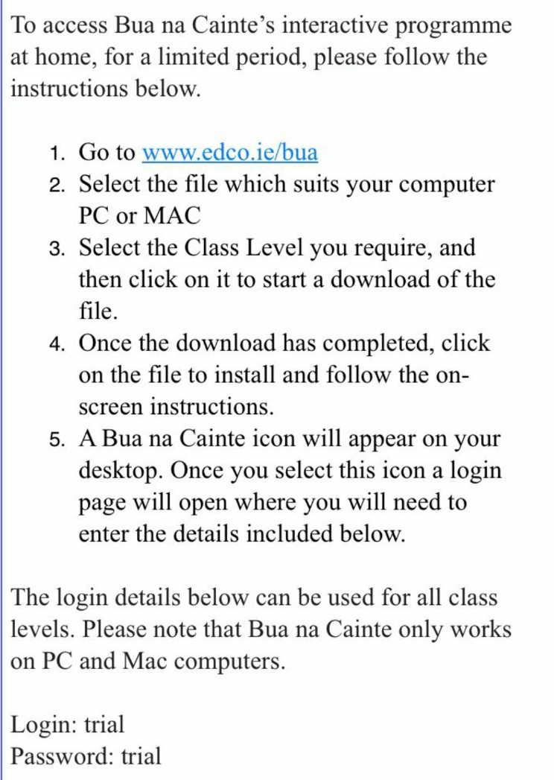

Appendix 3 (Monday) you could write this out in your copy:
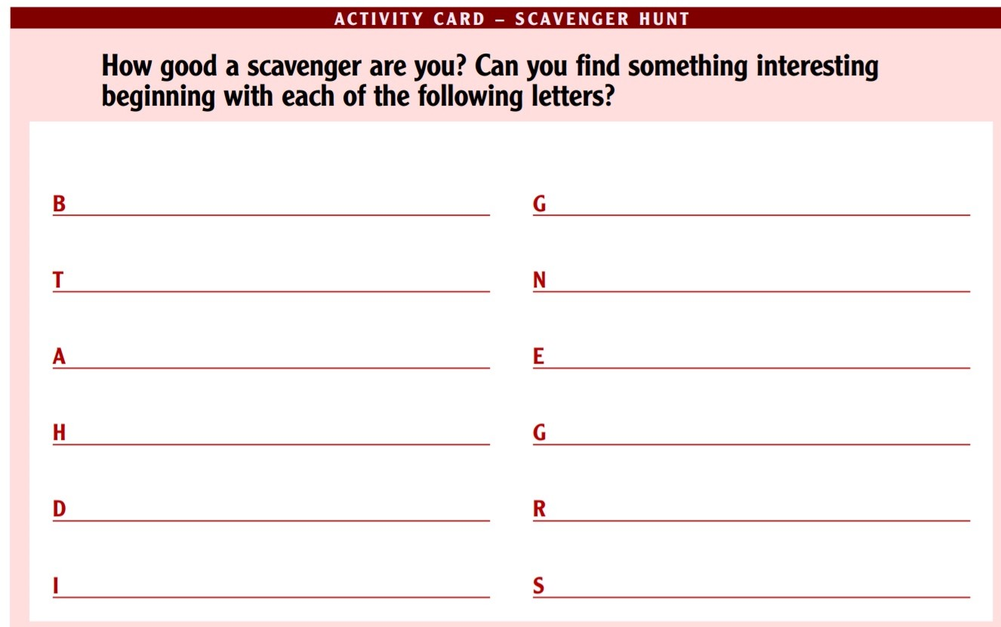

Appendix 4 (Wednesday) you could write this out in your copy:
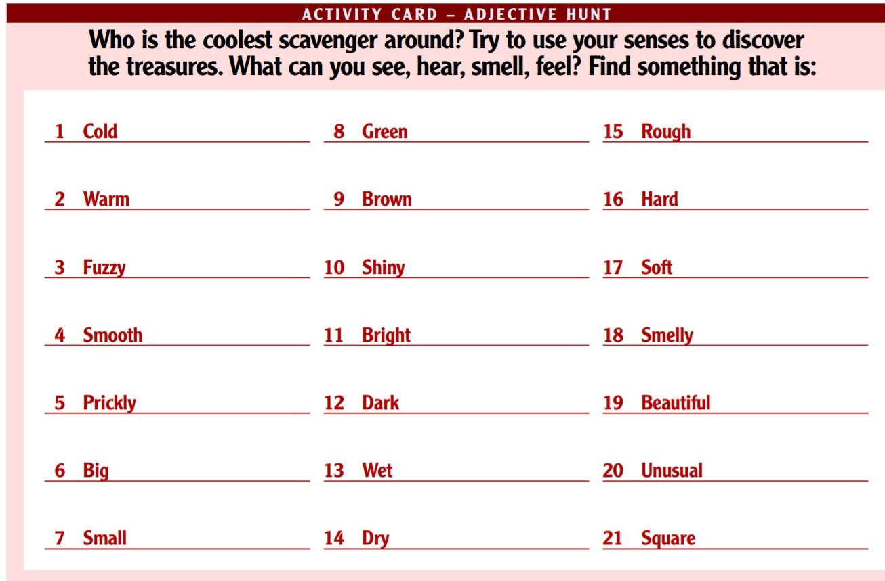
Appendix 5 (Friday):
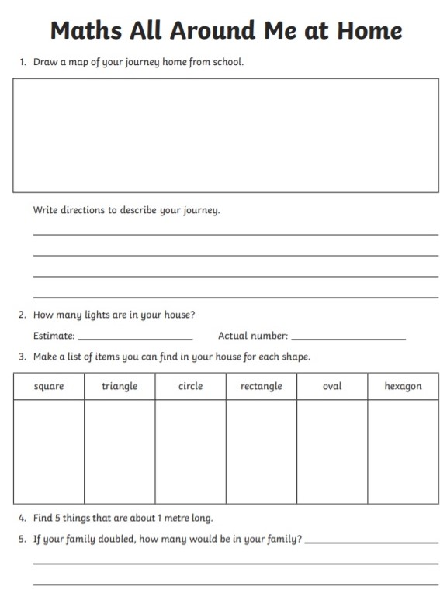
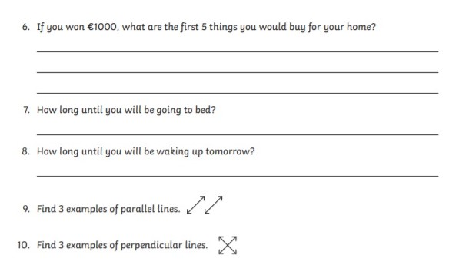

Appendix 6 (Monday - Friday):
English: Tongue Twisters
- Any noise annoys an oyster but a noisy noise annoys an oyster more.
- If a black bug bleeds black blood, what colour does a blue bug bleed?
- If two witches were watching two watches: which witch would watch which watch?
- She sold six shabby sheared sheep on ship.
- Mix a box of mixed biscuits with a boxed biscuit mixer.
- Does your sport shop stock short socks with spots?
- Many mumbling mice are making merry music in the moonlight.
- No need to light a night-light on a light night like tonight.
- Better bought butter but the butter was bitter, so Betty bought better butter to make the bitter butter better.
- Toy boat. Toy boat. Toy boat.

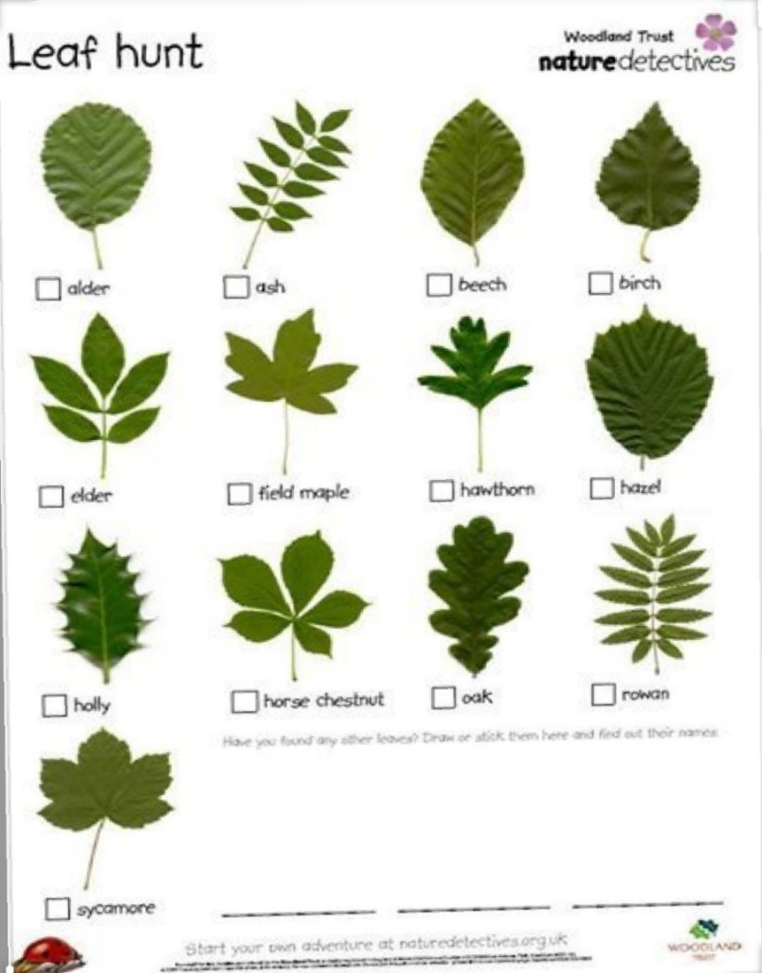
Appendix 7 (Tuesday):
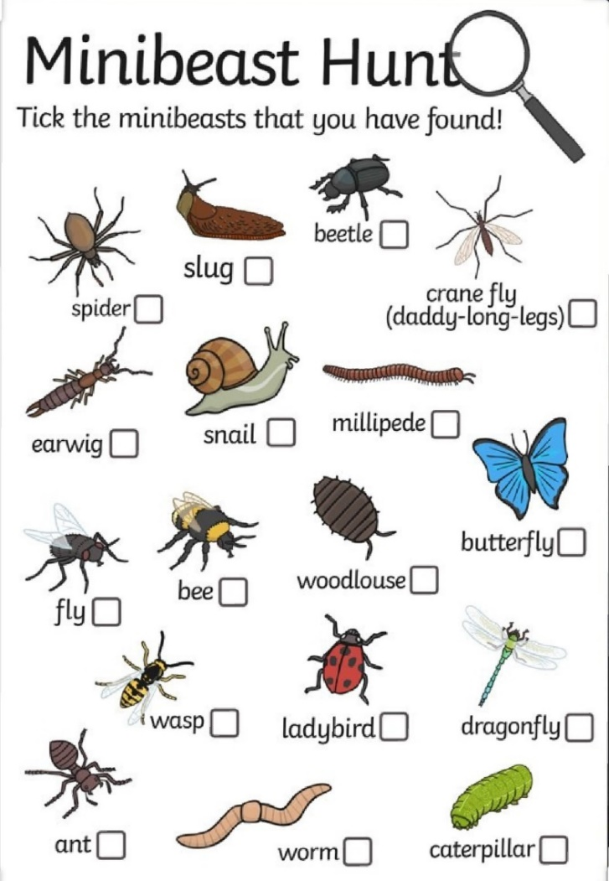

Mmm

Appendix 8 (Thursday):
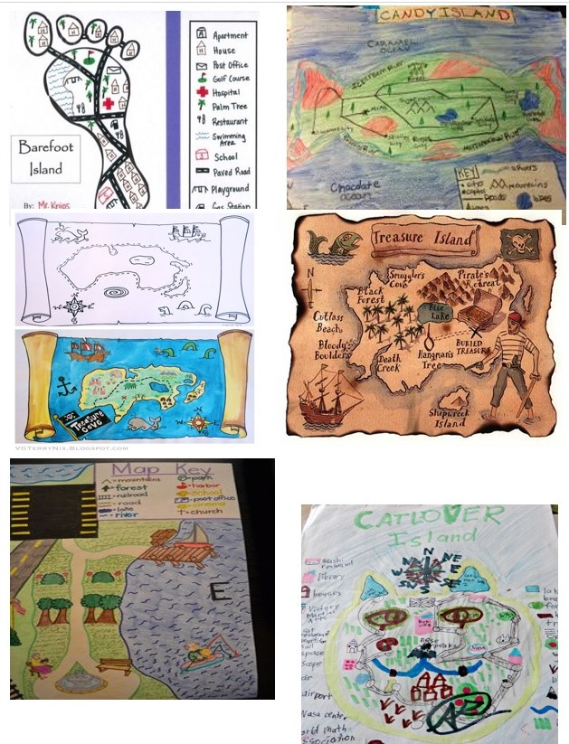

Appendix 9 (Friday):

1. Find a spot.
If you can see it when you’re in the midst of your flurried activities, maybe it will bring calmness to you. Then again, maybe you’d prefer to set it up as something that’s more of a destination. You decide.

2. Make it special.
If you have a statue of Mary, however large or small, make sure it’s part of your spot. A special cloth underneath—a pretty napkin or a doily, for example—and a vase or two (or even just a fancy glass), and you are ready to go!

3. Involve your whole family.
Someone has the task of keeping the vase filled with nice flowers. Someone could be inspired to include some artwork or maybe even a toy or two.

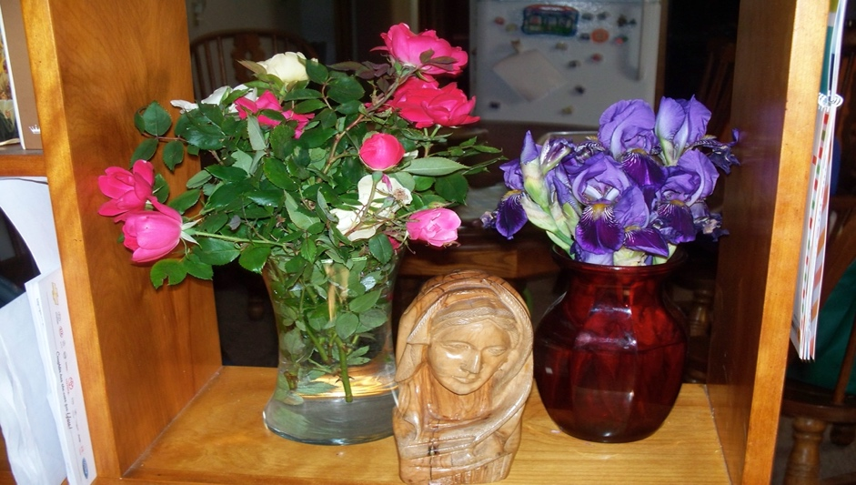

Teacher: Ms. Wilson
Note: SEN teachers have added work on to the teachers’ plan. Children can decide to do this work instead of something the teacher has assigned. It is not extra work. Also, we would be delighted if you could email on a picture of something that your child has done and is proud of so we can see their lovely work again!
Literacy -4th Class | - Continue with SNIP Literacy, Cloze Exercises and Gratitude Journal.  - We were working on “sh” “th” and “wh” using Newell Literacy. The lessons below might help to revise these digraphs.  http://www.theschoolhouse.us/lessons/lesson7.html  http://www.theschoolhouse.us/lessons/lesson8.html  http://www.theschoolhouse.us/lessons/lesson9.html  - Continue with independent reading for enjoyment. Use the website below and pick a level that suits you. Email me and let me know which books you have enjoyed. (If you are reading other books that is fine too. Just let me know).  https://www.oxfordowl.co.uk/for-home/find-a-book/library-page/  - You may prefer to listen to a story. You can continue with David Walliams as in last weeks plan or else try listening to The Secret Garden.  https://stories.audible.com/pdp/B002UZMRV8?ref=adbl_ent_anon_ds_pdp_pc_pg-1-cntr-0-43  (I loved this book when I was young. If you choose to listen to it let me know what you think).  - If you want to learn/ improve typing skills try games on this website.  https://www.education.com/resources/?q=typing+games  - Continue with TTRS if you have been using it in school already.
EAL - 4th Class | Theme : Transport and Travel  - Name the different ways we can travel in Kilcock.  - Now state your favourite way to travel.  - Open the link below and listen to the slide show Transport through the Ages.  https://rainbow3to6.cjfallon.ie/class/fourth/units/10/lesson/3/slide/1  - Now write 4 interesting things you found out when you were listening.  Next week we will read an article about transport from world book online

Contact SEN Teacher: mswilson@scoilchoca.ie
Teacher: Ms. Heffernan
Speech and Language | Try these conversation starters about pets.  https://rainbow3to6.cjfallon.ie/class/fourth/units/1/lesson/4/slide/2  https://rainbow3to6.cjfallon.ie/class/fourth/units/1/lesson/5/slide/1  Or what about an online game of Articulate? You have to describe the word without saying it!  https://rainbow3to6.cjfallon.ie/class/fourth/units/1/lesson/5/slide/3  You could try some memory games like we play in school. Ask someone to call out 4 digits forwards or backwards and see if you can write them down.  Keep reading!  If anybody needs any more reading material, please let me know. If you’ve read or listened to a story, I’d love to hear what you thought about it.  Send me an email to let me know how you’re getting on-I’d love to hear from you!
mathsisfun.com
https://www.topmarks.co.uk/maths-games/hit-the-button
https://www.topmarks.co.uk/maths-games/daily10

Here are some games to help you with your mental maths.
Send me an email to let me know what you have done or if you need help.

Contact SEN Teacher: msheffernan@scoilchoca.ie

