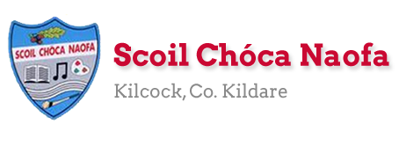
Work for Mr. Bracken’s 3rd Class: Monday 27/04/20 – Friday 01/05/20
Thought for the week: “It’s a good thing we’re growing, so we can fit in everything we’re learning.”

Dear 3rd class,
I hope you and your families are keeping well. Thank you for sending emails of the work you’re proudest of to mrbracken@scoilchoca.ie over the last week. Keep up the great work!
I hope the diary entries are going well. In maths this week I have given you a break from the maths booklet. Just focus on the division pages in Maths Matters and take your time.
A suggestion I have for you this week is to begin a nature scrapbook. The leaves are bursting out at the moment and there is lots of growth wherever we look. You can take some samples and stick them into your copy and label them. If you’re not sure what leaf you have found you can research it! You could gather a few examples when on a walk with an adult. You could even write about it in your diary. It’s just an idea if you have time.
This links in with our nature themed work in English this week, ‘Save Our Sanctuary’. Read it carefully. Each time you read it you will find it easier to find information when answering questions.
Also, I have to mention two birthdays that happened in April! Happy belated birthdays to Michelle (5th April) and to Reuben (24th April) I hope you both enjoyed your birthdays. I know that it is very strange celebrating a birthday at the moment. We can all sing happy birthday to you while we wash our hands at home! It was my birthday last week and my dog Sophie’s birthday is on the same day, she was 2. That’s 14 in dog years! I was just a little bit older…
Stay safe and look after each other,
Mr. Bracken

Monday | English:  - Read at Home pg 110 – ‘The Eiffel Tower’ - Read & answer questions orally  - Starlight 14A - ‘Save Our Sanctuary’. Read pages 158 – 160. Complete part A in your spare copy, using full answers.  - Diary entry (optional)  Maths:  - Read p. 122  - Maths Matters p 123 in book (division)  - Correct answers using a calculator  Irish:  - Léigh sa Bhaile - Read the next page. Freagair na Ceisteanna/Answer the 5 questions at the bottom of the page in your spare copy.  - Cúla ar scoil @10am https://www.cula4.com/en/  Science:  Nature scrapbook. Collect some small examples of leaves, bark, flowers etc. And stick them into a copy. You can;  - Label them  - Say where you found it  - Say when you found it  - Write down some thoughts on what you think about it
Tuesday | English:  - Read at Home pg 111- ‘Superman’s Diary’ - Read & answer questions orally  - Starlight 14A ‘Save Our Sanctuary!’ - Complete part B in your spare copy.  - Diary entry (optional)  Maths:  - Maths Matters pg 124 Q’s 1 & 2 – remember that division is just the opposite of multiplication  Irish:  - Léigh sa Bhaile: Read the next page. Freagair na ceisteanna: Answer the 5 questions at the bottom of the page in your spare copy  - Cúla ar scoil @10am https://www.cula4.com/en/  Science:  - Scavenger Hunt! See bottom of document for more information. You can print the page
Wednesday | English:  - Read at Home pg 112 ‘The World’s Biggest Omelette’ - Read & answer questions orally  - Starlight 14A ‘Save Our Sanctuary’ - Complete part C in your copy.  - Diary entry (optional)  Maths:  - Maths Matters pg 124 Q’s 3, 4 & 5  Irish:  - Léigh sa Bhaile: Read the next page. Freagair na ceisteanna: Answer the 5 questions at the bottom of the page in your spare copy  - Cúla ar scoil @10am https://www.cula4.com/en/  Science:  - Leaf & Minibeast hunt – see below
Thursday | English:  - Read at Home pg 113 - ‘Dream Catcher’ - Read & answer questions orally  - Starlight 14A ‘Save Our Sanctuary!’ – Complete part D  - Diary entry (optional)  Maths:  - Maths Matters pg 125 ‘Who Fell off the Wall?’  Irish:  - Léigh sa Bhaile: Read the next page. Freagair na ceisteanna: Answer the 5 questions at the bottom of the page in your spare copy  - Cúla ar scoil @10am https://www.cula4.com/en/  Art:  - Design your own Treasure Island – see below
Friday | English:  - Read at Home pg 114 - ‘Lulu’ - Read & answer questions orally  - Starlight 13B ‘Save Our Sanctuary!’ – Complete part E (it’s & its) in your copy  - Diary entry (optional)  Maths:  - Maths Matters pg 126 Q’s 1, 2, 3 & 5 (skip Q. 4)  - Maths Trail! See the bottom of the document for a printable sheet.  Irish:  - Léigh sa Bhaile: Read the next page. Freagair na ceisteanna: Answer the 5 questions at the bottom of the page in your spare copy  - Cartún ar TG4  Religion:  May, the month of Mary  - Linking with our nature theme, create a nature table at home for the month of May.  - Mary’s colour is blue, so a blue piece of cloth/flowers  - Flowers can be collected on your nature walk, and refreshed each Friday for the month of May. Don’t forget a little bit of water!  - See end of document for some ideas
Useful websites for this week:
- Maths: a helpful video for division: https://www.youtube.com/watch?v=Dv8BOsG8cPc and another one here: https://www.youtube.com/watch?v=KGMf314LUc0
- Maths: Tables revision games- https://www.topmarks.co.uk/maths-games/7-11-years/multiplication-and-division
- PE: Joe Wicks’ Live Daily PE workouts: https://www.youtube.com/
- General: Twinkl: Worksheets/Powerpoints available: Free access if you use code CVDTWINKLHELP

SEN/EAL work 3rd class Teachers: Ms. Curran & Ms. McCabe
Note: SEN teachers have added work on to the teachers’ plan. Children can decide to do this work instead of something the teacher has assigned. It is not extra work. Also, we would be delighted if you could email on a picture of something that your child has done and is proud of, so we can see their lovely work again! All groups can look at the clock and tell the time 3 times per day.
EAL - Animals | ORAL: Name as many domestic animals as you can.  WRITE: Mindmapping animals : https://www.twinkl.ie/resource/us2-e-53-mind-map-writing-template
Speech and Language | Conversation Starters – Continue with these, one per day, this is a fun activity to do with someone at home.  Continue with activities from Speech & Language pack.
Literacy A & B | SNIP programme – the next session. 3 pages per week. Please read the next 6 blends lists br/cr/dr/fr/gr/pr/ at least 3 times each from below link:  http://www.theschoolhouse.us/lessons/lesson56.html  Please keep up the reading, every day  https://www.oxfordowl.co.uk/for-school/oxford-owl-ebook-collection  These are free ebooks and you can find your level (your parents can help if they have time) Read yourself or to a younger sibling
Toe by Toe | Next SNIP session (18)..... 3 pages for the week.  Please read and ask an adult to read with you!
SEN Individuals | https://www.twinkl.ie/resource/t-s-4386-reading-and-writing-its-ok-to-make-mistakes-social-situation ( Social story about making mistakes reading and writing)  Write Reader – Continue with Dolphins or Sharks.  Fry’s Words: Continue with the list you are on.  Cloze Sheet –Number 3./ Converstion Starter daily.

Contact SEN Teachers: mscurran@scoilchoca.ie / msmccabe@scoilchoca.ie

Tuesday – Scavenger Hunt
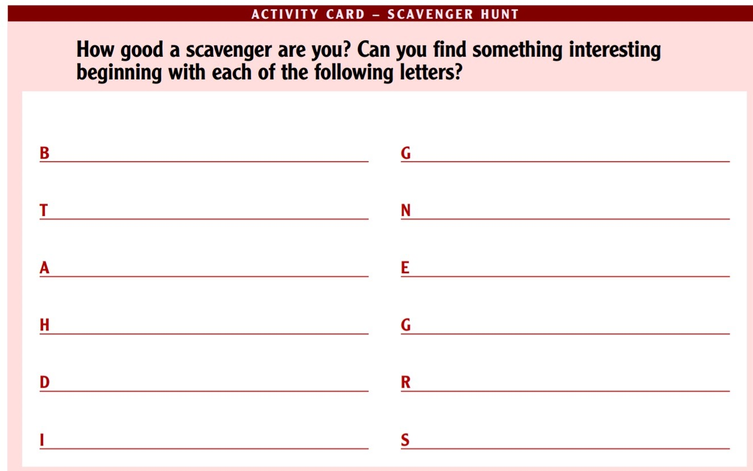

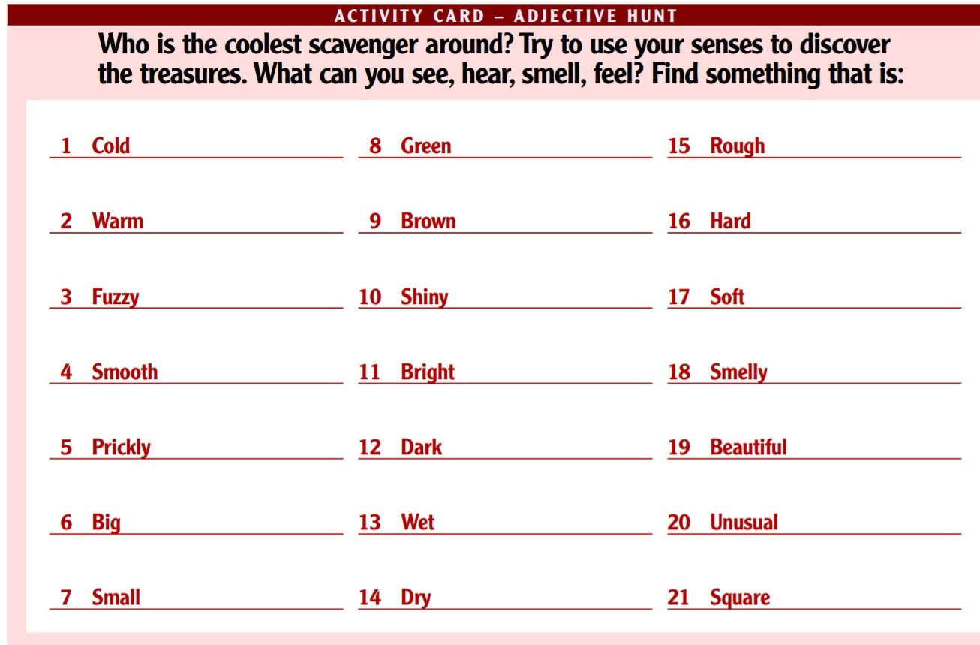

Wednesday – Science – Leaf & Minibeast Hunt
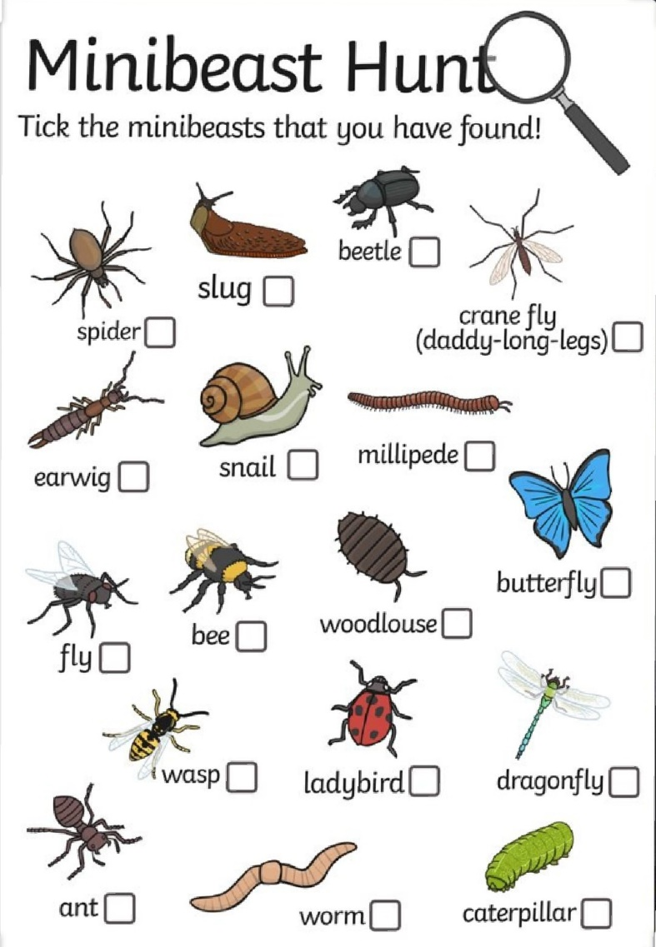
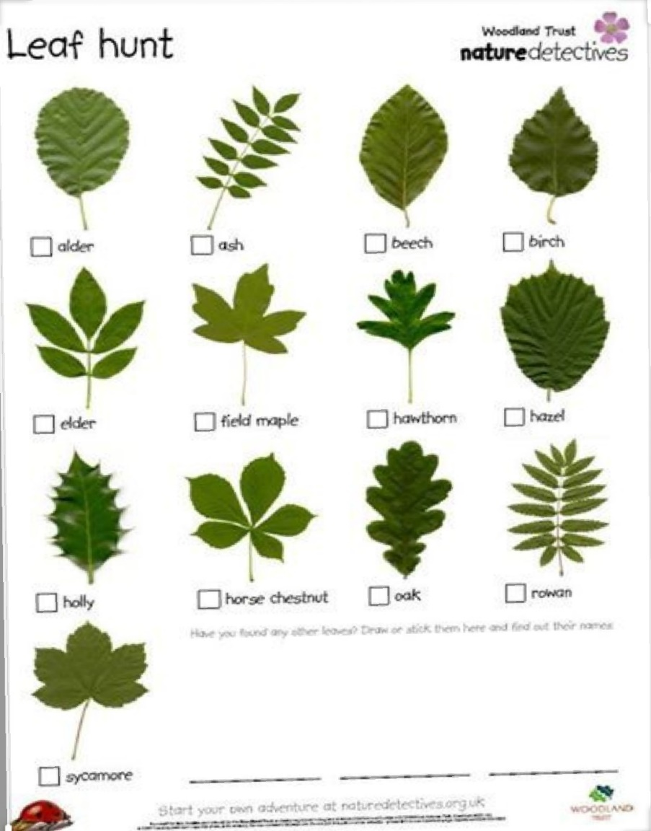

Thursday – Art - Create your own island
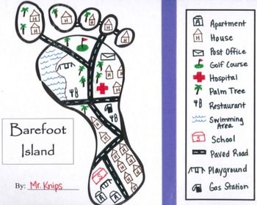
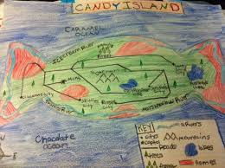
Examples

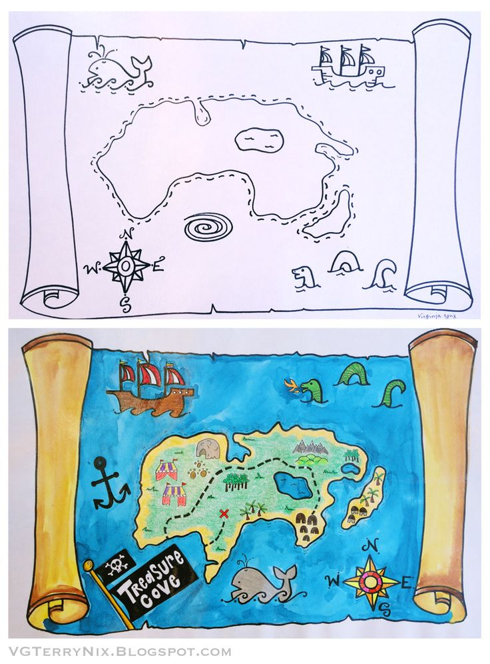
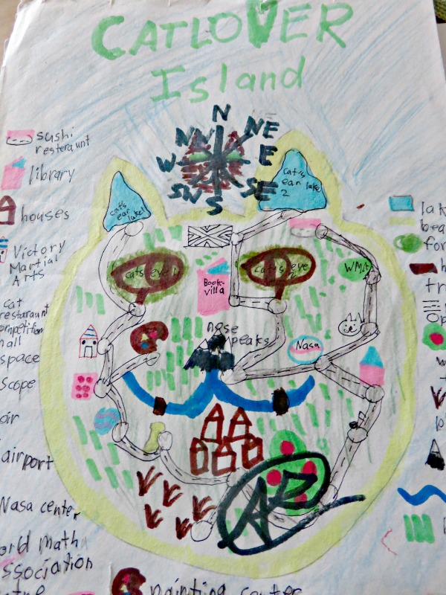

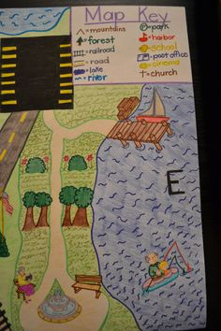
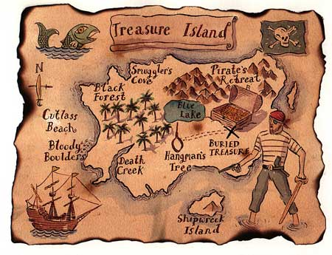

Friday – Maths Trail at Home:
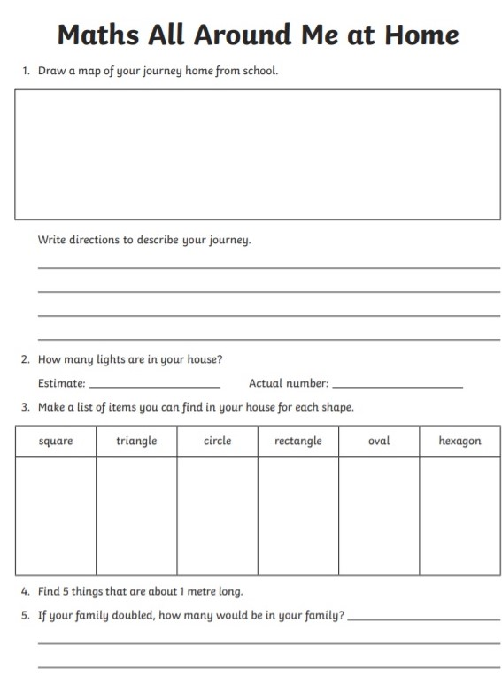
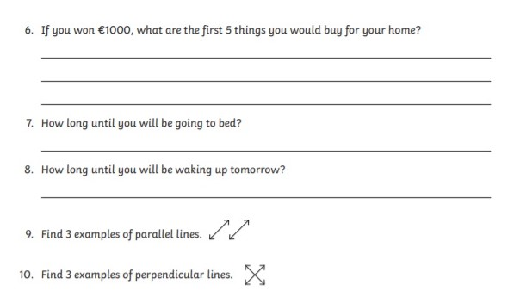

Friday – Religion – May Altar

1. Find a spot.
If you can see it when you’re in the midst of your flurried activities, maybe it will bring calm to you. Then again, maybe you’d prefer to set it up as something that’s more of a destination. You decide.

2. Make it special.
If you have a statue of Mary, however large or small, make sure it’s part of your spot. A special cloth underneath—a pretty napkin or a doily, for example—and a vase or two (or even just a fancy glass), and you are ready to go!

3. Involve your whole family.
Someone has the task of keeping the vase filled with nice flowers. Someone could be inspired to include some artwork or maybe even a toy or two.
