Dear 4th Class,
I hope you and your family are keeping well and that you have been enjoying this beautiful weather. Here is some work for you to complete this week. Try your best and don’t worry if you don’t get it all finished. Thank you for sending me emails of the work you are proudest of. I was so impressed and I’m so happy to see that you are trying your best to keep up with your school work at home. Please continue to send your work to mstierney@scoilchoca.ie
Stay safe,
Ms. Tierney

Wishing a belated Happy Birthday to the following children:
Luella Chell (10th April), Maureen Halewood (22nd March) and Sophie Creusat (20th March)
We will all sing happy birthday to the girls as we wash our hands at home.

Work for Ms. Tierney’s 4th Class:
Monday 27/04/20 – Friday 01/05/20
Monday | English:  - Read at Home pg 105  - Read Chapter 13 in your novel ‘The Boy in the Dress.’  - Using speech bubbles, draw a conversation between any two characters from the story.  - Practise saying some tricky tongue twisters (2 per day)  - Diary entry (optional)  Maths:  - Maths Matters pg 136  - Mathletics activities  - Count up and down in multiples 2-20, 3-30, 4-40  Irish:  - Léigh Scuab Fiacal Danny (1pg)  - Can an t-amhrán/Sing the song: Téir Abhaile Riú  - Watch Cúla4 ar Scoil on TG4 at 10 a.m.  - Imir cluichí ar Duolingo/Play games on Duolingo  P.E:  - PE with Joe Wicks on YouTube  Other:  Science/Nature: Living Things  - Scavenger hunt (see below for details)
Tuesday | English:  - Read at Home pg 106  - Read Chapter 14 in your novel ‘The Boy in the Dress.’  - Imagine a genie lands in the middle of the story and grants one of the characters 3 wishes. What would they wish for and why? Write 3 wishes.  - Practise saying some tricky tongue twisters (2 per day)  - Diary entry (optional)  Maths:  - Maths Matters pg 137  - Mathletics Activties  - Count up and down in multiples from 5-50, 6-60  Irish:  - Léigh Scuab Fiacal Danny (1pg)  - Can an t-amhrán/Sing the song: Téir Abhaile Riú  - Watch Cúla4 ar scoil on TG4 at 10 a.m.  - Imir cluichí ar Duolingo/Play games on Duolingo  P.E:  - PE with Joe Wicks on YouTube  Other:  Science/Nature: Living Things  - Minibeasts hunt and leaf hunt: Go explore outside and see if you can find any minibeasts/leaves (See below for details)
Wednesday | English:  - Read at Home pg 107  - Read Chapter 15 in your novel ‘The Boy in the Dress.’  - Write a short letter to the author of the book and explain to them how you feel about the book.  - Practise saying some tricky tongue twisters (2 per day)  - Diary entry (optional)  Maths:  - Maths Matters pg 138  - Mathletics Activties  - Count up and down in multiplies from 7-70, 8-80  Irish:  - Léigh Scuab Fiacal Danny (1pg)  - Can an t-amhrán/Sing the song: Téir Abhaile Riú  - Watch Cúla4 ar scoil on TG4 at 10 a.m.  - Imir cluichí ar Duolingo/Play games on Duolingo  P.E:  - PE with Joe Wicks on Youtube  Other:  Science/Nature: Living Things  - Adjective hunt (see below for details)
Thursday | English:  - Read at Home pg 108  - Read Chapter 16 in your novel ‘The Boy in the Dress.’  - Write a short acrostic poem about the main character ‘Denis.’  - Practise saying some tricky tongue twisters (2 per day)  - Diary entry (optional)  Maths:  - Maths Matters pg 139  - Mathletics Activities  - Count up and down in multiples from 9-90, 10-100  Irish:  - Léigh Scuab Fiacal Danny (1pg)  - Can an t-amhrán/Sing the song: Téir Abhaile Riú  - Watch Cúla4 ar scoil on TG4 at 10 a.m.  - Imir cluichí ar Duolingo/Play games on Duolingo  P.E:  - PE with Joe Wicks on YouTube  Other:  Art:  - Design your own treasure island. See below for examples.
Friday | English:  - Read at Home pg 109  - Read Chapter 17 in your novel ‘The Boy in the Dress.’  - Chose a scene/event from the book and illustrate it.  - Practise saying some tricky tongue twisters (2 per day)  - Diary entry (optional)  Maths:  - Maths trail: All around me at home  - Count up and down in multiples from 11-110, 12-120  Irish:  - Léigh Scuab Fiacal Danny (1pg)  - Can an t-amhrán/Sing the song: Téir Abhaile Riú  - Watch Cúla4 ar scoil on TG4 at 10 a.m  - Imir cluichí ar Duolingo/Play games on Duolingo  P.E:  - PE with Joe Wicks on YouTube  Other:  Religion  May, the month of Mary  - Create a May altar/nature table (see below for some ideas)

Useful websites for this week:
- Maths: https://www.mathletics.com/uk/
- Maths: Tables revision games- https://www.topmarks.co.uk/maths-games/7-11-years/multiplication-and-division
- Gaeilge: Can an t-amhrán/sing the song: https://www.youtube.com/watch?v=CNlpY-x0wDA
- PE: Joe Wicks’ Live Daily PE workouts: https://www.youtube.com/
- General: Twinkl: Worksheets/Powerpoints available: Free access if you use code CVDTWINKLHELPS
- RTE’s Home School Hub. If you miss it, you might be able to watch it back on RTE Player. https://www.rte.ie/player/
English Resources:
English: Tongue Twisters
- Any noise annoys an oyster but a noisy noise annoys an oyster more.
- If a black bug bleeds black blood, what colour does a blue bug bleed?
- If two witches were watching two watches: which witch would watch which watch?
- She sold six shabby sheared sheep on ship.
- Mix a box of mixed biscuits with a boxed biscuit mixer.
- Does your sport shop stock short socks with spots?
- Many mumbling mice are making merry music in the moonlight.
- No need to light a night-light on a light night like tonight.
- Better bought butter but the butter was bitter, so Betty bought better butter to make the bitter butter better.
- Toy boat. Toy boat. Toy boat.

Gaeilge Resources:
Irish song: Téir Abhaile Riú
Téir abhaile riú
Téir abhaile riú
Téir abhaile riú, a Mhéaraí
Téir abhaile riú 's fan sa bhaile
Mar tá do mhargadh déanta.

Is cuma cé dhein é nó nár dhein
Is cuma cé dhein é, a Mhéaraí
Is cuma cé dhein é nó nár dhein mar
Tá do mhargadh déanta.

Pós an piobaire
Pós an piobaire
Pós an piobaire, a Mhéaraí
Pós an piobaire i dtús na hoíche
Is beidh sé agat ar maidin.
Tá do mhargadh
Níl mo mhargadh
Tá do mhargadh déanta
Níl mo mhargadh
Tá do mhargadh
Nil mo mhardadh déanta

Monday
Scavenger Hunt:
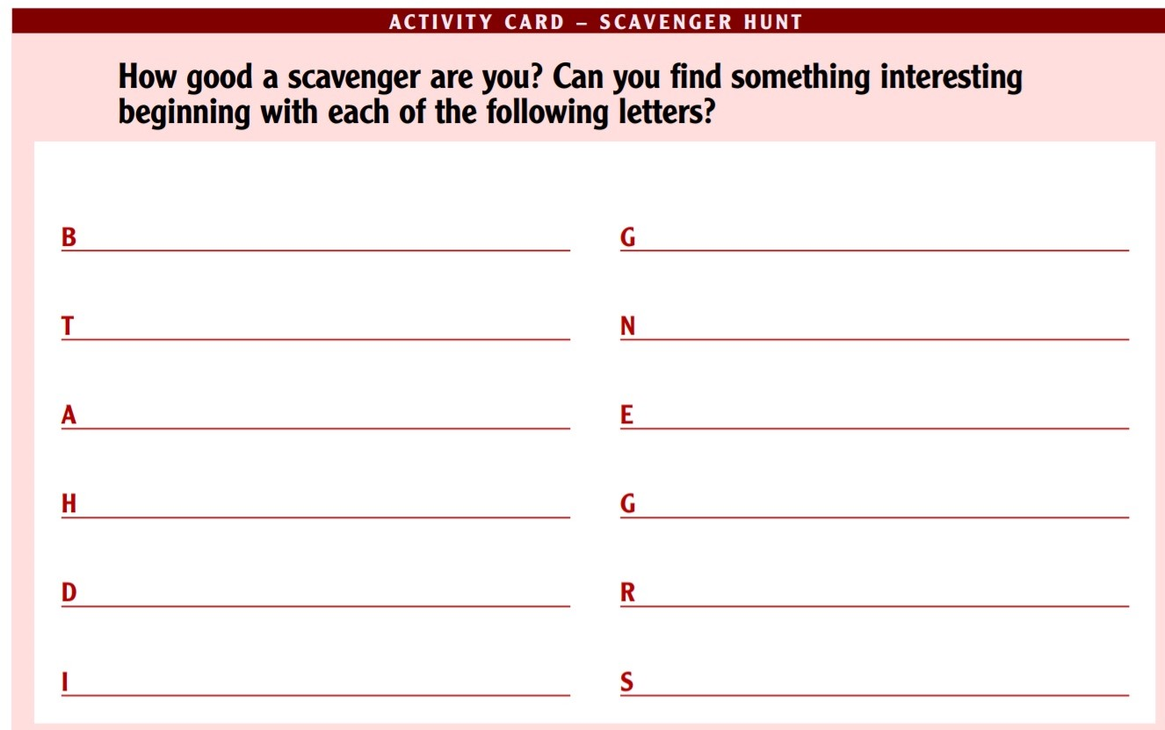

Tuesday
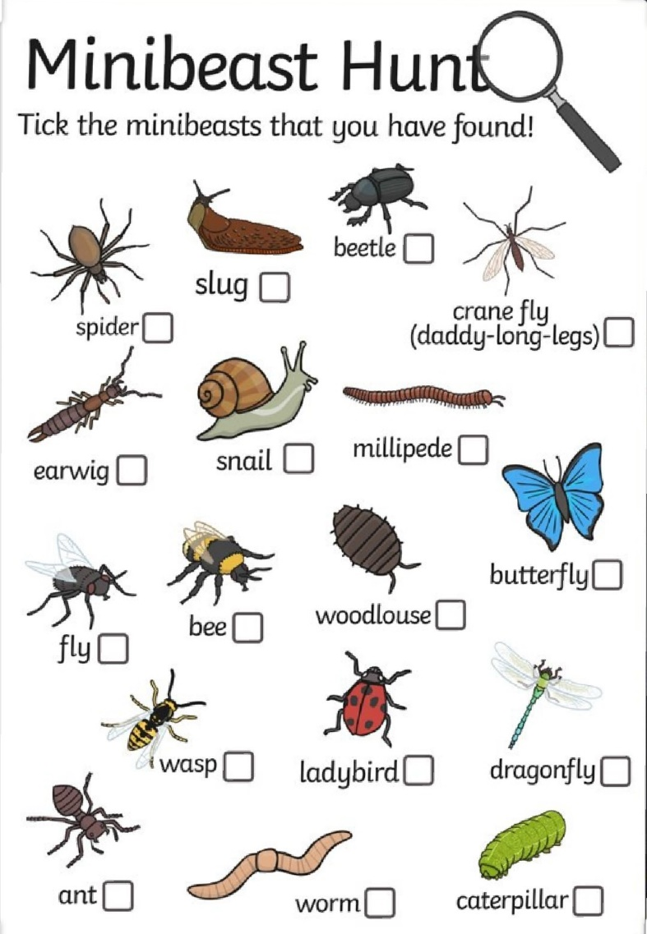
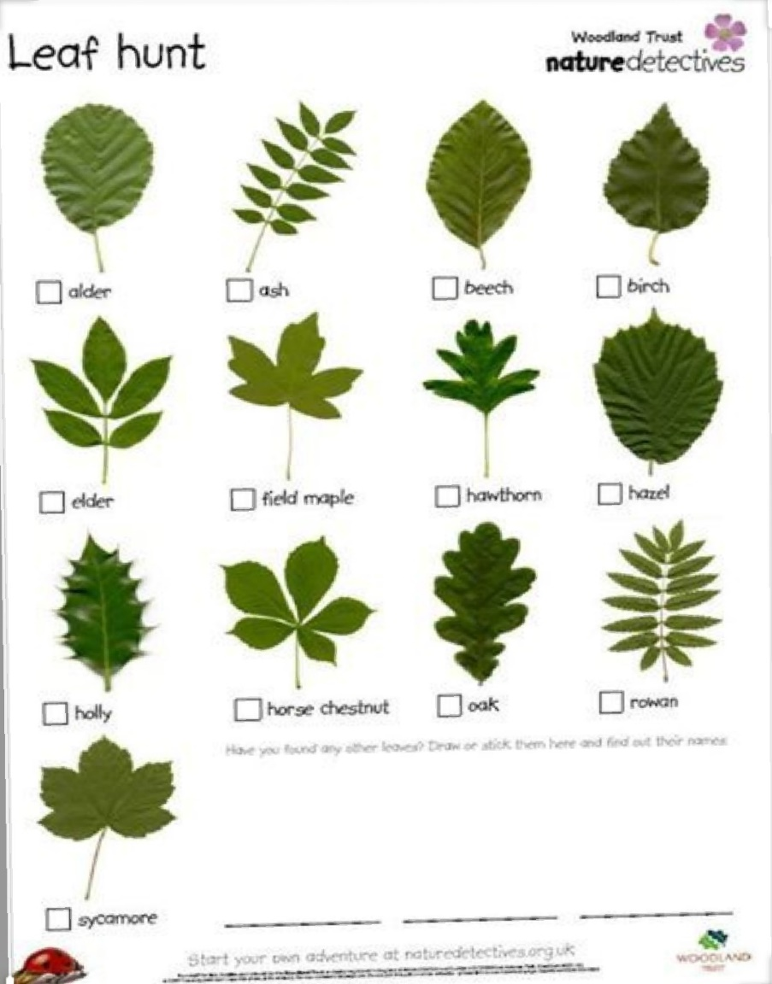
Minibeast/Leaf Hunt:

Wednesday
Wednesday
Adjective hunt:
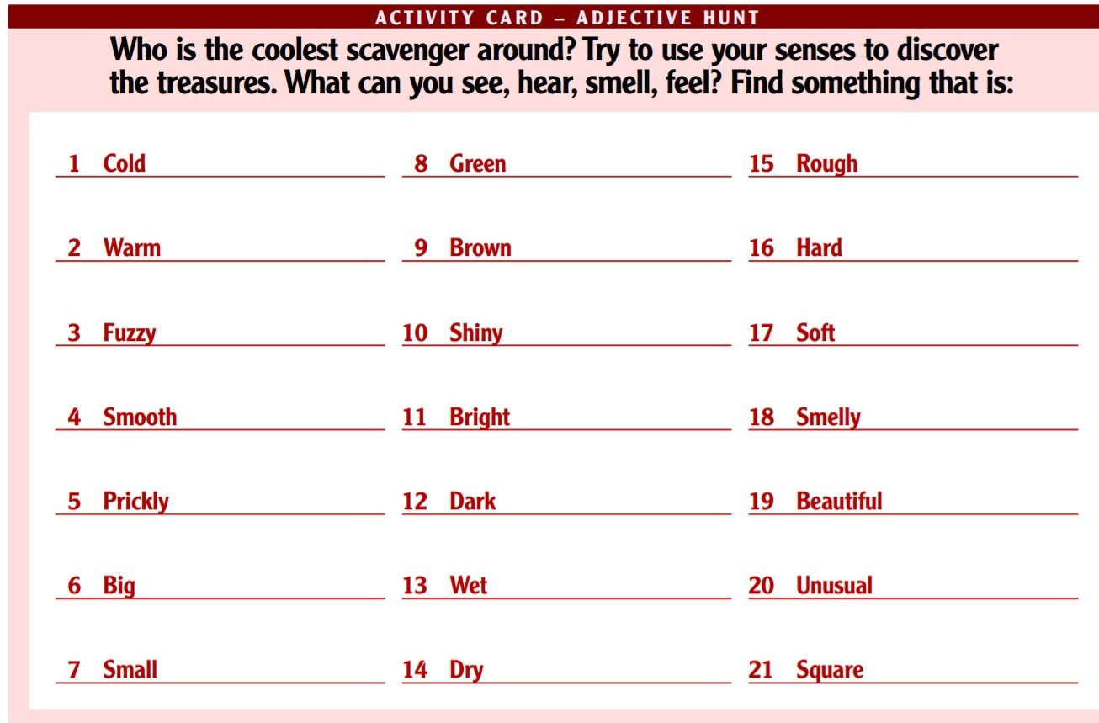

Thursday
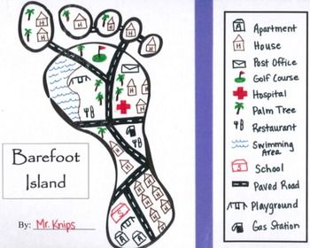
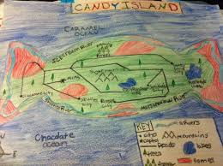
Art Examples:

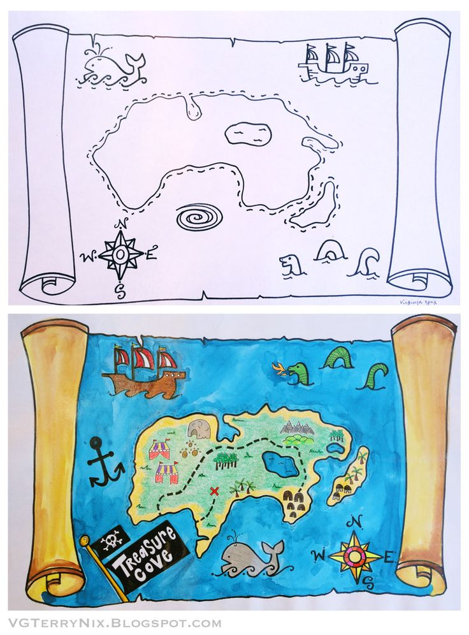
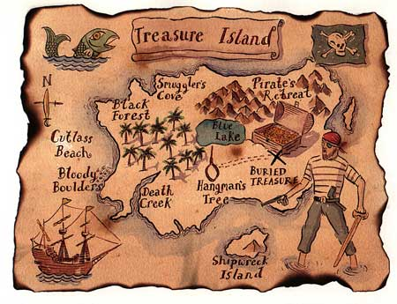

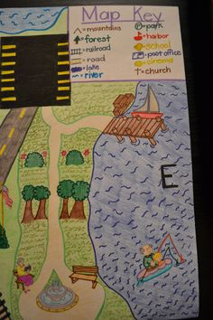
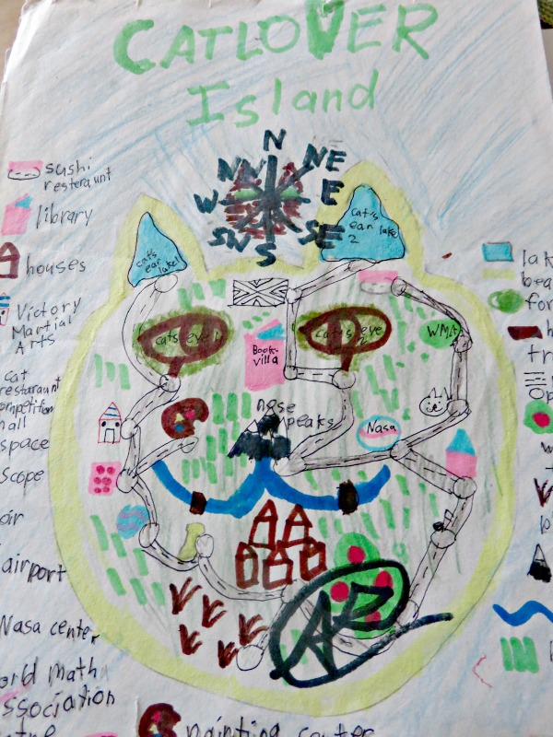

Friday
Maths Trail:
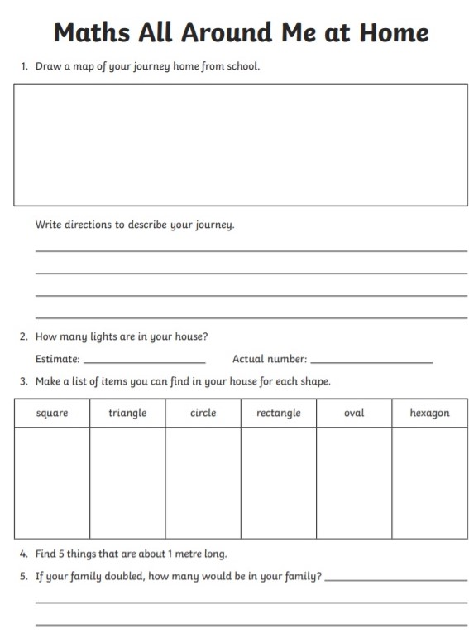
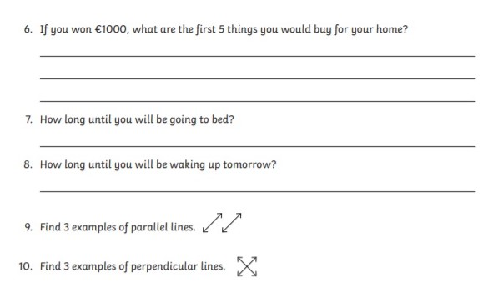
Religion: May Altar Ideas

1.Find a spot.
If you can see it when you’re in the middle of your flurried activities, maybe it will bring calm to you. Then again, maybe you’d prefer to set it up as something that’s more of a destination. You decide.
2. Make it special.
If you have a statue of Mary, however large or small, make sure it’s part of your spot. Mary’s colour is blue. A special cloth underneath—a pretty napkin or a doily, for example—and a vase or two (or even just a fancy glass), and you are ready to go!

3. Involve your whole family.
Someone has the task of keeping the vase filled with nice flowers. Someone could be inspired to include some artwork or maybe even a toy or two.
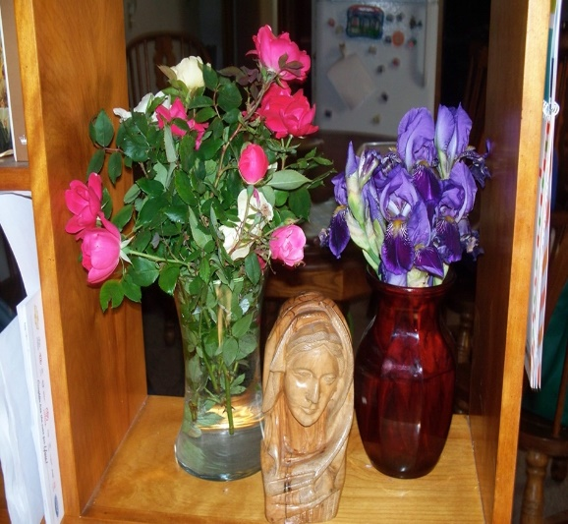
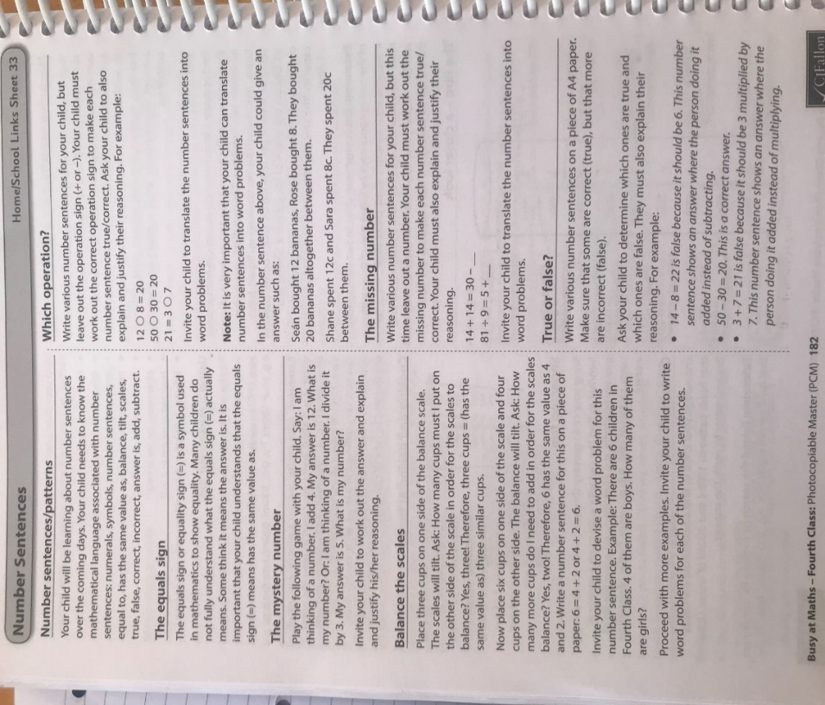
Maths Matters answers for self-correction
Pg. 136
1 a. 0,1,2,3,4,5 b. 0,1,2,3,4 c. 0, 1, 2 3, 4
d. 0,1,2 e. 0, 1,2,3,4,5,6
2a. 0,1,2 b. 0,1 c. 0 d. 0,1,2 e.0,1,2
f. 0,1,2 g. 4,5,6 h.6,7,8 3b. X c. √ d.X
e. √ f. X g. √ h. X i. X j. √
Pg. 137
1a. 6 frame 3 b. 486 frame 1 c. 6 frame 2
2a. 125 x7=875 b. 270÷9 = 30
c. 72 ÷8=9 d. 2.75 x3=8.25
3 a. 24 b.225 c.8

Teacher: Ms. Heffernan
Note: SEN teachers have added work on to the teachers’ plan. Children can decide to do this work instead of something the teacher has assigned. It is not extra work. Also, we would be delighted if you could email on a picture of something that your child has done and is proud of so we can see their lovely work again!
Language | Try these conversation starters about pets.  https://rainbow3to6.cjfallon.ie/class/fourth/units/1/lesson/4/slide/2  https://rainbow3to6.cjfallon.ie/class/fourth/units/1/lesson/5/slide/1  Or what about an online game of Articulate? You have to describe the word without saying it!  https://rainbow3to6.cjfallon.ie/class/fourth/units/1/lesson/5/slide/3  You could try some memory games like we play in school. Ask someone to call out 4 digits forwards or backwards and see if you can write them down.  Keep reading!  If anybody needs any more reading material, please let me know. If you’ve read or listened to a story, I’d love to hear what you thought about it.  Send me an email to let me know how you’re getting on-I’d love to hear from you!
Contact SEN Teacher: msheffernan@scoilchoca.ie

