Dear 4th Class,
I hope you and your family are well and that you enjoyed the Easter break. I miss you all.
As you all know, we are living in unusual times at the moment. I think it is a good idea to keep a diary based on your days. When you are older you will be able to tell people about what happened during Covid-19. It could be very valuable to write down your experiences and your feelings. So that is something I invite you to do from now on (Refer to Appendix 2). Remember to:
- Write the date at the top of every entry
- Begin with ‘Dear Diary’
- Skip a line, then begin your sentences
- Write about one feeling you are experiencing (happiness, excitement, frustration etc.)
- Sign off at the end - ‘Yours sincerely’, ‘That’s all for now’ etc. and your name.
- Use your copy and start from the back
Continue to help out at home. If the weather is good then use it to exercise outside! You can do a lot in a small space – planks, bear crawls, crab crawl, burpees, football skills, hurling/camogie skills and so on. Ask an adult to send pictures of the work you are proudest of to mssmith@scoilchoca.ie
Stay safe,
Ms. Smith

Work for Ms. Smith’s 4th Class : Week 4 Starting 20.04.2020 – 24.04.2020
Monday | English:  - Read at Home pg 100  - Starlight 13B ‘Why do we laugh?’ Complete A Comprehension: Fact Finding and B Comprehension: Read Between the lines in copy pg 155  - Use your dictionary to look up any new words  Maths:  - Maths Matters pg 131 in book (Refer to Appendix 1 for further learning experiences)  - Figure out the number sentences in your head first then check your answers using a calculator  - Complete Mathletics activities  Irish:  - Leabhar Litrithe lch 12  Other:  - Watch this video and answer the questions below in your copy. Note that all the answers are in this video clip (refer to Appendix 3 below) https://www.youtube.com/watch?v=12wYnjmp3zU
Tuesday | English:  - Read at Home pg 101  - Starlight 13A ‘Why do we laugh?’ Complete C Vocabulary in copy pg 155  Maths:  - Maths Matters pg 132 Q1, Q2 and Q3 in book  - Correct your answers using a calculator  - Complete Mathletics activities  Irish:  - Leabhar Lirtithe lch 13  Other:  - Watch this video and answer the questions below (refer to Appendix 4) https://www.youtube.com/watch?v=i4PcOZ8xMsA&t=13s  - We have studied Arranmore Island with Ms. Sweeney before. Create and complete a factfile on Arranmore Island in your copy (refer to Appendix 5)  - Using the back of your copy, write a diary entry.
Wednesday | English:  - Read at Home pg 102  - Starlight 13A ‘Why do we laugh?’ Complete D Vocabulary in copy pg 156  Maths:  - Maths Matters pg 132 Q4 and Q5 in book  - Correct your answers using a calculator  - Complete Mathletics Activities  Irish:  - Leabhar Litrithe lch 14  Other:  - Examine the map of Arranmore Island below and draw it in your copy. Answer the questions below in your copy. (Refer to Appendix 6)
Thursday | English:  - Read at Home pg 103  - Starlight 13A ‘Why do we laugh?’ Complete E Grammar pg 156  Maths:  - Maths Matters pg 133 in book  - Correct your answers using a calculator  - Complete Mathletics Activities  Irish:  - Leabhar Litirthe lch 15  Other:  - Using the back of your copy, write a diary entry.  - Compare Kilcock and Arranmore Islands. Discuss the similarities and differences between the two locations with an adult (Refer to Appendix 7).
Friday | English:  - Read at Home pg 104  - Starlight 13A ‘Why do we laugh?’ Complete F Writing Skills pg 157  Maths:  - Maths Matters pg 134 Q1 in book  - Correct your answers using a calculator  - Complete Mathletics Activities  Irish:  - Leabhar Litrithe lch 16  - Cartún ar TG4  https://www.cula4.com/en/watch/  Other:  - Starlight 13B ‘Why do we laugh?’ Complete G Writing Genre. Using your planning from week 3 try and write your first draft in your copy.

Useful web links for this week:
- Google PE with Joe Wicks
- Cúla4 ar Scoil (starting 20th April @10am TG4);
https://www.cula4.com/en/shows/cula4-ar-scoil/
- Arranmore Island website:
http://www.arainnmhor.com/
- Twinkl: Worksheets/Powerpoints available: Free access if you use code CVDTWINKLHELPS

- RTE’s Home School Hub. If you miss it, you might be able to watch it back on RTE Player.

https://www.rte.ie/player/

Appendix 1:
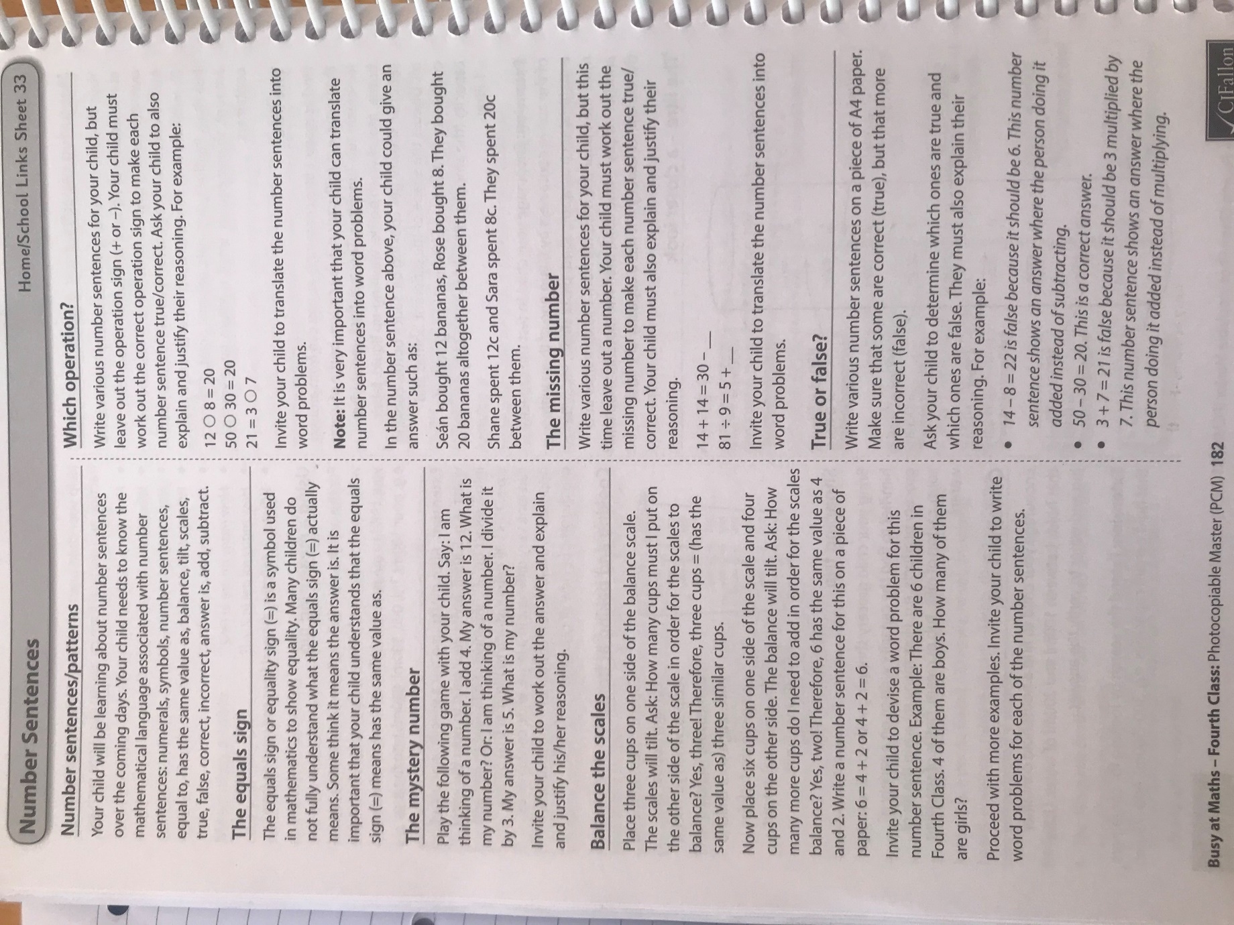

Appendix 2:
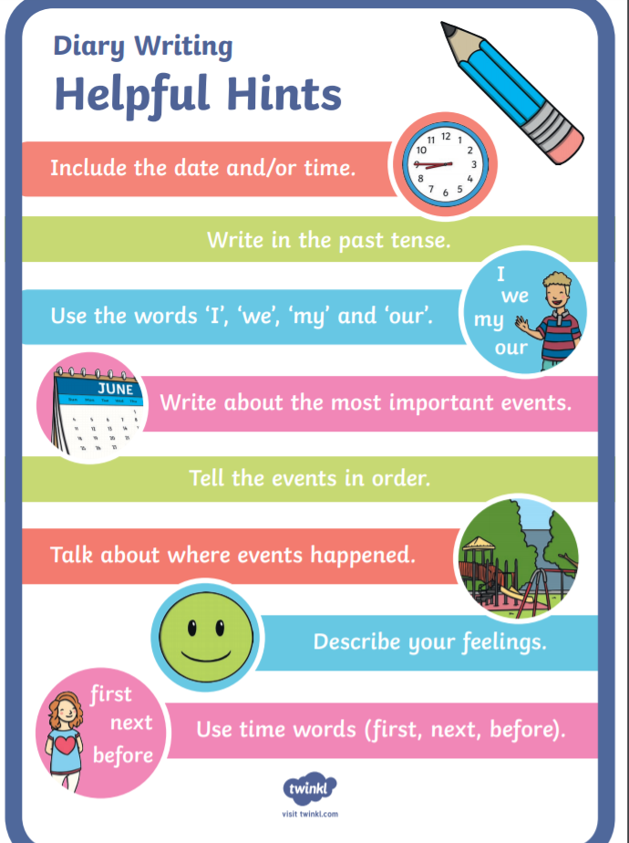

Appendix 3 (Monday):
Please answer the questions based on the interview of a local man from Arranmore Island in your copy:
- What businesses does Jerry Early run on the island?
- How far away is Arranmore Island from the mainland by boat? How long would the boat journey take on a good day?
- Name some of the activities Jerry Early suggests people could do if they visited Arranmore Island?
- What is Arranmore Island as Gaeilge? (It’s on a sign in the video).
- Is Jerry positive about the future of Arranmore Island? Explain your answer.
- Would you like to visit Arranmore Island? Explain your answer.

Appendix 4 (Tuesday):
Please answer the questions based on the video:
- A child was born a few weeks ago on the island. How long has it been since a child was born on Arranmore?
- What could help people work remotely on the island?
- What percentage of the island’s population is over 65 years old?
- What is the biggest silence the man hears on Arranmore?
- Arranmore is located in which ocean?
- Write 3 adjectives you might use to describe the island.
- Would you like to live and work/go to school on the island? Give reasons for your answer.

Appendix 5 (Tuesday):
Use the following for your fact file (feel free to make up your own headings also);
- Name of place
- Location
- Population
- Size of the island
- Languages spoken
- Weather
- Local businesses
- Schools
- Name 3 places of interest for visitors

Appendix 6 (Wednesday):
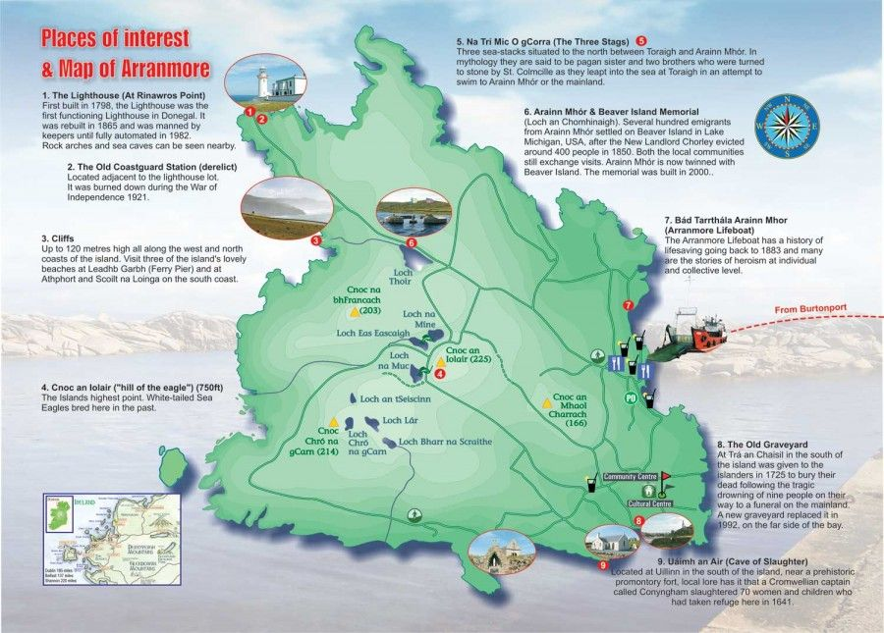
Questions on Map:
- Identify and name the lakes on the map.
- Identify and name the hills on the map.
- When was ‘The Lighthouse’ built?
- Identify and name the island’s highest point? How tall is the highest point?
- Draw the map in your copy. Mark and label the natural features (lakes and hills). Mark and label the lighthouse on your map.

Appendix 7 (Thursday):
Identify and examine the aerial images of Kilcock and Arranmore Island. Can you name any similarities and differences between the two places?
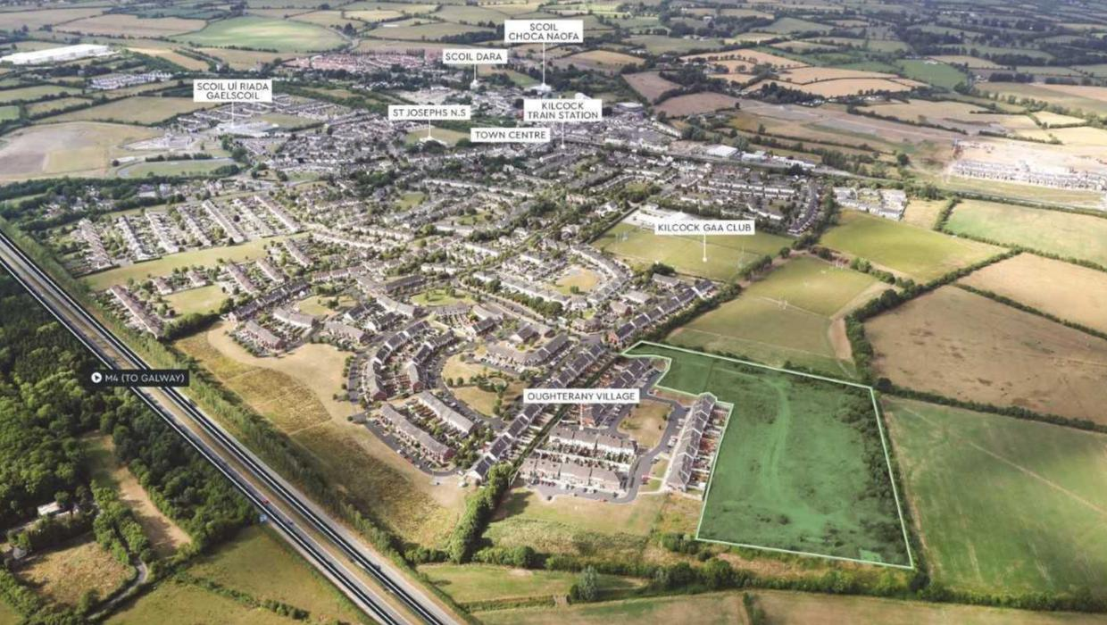

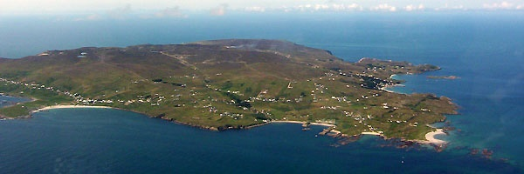

SEN/EAL work
Teacher: Ms. Wilson
Note: SEN teachers have added work on to the teachers’ plan. Children can decide to do this work instead of something the teacher has assigned. It is not extra work. Also, we would be delighted if you could email on a picture of something that your child has done and is proud of so we can see their lovely work again!
EAL | Theme : People Who Help Us  Before Easter you researched an occupation of your choice.  This week I would like you to write a report about this occupation. Mention role, place of work, daily routine, skills needed, qualifications needed, equipment used etc.  The website below might be of help.  https://www.worldbookonline.com/kids/home#article/ar830398  You can also base your report on the occupation of a family member.  Keep the report short and use your own words. Try to include a picture or drawing related to the occupation you have chosen. I would be delighted if you could send me on a picture of the report when it is finished.
Literacy | Continue with SNIP Literacy, Cloze Exercises and Gratitude Journal.  Try some independent reading for enjoyment. See website below for online readers. Pick a suitable age level. Email me and let me know which books you have enjoyed. (If you are reading other books that is fine too. Just let me know).  https://www.oxfordowl.co.uk/for-home/find-a-book/library-page/  You may prefer to listen to a story. You can access some of David Walliam’s audio books on this website.  https://www.worldofdavidwalliams.com/elevenses/  If you want to learn/ improve typing skills try games on this website.  https://www.education.com/resources/?q=typing+games
Contact SEN Teacher: mswilson@scoilchoca.ie

SEN Teacher 2: Ms. Heffernan
Speech and Language | Try these conversation starters about pets.  https://rainbow3to6.cjfallon.ie/class/fourth/units/1/lesson/4/slide/1  Or what about an online game of Articulate? You have to describe the word without saying it!  https://rainbow3to6.cjfallon.ie/class/fourth/units/1/lesson/5/slide/3  You could try some memory games like we play in school. Ask someone to call out 4 digits forwards or backwards and see if you can write them down.  Keep reading!  https://www.oxfordowl.co.uk/for-school/oxford-owl-ebook-collection  These are free ebooks and you can find your level (your parents can help if they have time)  Read yourself or to a younger sibling.  Here is the link to a selection of folk and fairytales that you might like to listen to from Audible (free at the moment) https://stories.audible.com/discovery/enterprise-discovery-21122352011?ref=adbl_ent_anon_ds_ds_dccs_sbtp-0-5  Alice’s Adventures in Wonderland https://stories.audible.com/pdp/B015D78L0U?ref=adbl_ent_anon_ds_pdp_pc_pg-1-cntr-0-2  The Wonderful Wizard of Oz https://stories.audible.com/pdp/B015D78L0U?ref=adbl_ent_anon_ds_pdp_pc_pg-1-cntr-0-2  The Secret Garden https://stories.audible.com/pdp/B002UZMRV8?ref=adbl_ent_anon_ds_pdp_pc_pg-1-cntr-0-43  Send me an email to let me know how you’re getting on-I’d love to hear from you!
Numeracy | mathsisfun.com  Practise your tables and the topic for the week. Send me an email to let me know what you have done or if you need help.
Contact SEN Teacher: msheffernan@scoilchoca.ie

