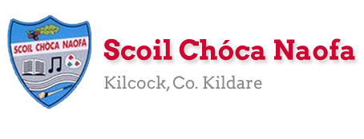
Work for Fifth Class: 5th of May – 8th of May 2020
Please remember: You are encouraged to complete one hour of work. The work we have given may take longer than one hour. If you want to do more than one hour that is fine but please don’t feel you have to. Do what you can and keep smiling! :)
Ms. Heffernan’s and Ms. Clancy’s (Now Ms. Tone’s) groups will find work for them attached to the end of this plan. Those not doing Gaeilge please access your TTRS account
Please send us pictures of your maths work and 2 other pieces of work you are proud of if you can. We would love to hear from you!
Our e-mail addresses are msfield@scoilchoca.ie and msmahon@scoilchoca.ie
Mon | English | Enjoy
 | Maths | The
 | Gaeilge | Bank
 | P.E. | Holiday
 | Other | Weekend
Tue – Optional. You were meant to have this day off on the school calendar | English | - RAH Wk. 30 D. 1  - Spellbound: p. 64 - Week 31: Learn block 109. Locate the words in block 109 on a map of Ireland. Exercise 1
 | Maths | - Mathletics or Maths Challenge Test 40 (Please write a clear title: E.g. Test 40) If you don’t have the book please see Test 40, 41 and 42 below
 | Gaeilge | - Duolingo: Collect 10XP
 | P.E. | - Run on the spot for 1 minute, 5 squats, 10 jumping jacks, 30 second plank, 5 press-ups, 20 high knees, 5 elbow to knees & 5 leg lunges (each side) with a 20 second rest after each exercise. Repeat x5
 | Other | S.P.H.E: See Well-being Activity 1 below
Wed | English | - RAH Wk. 30 D. 2  - Spellbound: p. 64 Learn block 110. Look up the words you don’t understand in block 110. Exercise 2 & 3.  - Starlight Unit 13a How Do Deep Sea Creatures Survive? Read p. 146-148. Complete p. 149 A & C.
 | Maths | - Mathletics or Maths Challenge Test 41 (Please write a clear title: E.g. Test 41) If you don’t have the book please see Test 40, 41 and 42 below  - Maths Matters pg. 133 Q. 1 (See picture of time facts below if you need help)
 | Gaeilge | - Béal Beo: lch. 137 An Phictiúrlann – Léigh agus scríobh na freagraí  - Duolingo: Collect 10XP
 | P.E. | - Get outside and be active for at least 30 minutes  - Suggested activity: Run 1 minute, walk 1 minute x 15
 | Other | S.P.H.E: See Well-being Activity 2 below
Thurs | English | - RAH Wk. 30 D. 3  - Spellbound: p. 64 Learn block 111. Look up the words you don’t understand in block 111. Exercise 4 & 5.  - Starlight: Unit 13a. Complete p. 151 F
 | Maths | - Mathletics or Maths Challenge 1 Test 42 If you don’t have the book please see Test 40, 41 and 42 below  - Maths Matters pg. 133 Q. 2 – 6  Count on or count back in your head. To make it easier break the number up.  E.g. Q. 2a What time was 15 minutes before 4:05? Break 15 mins up into 5 mins and 10 mins. Count back 5 mins from 4:05 = 4:00. Now count back another 10 mins from 4:00 and you get 3:50.  E.g. Q3a. What time will it be 35 mins later than 12:36?  Break 35 mins into 10, 10, 10 & 5. Count on 10 mins from 12:36 = 12:46. Count on 10 mins from 12:46 = 12:56. Count on 10 mins from 12:56 = 1:06 and finally count on 5 mins from 1:06 = 1:11. Draw this on the clock.  - Please email us if you are stuck on this.
 | Gaeilge | - Béal Beo lch. 138 & 139 (Use the yellow box and the clues in the brackets to figure out the answers)
 | P.E. | - Get outside and be active for at least 30 minutes. Go for a jog or walk, staying within 2km of your home.
 | Other | S.P.H.E: See Well-being Activity 3 below
Fri | English | - RAH Wk. 30 D. 4  - Spellbound: p. 64 Learn block 112. Look up the words you don’t understand in block 112. Exercise 6 & 7  - Starlight: Unit 13a. Complete p. 151 G
 | Maths | - Maths Matters pg. 134 Q. 1 – 5. Use the same strategy as yesterday. Counting on or counting back in 10s or 5s to get your answers. Remember for Q.2 there are only 60 minutes in an hour.
 | Gaeilge | - Léigh sa Bhaile: Seachtain 30 Lá 4 Scannán Taobh Amuigh. Léigh agus freagair na ceisteanna i do chóipleabhar  - Duolingo: Collect 10XP
 | P.E. | - Suggestion: Do 5 x 30 seconds of the following; jumping jacks, squats, burpees, hopping on right leg, hopping on left leg. Take 30 second rest after each exercise. Repeat x 6
 | Other | - SPHE: Listen to and follow along with this podcast. It involves a mindful body scan. https://app.kidslisten.org/ep/Peace-Out-Time-to-Pause-Friday
Extra Activities – Optional
Inside  - Learn a magic trick  - Research your family tree  - Make playdough | Outside  - Make an obstacle course (and clean up after)  - Pick a flower and paint it

SEN work
Teacher: Ms. Heffernan
Note: SEN teachers have added work on to the teachers’ plan. Children can decide to do this work instead of something the teacher has assigned. It is not extra work. Also, we would be delighted if you could email on a picture of something that your child has done and is proud of so we can see their lovely work again!
Literacy | Keep reading!  If any of you need more reading material, just let me know.  If you’ve read or listened to a story, let me know what you thought about it.  Do a little writing every day.  Keep a diary.  Keep a gratitude journal-write down 3 things you are grateful for each day.  Use www.writereader.com to create your own book.  Here’s a cloze procedure about European landmarks-no peeking at the answers until you’re finished!!  Keep practising your TTRS. See if you can still type while covering your hands with a towel!  Send me an email to let me know how you’re getting on-I’d love to hear from you!
Numeracy | Keep doing your Mathletics or you could also try https://www.mathsisfun.com/time-clocks.html to help you with telling the time.  Here are 2 other games to help with your mental maths.  https://www.topmarks.co.uk/maths-games/hit-the-button  https://www.topmarks.co.uk/maths-games/daily10  Send me an email to let me know what you have done or if you need help.
Contact SEN Teacher: msheffernan@scoilchoca.ie

SEN work

Teacher: Ms Tone / Ms Clancy

Note: SEN teachers have added work on to the teachers’ plan. Children can decide to do this work instead of something the teacher has assigned. It is not extra work. Also, we would be delighted if you could email on a picture of something that your child has done and is proud of so we can see their lovely work again!

Literacy | Word games:  - How many words can you find in your name? e.g. Kate – at, ate  - Can you find words in your surname? e.g. Tone – to, ton, on, one  - b _ _ d How many words can you make? e.g. bird  - _ a t _ How many words can you make? e.g. path  - Can you think of some words that contain ‘one’? e.g. Tone  - Can you think of some words that contain ‘he’? e.g. the  - Keep reading!
Numeracy | - Time: See clocks worksheet below.  Send me an email if you need any help.

Contact SEN Teacher: mstone@scoilchoca.ie

Ms. Tone’s Group - Time: Remember!

The big hand points to 12 at o’clock.
The small hand tells us the hour.
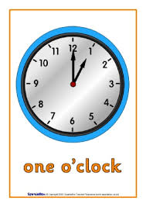
The big hand points to 6 at half past.
The small hand tells us the hour.
The small hand points after the number.

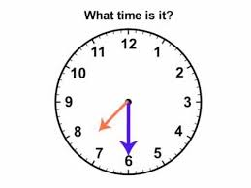
Half past 7

- Draw 4 clocks. Show these times: 4 o’clock 8 o’clock half past 5 half past 10
What time is it?
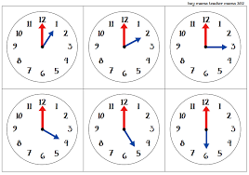

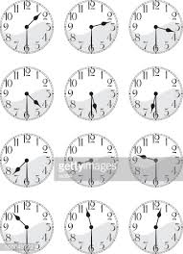
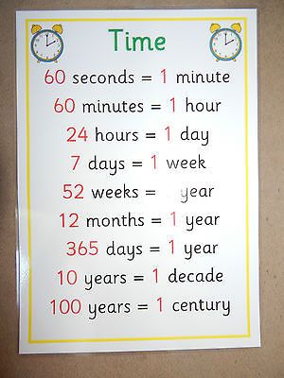
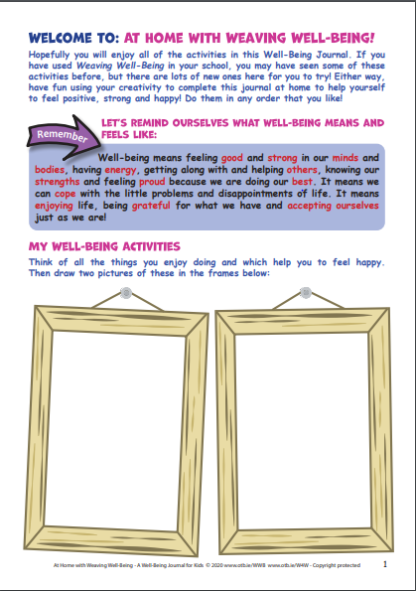
Well Being Activity 1

Well Being Activity 2 Well Being Activity 3
