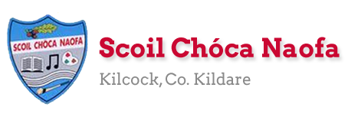
Work for Mr. Bracken’s 3rd Class: Monday 20/04/20 – Friday 24/04/20
Thought for the week comes from the Irish writer Oscar Wilde – “I never travel without my diary. One should always have something sensational to read on the train.”

Dear 3rd class,
I hope you and your family are well and that you enjoyed the Easter break.
This week’s work is explained below. Do you remember we had a nutritionist visit our class a few weeks ago? He talked about the different food groups and how our bodies break down food. In English this week our chapter is based on the human digestive system, so it is also a science topic. Some of the words can be tricky to pronounce. Remember to break them into bits.
As you all know, these are very unusual times that we are living in. I think it is a good idea to start to keep a diary based on your days. We are living in history at the moment! When you are older you will be able to tell people about what happened during Covid-19. It could be very valuable to write down your experiences and your feelings. So that is something I invite you to do from now on. You can write a daily entry in your diary, twice a week or just once a week. I will leave it up to you and your family. There is a sheet to help you with this at the end of the document. Remember to:
- write the date at the top of every entry
- begin with ‘Dear Diary’
- skip a line, then begin your sentences
- write about one feeling you are experiencing (happiness, excitement, frustration etc.)
- sign off at the end - ‘Yours Sincerely’, ‘That’s all for now’ etc. and your name.
- use your spare copy, start from the back
Continue to help out at home. If the weather is good then use it to exercise outside! You can do a lot in a small bit of space – planks, bear crawls, crab crawl, burpees, football skills, hurling/camogie skills and so on. Let me know what exercises you’re doing and send pictures of the work you are proudest of to mrbracken@scoilchoca.ie .
Stay safe and look after each other,
Mr. Bracken

Monday | English:  - Read at Home pg 105 – ‘Supergirl’ - Read & answer questions orally  - Starlight 13B ‘How Do Humans Digest a Tuna Sandwich?’  - Read pages 152 – 154. Complete part A in your spare copy, using full answers.  - Diary entry (optional)  Maths:  - Maths Matters p 115 in book (multiplication)  - Do page 5 of maths booklet (Pencil Power – multiplication sums)  - Remember to multiply units first, then tens  Irish:  - Léigh sa Bhaile - Read the next page  - Freagair na Ceisteanna/Answer the 5 questions at the bottom of the page in your spare copy.  - Cúla ar scoil @10am https://www.cula4.com/en/  P.E: PE with Joe Wicks on YouTube  Geography:  ‘Three’ have an advertisement based on Arranmore Island at the moment, you might have seen it on TV. They are trying to bring WiFi to the island to make it ‘the most connected island in the world’. Follow the link to a longer video on the island.  https://www.youtube.com/watch?v=i4PcOZ8xMsA&t=11s  Watch this video and answer the questions below in your copy. All the answers are in this video clip.
Tuesday | English:  - Read at Home pg 106- ‘Spiders’ - Read & answer questions orally  - Starlight 13B ‘How do Humans Digest a Tuna Sandwich?’ Complete part B in your spare copy.  - Diary entry (optional)  Maths:  - Maths Matters pg 116  - Maths booklet page 6 (fractions)  Irish:  - Léigh sa Bhaile: Read the next page  - Freagair na ceisteanna: Answer the 5 questions at the bottom of the page in your spare copy  - Watch a cartoon on TG4  P.E: PE with Joe Wicks on YouTube  Geography:  Look at Arranmore Island on Google Maps. There is also an aerial photograph at the end of this document.  Write a fact file in your copy based on Arranmore.
Wednesday | English:  - Read at Home pg 107 ‘Odd Jobs’ - Read & answer questions orally  - Starlight 13B ‘How do Humans Digest a Tuna Sandwich?’ Complete part C in your copy.  - Diary entry (optional)  Maths:  - Maths Matters pg 117 & 118  - Maths booklet p 7 (division with remainders)  Irish:  - Léigh sa Bhaile: Read the next page  - Freagair na ceisteanna: Answer the 5 questions at the bottom of the page in your spare copy  - Watch a cartoon on TG4  P.E: PE with Joe Wicks on Youtube  Geography:  Examine the map of Arranmore Island below and draw it in your copy. Mark and label the main sites. Answer the question below in your copy.
Thursday | English:  - Read at Home pg 108 ‘The Little Dutch Boy’ - Read & answer questions orally  - Starlight 13B ‘How do Humans Digest a Tuna Sandwich?’  - Draw the human digestive system. Label your image.  - Diary entry (optional)  Maths:  - Maths Matters pg 119  - Maths booklet p 8 (division)  Irish:  - Léigh sa Bhaile: Read the next page  - Freagair na ceisteanna: Answer the 5 questions at the bottom of the page in your spare copy  P.E: PE with Joe Wicks on YouTube  Geography:  Compare Kilcock and Arranmore Island. Complete this in your copy. What are the similarities and differences between the two locations?
Friday | English:  - Read at Home pg 109 ‘Climbing the Wall’ - Read & answer questions orally  - Starlight 13B ‘How Do Humans Digest a Tuna Sandwich?’  - Complete section D in your copy.  - Diary entry (optional)  Maths:  - Maths Matters pg 121 – it's tricky, take your time!  - Maths booklet p 9 (sets)  Irish:  - Léigh sa Bhaile: Read the next page  - Freagair na ceisteanna: Answer the 5 questions at the bottom of the page in your spare copy  - Cartún ar TG4  P.E: PE with Joe Wicks on YouTube  Geography/Art:  Design a tourist brochure based on Arranmore Island (an A4 page folded) Here’s a helpful video: https://www.youtube.com/watch?v=vBDr0YotAb0
Useful websites for this week:
- Maths: a helpful video for multiplying this week. The video deals with even bigger numbers than we are doing but the steps are the same. In the video they carry their digits in a different way than we do. Make sure to put your carrying digits on the line of the sum, not above the numbers. https://www.youtube.com/watch?v=FJ5qLWP3Fqo
- Art: How to make a brochure: https://www.youtube.com/watch?v=vBDr0YotAb0
- Geography: Video for questions about Arranmore Island https://www.youtube.com/watch?v=12wYnjmp3zU
- Geography: Watch a video about Arranmore Island https://www.youtube.com/watch?v=i4PcOZ8xMsA&t=11s
- Geography: Arranmore website- www.arainnmhor.com
- Geography: Wikipedia on Arranmore- https://en.wikipedia.org/wiki/Arranmore
- Maths: Tables revision games- https://www.topmarks.co.uk/maths-games/7-11-years/multiplication-and-division
- PE: Joe Wicks’ Live Daily PE workouts: https://www.youtube.com/
- General: Twinkl: Worksheets/Powerpoints available: Free access if you use code CVDTWINKLHELPS
- Gaeilge: Cúla ar Scoil begins on Monday, April 20th @10am – you can find it here: https://www.cula4.com/en/ , would be excellent for listening to Gaeilge during the week. I know the presenter of the show, listen out, our school might get a mention!

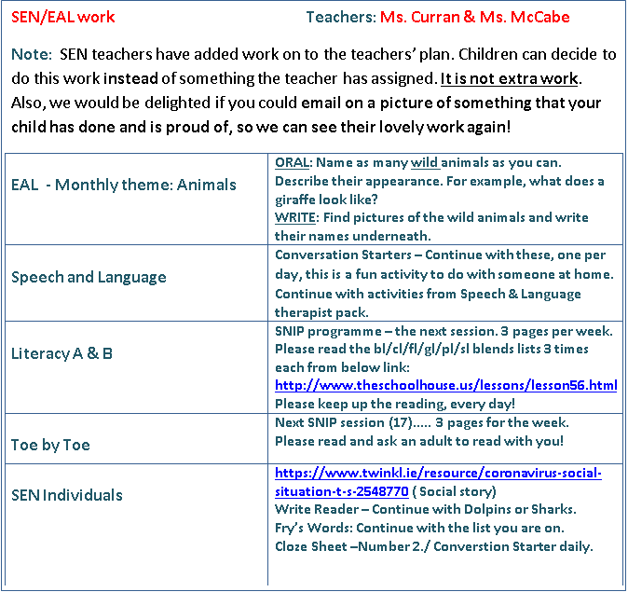

We are watching RTE Home School Hub @ 11am each day, and it is really interesting, full of general knowledge. It is well worth watching!
PLEASE email us, we miss you all! mscurran@scoilchoca.ie / msmcabe@scoilchoca.ie ..............Ms. Curran is working, this week!

Diary entry tips:
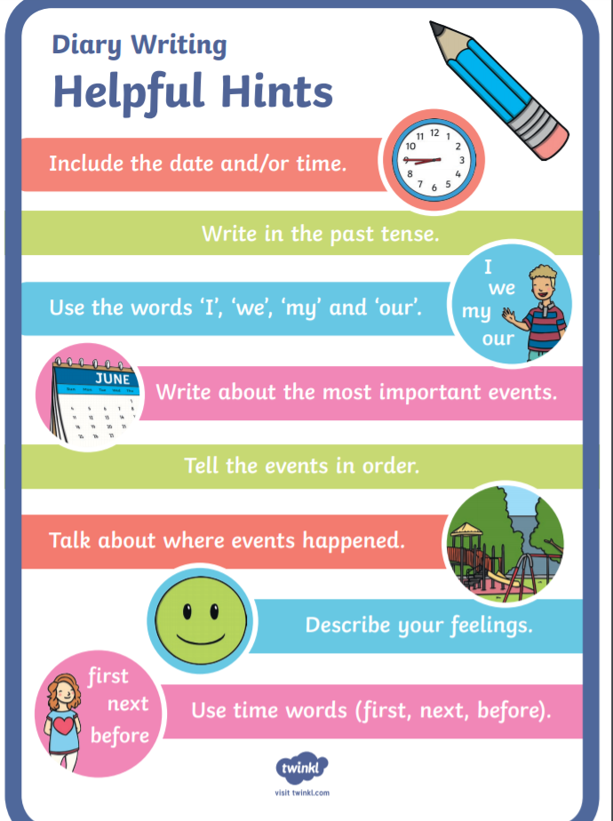

Geography Resources
Questions to answer on Arranmore video clip (Monday)
- A child was born a few weeks ago on the island. How long has it been since a child was born on Arranmore?
- What could help people work remotely on the island?
- What percentage of the island’s population is over 65 years old?
- What is the biggest silence the man hears on Arranmore?
- Arranmore is located in which ocean?
- Write 3 adjectives you might use to describe the island.
- Would you like to live and work/go to school on the island? Give reasons for your answer.

Use the following headings to help with your fact file and tourist brochure. You can use as many or as few as you want. Feel free to add more if you wish:
- Clear title
- Location
- Population
- Languages spoken
- Weather
- Local businesses
- Name of school
- Name 3 places of interest for visitors
Map of Arranmore Island:
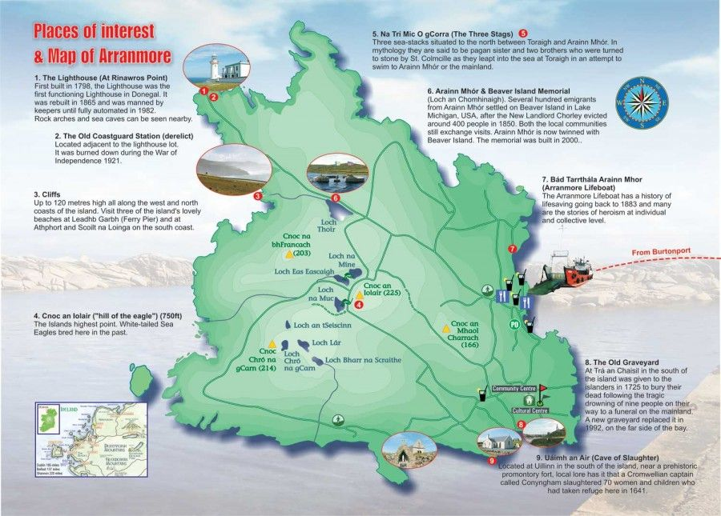
Questions on Map:
- Name the lakes on the map.
- Name the hills on the map.
- When was the lighthouse built?
- Can you name any other lighthouses in Ireland? Think back to our projects.
- What is the island’s highest point?
- Draw and label the map in your copy. (optional)

Aerial photographs of Kilcock and Arranmore Island:
