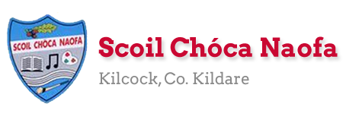
Work for Ms. Tierney’s 4th Class:
Monday 20/04/20 – Friday 24/04/20
Monday | English:  Read at Home pg 100- Read & answer questions orally.  Read Chapter 8 in your novel ‘The Boy in the Dress.’  Write 7 questions you would like to ask one of the characters in the novel. Don’t forget your ? marks.  Keep a diary (optional)- Write about your day and how you’re feeling right now.  Recite this week’s poem: Today I Had a Rotten Day  Maths:  Maths Matters pg 131  Complete Mathletics activities  Count up and down in multiples from 2-20, 3-30, 4-40  Irish:  Léigh Scuab Fiacal Danny: Read Irish Novel (1 pg)  Can an t-amhrán/Sing the song: Óró Sé do Bheatha ‘Bhaile.  Watch Cúla4 ar Scoil on TG4 at 10 a.m.  Imir cluichí ar Duolingo/Play games on Duolingo  P.E: PE with Joe Wicks on YouTube  Other: Geography- Arranmore Island  The mobile network ‘Three’ have an advertisement based on Arranmore Island at the moment. You might have seen it on TV. They are trying to bring WiFi to the island to make it ‘the most connected island in the world’.  Follow the link below to a watch a video about the island.  Answer the questions below in your copy. All of the answers are in this video clip.
Tuesday | English:  Read at Home pg 101- Read & answer questions orally.  Read Chapter 9 in your novel ‘The Boy in the Dress.’  Make a factfile about one of the characters. Add details to it as you read through the rest of the novel.  Keep a diary (optional)- Write about your day and how you’re feeling right now.  Recite this week’s poem ‘Today I Had a Rotten Day’  Maths:  Maths Matters pg 132  Complete Mathletics Activties  Count up and down in multiples from 5-50, 6-60  Irish:  Léigh Scuab Fiacal Danny: Read Irish Novel (1 pg)  Can an t-amhrán/Sing the song: Óró Sé do Bheatha ‘Bhaile.  Watch Cúla4 ar Scoil on TG4 at 10 a.m.  Imir cluichí ar Duolingo/Play games on Duolingo  P.E: PE with Joe Wicks on YouTube  Other: Geography- Arranmore Island  Visit the Arranmore Island website and Wikipedia. Do some research on the island.  Write up to 10 facts about the island.
Wednesday | English:  Read at Home pg 102- Read & answer questions orally.  Read Chapter 10 in your novel ‘The Boy in the Dress.’  Write a short paragraph about a memory/experience of your own that is similar to what you have read in the book.  Keep a diary (optional)- Write about your day and how you’re feeling right now.  Recite this week’s poem: ‘Today I Had a Rotten Day.’  Maths:  Maths Matters pg 133  Complete Mathletics Activties  Count up and down in multiplies from 7-70, 8-80  Irish:  Léigh Scuab Fiacal Danny: Read Irish Novel (1 pg)  Can an t-amhrán/Sing the song ‘Óró Sé do Bheatha ‘Bhaile.’  Watch Cúla4 ar scoil on TG4 at 10 a.m.  Imir cluichí ar Duolingo/Play games on Duolingo  P.E: PE with Joe Wicks on Youtube  Other: Geography-Arranmore Island  Examine the map and aerial photograph of Arranmore Island below and draw it in your copy. Mark and label the main sites. Answer the questions orally.
Thursday | English:  Read at Home pg 103- Read & answer questions orally.  Read Chapter 11 in your novel ‘The Boy in the Dress.’  Imagine David Walliams, the author, came for a visit: write 7 questions you would like to ask him. Don’t forget your ? marks.  Keep a diary (Optional)- Write about your day and how you’re feeling right now.  Recite this week’s poem: ‘Today I Had a Rotten Day.’  Maths:  Maths Matters pg 134  Complete Mathletics Activities  Count up and down in multiples from 9-90, 10-100  Irish:  Léigh Scuab Fiacal Danny: Read Irish Novel (1 pg)  Can an t-amhrán/Sing the song ‘Óró Sé do Bheatha ‘Bhaile.’  Watch Cúla4 ar scoil on TG4 at 10 a.m.  Imir cluichí ar Duolingo/Play games on Duolingo  P.E: PE with Joe Wicks on YouTube  Other: Geography- Arranmore Island  Compare and contrast Kilcock and Arranmore Island- Write 3 ways in which the places are similar and write 3 ways in which they are different.
Friday | English:  Read at Home pg 104- Read & answer questions orally.  Read Chapter 12 in your novel ‘The Boy in the Dress.’  Make a prediction at the end of the chapter. Write what you think will happen next.  Keep a diary (optional)- Write about your day and how you’re feeling right now.  Recite this week’s poem: ‘Today I Had a Rotten Day.’  Maths:  Maths Matters pg 135  Complete Mathletics Activties  Count up and down in multiples from 11-110, 12-120  Irish:  Léigh Scuab Fiacal Danny: Read Irish Novel (1 pg)  Can an t-amhrán/Sing the song ‘Óró Sé do Bheatha ‘Bhaile.’  Watch Cúla4 ar scoil on TG4 at 10 a.m.  Imir cluichí ar Duolingo/Play games on Duolingo  P.E: PE with Joe Wicks on YouTube  Other: Geography- Arranmore Island  Design a tourist brochure based on Arranmore Island to attract visitors to the island.

Useful websites for this week:
- Maths: https://www.mathletics.com/uk/
- Maths: Tables revision games- https://www.topmarks.co.uk/maths-games/7-11-years/multiplication-and-division
- Gaeilge: Can an t-amhrán/sing the song: https://www.youtube.com/watch?v=bzXswoAUi0U
- PE: Joe Wicks’ Live Daily PE workouts: https://www.youtube.com/
- Geography: Video for questions about Arranmore Island https://www.youtube.com/watch?v=12wYnjmp3zU
- Geography: Watch a video about Arranmore Island https://www.youtube.com/watch?v=i4PcOZ8xMsA&t=11s
- Geography: Arranmore website- www.arainnmhor.com
- Geography: Wikipedia on Arranmore- https://en.wikipedia.org/wiki/Arranmore
- General: Twinkl: Worksheets/Powerpoints available: Free access if you use code CVDTWINKLHELPS
- RTE’s Home School Hub. If you miss it, you might be able to watch it back on RTE Player. https://www.rte.ie/player/

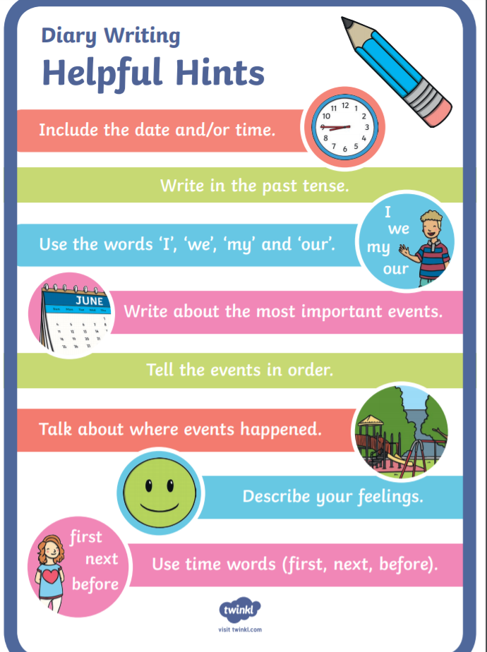
English Resources:
English Poem
Today I Had a Rotten Day
Today I had a rotten day.
As I was coming in from play
I accidentally stubbed my toes
and tripped and fell and whacked my nose.
I chipped a tooth. I cut my lip.
I scraped my knee. I hurt my hip.
I pulled my shoulder, tweaked my ear,
and got a bruise upon my rear.
I banged my elbow, barked my shin.
A welt is forming on my chin.
My pencil poked me in the thigh.
I got an eyelash in my eye.
I sprained my back. I wrenched my neck.
I’m feeling like a total wreck.
So that’s the last time I refuse
when teacher says to tie my shoes.

Gaeilge Resources:
Irish song: Óró Sé do Bheatha ‘Bhaile
Oro, se do bheatha 'bhaile!
Oro, se do bheatha 'bhaile!
Oro, se do bheatha 'bhaile!
Anois ar theacht an tsamhraidh
Se do bheatha a bhean ba leanmhar!
B'e ar gcreach tu bheith i ngeibhinn
Do dhuiche bhrea i seilbh meirleach
'S tu diolta leis na Ghallaibh
Oro, se do bheatha 'bhaile!
Oro, se do bheatha 'bhaile!
Oro, se do bheatha 'bhaile!
Anois ar theacht an tsamhraidh
Ta Grainne Mhaol ag teacht thar saile
Oglaigh armtha lei mar gharda
Gaeil iad fein 's ni Gaill na Spainnigh
'S cuirfid siad ruaig ar Ghallaibh
Oro, se do bheatha 'bhaile!
Oro, se do bheatha 'bhaile!
Oro, se do bheatha 'bhaile!
Anois ar theacht an tsamhraidh
A bhui le Ri na bhfeart go bhfeiceam
Muna mbeam beo 'na dhiaidh ach seachtain
Grainne Mhaol agus mile gaiscioch
Ag fogairt fain ar Ghallaibh

Geography Resources:
Questions to answer about the video clip on Arranmore Island:
- What business does Jerry Early run on the island?
- How far away is Arranmore Island from the mainland by boat?
- How long would the boat journey take on a good day?
- Name some of the activities Jerry Early suggests people could do if they visited Arranmore Island?
- What is Arranmore Island as Gaeilge? (It’s on a sign in the video)
- Is Jerry positive about the future of the island? Explain your answer.
- Would you like to visit Arranmore Island? Give a reason for your answer.

Map and Aerial Photograph of Arranmore Island:
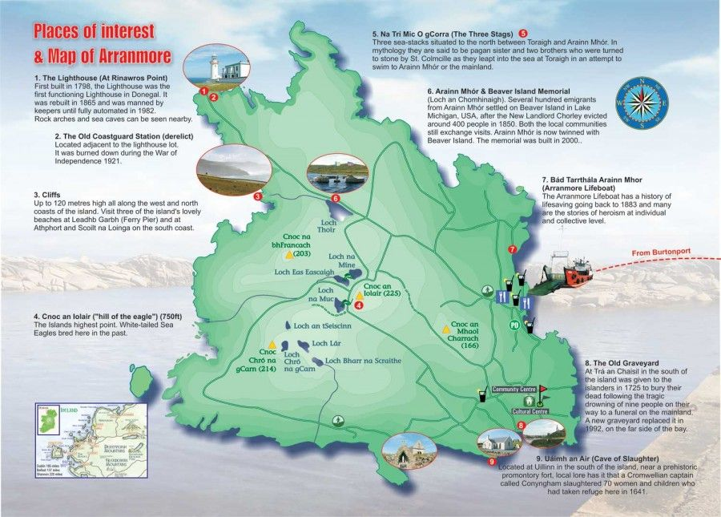
Questions to answer orally based on the map:
- Identify and name the lakes on the map.
- Identify and name the hills on the map.
- When was the lighthouse built?
- Identify and name the island’s highest point. How tall is the highest point?

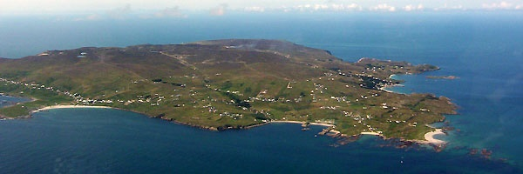
Tourist Brochure Template:
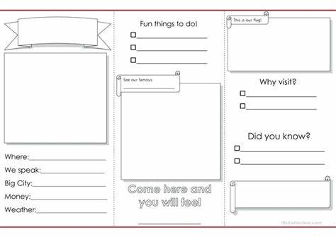
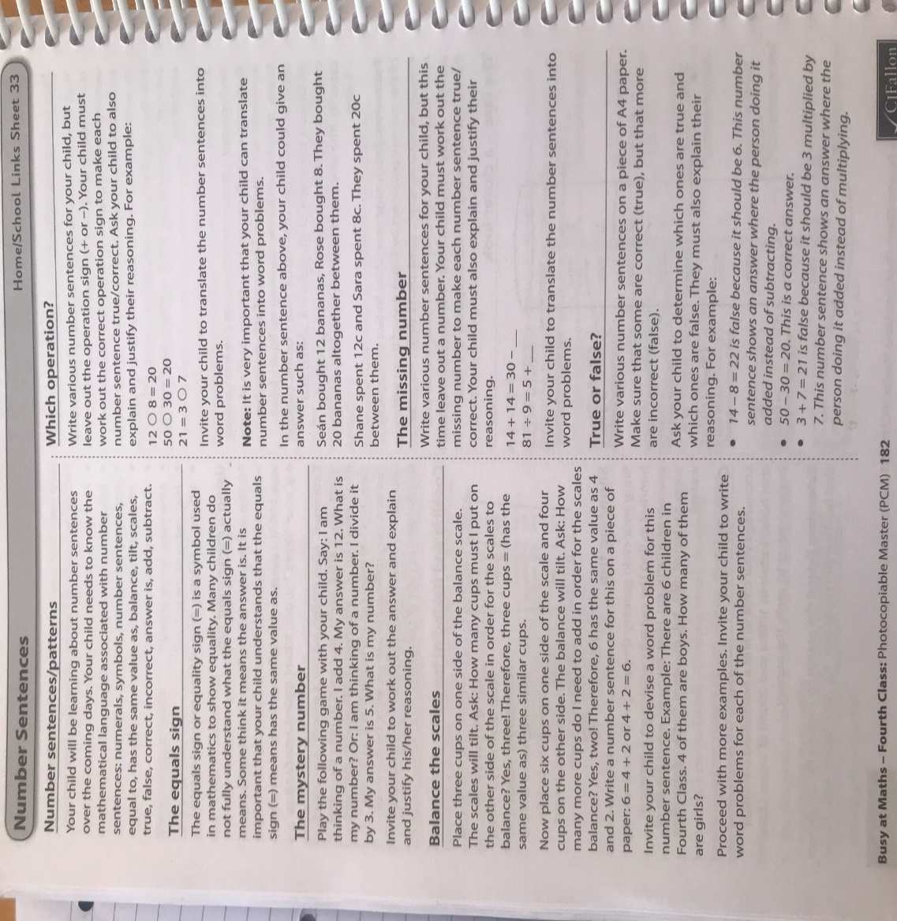
Maths resources:

Maths answer book for self-correction:

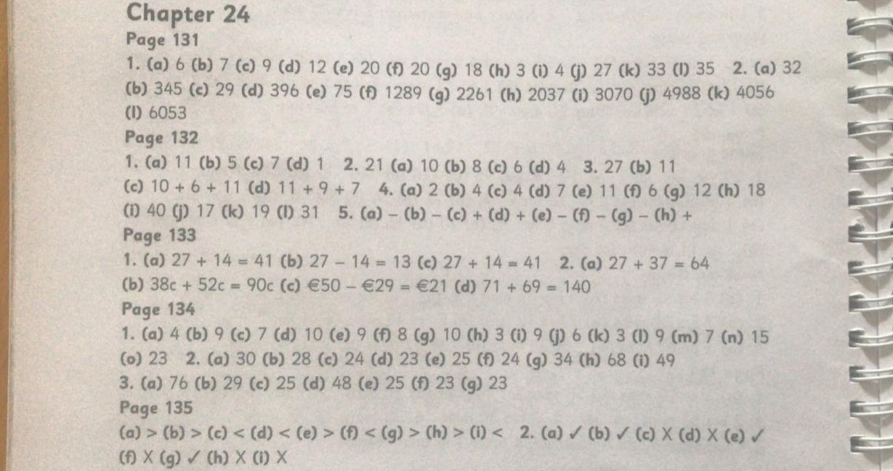

Dear 4th Class,
I hope you and your families are keeping well. I do hope you enjoyed the Easter holidays. The weather has been so nice and warm outside so I hope you are getting outside to play in the garden. Remember to help out at home as much as you can. Here is some work to keep you busy during the week. There is a lot of work here for you to complete. Do not worry if you do not get it all finished. Just do your best Girls, you are living through history at the moment! That is why I think it would be a fantastic idea for you to keep a diary so that you can look back at this time in years to come. You will be able to tell people what life was like during Covid-19. Write about what you are doing every day and how you are feeling right now.
I miss you all and I would really love to see what you have been up to for the past few weeks. If you or your parents/guardians would like to send some pictures of any work you have completed, I would be delighted to see it. You can send it to my email address – mstierney@scoilchoca.ie .
Stay safe,
Ms. Tierney

*Please see Ms. Heffernan’s plan below if applicable.

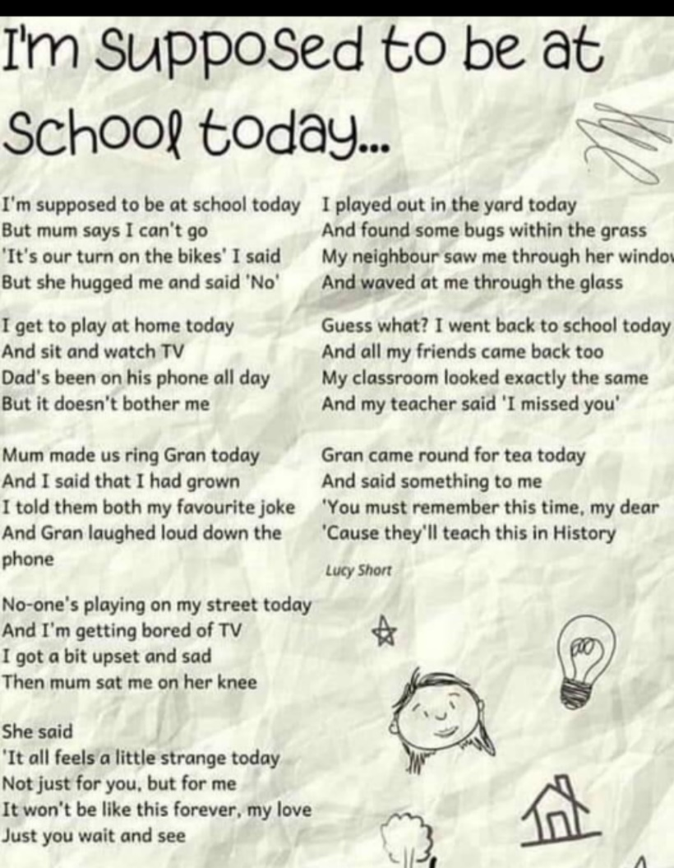

Teacher: Ms. Heffernan
Note: SEN teachers have added work on to the teachers’ plan. Children can decide to do this work instead of something the teacher has assigned. It is not extra work. Also, we would be delighted if you could email on a picture of something that your child has done and is proud of so we can see their lovely work again!
Language | Try these conversation starters about pets.  https://rainbow3to6.cjfallon.ie/class/fourth/units/1/lesson/4/slide/1  Or what about an online game of Articulate? You have to describe the word without saying it!  https://rainbow3to6.cjfallon.ie/class/fourth/units/1/lesson/5/slide/3  You could try some memory games like we play in school. Ask someone to call out 4 digits forwards or backwards and see if you can write them down.  Keep reading!  https://www.oxfordowl.co.uk/for-school/oxford-owl-ebook-collection  These are free ebooks and you can find your level (your parents can help if they have time)  Read yourself or to a younger sibling.  Here is the link to a selection of folk and fairytales that you might like to listen to from Audible (free at the moment) https://stories.audible.com/discovery/enterprise-discovery-21122352011?ref=adbl_ent_anon_ds_ds_dccs_sbtp-0-5  Alice’s Adventures in Wonderland https://stories.audible.com/pdp/B015D78L0U?ref=adbl_ent_anon_ds_pdp_pc_pg-1-cntr-0-2  The Wonderful Wizard of Oz https://stories.audible.com/pdp/B015D78L0U?ref=adbl_ent_anon_ds_pdp_pc_pg-1-cntr-0-2  The Secret Garden https://stories.audible.com/pdp/B002UZMRV8?ref=adbl_ent_anon_ds_pdp_pc_pg-1-cntr-0-43  Send me an email to let me know how you’re getting on-I’d love to hear from you!
Contact SEN Teacher: msheffernan@scoilchoca.ie

