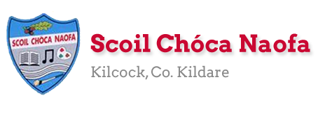
Work for Ms. Tierney’s 3rd Class:
Monday 20/04/20 – Friday 24/04/20
Monday | English:  Read at Home pg 100- Read & answer questions orally.  Read Chapter 8 in your novel ‘The Boy in the Dress.’  Write 5 questions you would like to ask one of the characters in the novel. Don’t forget your ? marks.  Keep a diary (optional)- Write about your day and how you’re feeling right now.  Recite this week’s poem: Today I Had a Rotten Day  Maths:  Maths Matters pg 122 + 123 (Answers at end of document)  Complete Mathletics activities  Count up and down in multiples 2-20, 3-30, 4-40  Irish:  Léigh sa Bhaile- Read the next page  Freagair na Ceisteanna/Answer the 5 questions at the bottom of the page in your copy  in your spare copy.  Can an t-amhrán/Sing the song: Óró Sé do Bheatha ‘Bhaile.  Watch Cúla4 ar Scoil on TG4 at 10 a.m.  P.E: PE with Joe Wicks on YouTube  Other: Geography- Arranmore Island  The mobile network ‘Three’ have an advertisement based on Arranmore Island at the moment. You might have seen it on TV. They are trying to bring WiFi to the island to make it ‘the most connected island in the world’.  Follow the link below to a watch a video about the island.  Answer the questions below in your copy. All of the answers are in this video clip.
Tuesday | English:  Read at Home pg 101- Read & answer questions orally.  Read Chapter 9 in your novel ‘The Boy in the Dress.’  Make a factfile about one of the characters. Add details to it as you read through the rest of the novel.  Keep a diary (optional)- Write about your day and how you’re feeling right now.  Recite this week’s poem ‘Today I Had a Rotten Day’  Maths:  Maths Matters pg 124 (Answers at end of document)  Complete Mathletics Activties  Count up and down in multiples from 5-50, 6-60  Irish:  Léigh sa Bhaile: Read the next page  Freagair na ceisteanna: Answer the 5 questions at the bottom of the page.  Can an t-amhrán/Sing the song- Óró Sé do Bheatha ‘Bhaile.  Watch Cúla4 ar scoil on TG4 at 10 a.m.  P.E: PE with Joe Wicks on YouTube  Other: Geography- Arranmore Island  Visit the Arranmore Island website and Wikipedia. Do some research on the island.  Write up to 10 facts about the island.
Wednesday | English:  Read at Home pg 102- Read & answer questions orally.  Read Chapter 10 in your novel ‘The Boy in the Dress.’  Write a short paragraph about a memory/experience of your own that is similar to what you have read in the book.  Keep a diary (optional)- Write about your day and how you’re feeling right now.  Recite this week’s poem: ‘Today I Had a Rotten Day.’  Maths:  Maths Matters pg 125 (Answers at end of document)  Complete Mathletics Activties  Count up and down in multiplies from 7-70, 8-80  Irish:  Léigh sa Bhaile: Read the next page  Freagair na ceisteanna: Answer the 5 questions at the bottom of the page.  Can an t-amhrán/Sing the song ‘Óró Sé do Bheatha ‘Bhaile.’  Watch Cúla4 ar scoil on TG4 at 10 a.m.  P.E: PE with Joe Wicks on Youtube  Other: Geography- Arranmore Island  Examine the map and aerial photograph of Arranmore Island below and draw it in your copy. Mark and label the main sites. Answer the questions orally.
Thursday | English:  Read at Home pg 103- Read & answer questions orally.  Read Chapter 11 in your novel ‘The Boy in the Dress.’  Imagine David Walliams, the author, came for a visit: write 5 questions you would like to ask him. Don’t forget your ? marks.  Keep a diary (Optional)- Write about your day and how you’re feeling right now.  Recite this week’s poem: ‘Today I Had a Rotten Day.’  Maths:  Maths Matters pg 126 (Answers at end of document)  Complete Mathletics Activities  Count up and down in multiples from 9-90, 10-100  Irish:  Léigh sa Bhaile: Read the next page  Freagair na ceisteanna: Answer the 5 questions at the bottom of the page  Can an t-amhrán/Sing the song: Óró Sé do Bheatha ‘Bhaile  Watch Cúla4 ar scoil on TG4 at 10 a.m.  P.E: PE with Joe Wicks on YouTube  Other: Geography- Arranmore Island  Compare and contrast Kilcock and Arranmore Island- Write 3 ways in which the places are similar and write 3 ways in which they are different.
Friday | English:  Read at Home pg 104- Read & answer questions orally.  Read Chapter 12 in your novel ‘The Boy in the Dress.’  Make a prediction at the end of the chapter. Write what you think will happen next.  Keep a diary (optional)- Write about your day and how you’re feeling right now.  Recite this week’s poem: ‘Today I Had a Rotten Day.’  Maths:  Maths Matters pg 127 (Answers at end of document)  Complete Mathletics Activties  Count up and down in multiples from 11-110, 12-120  Irish:  Léigh sa Bhaile: Read the next page  Freagair na ceisteanna: Answer the 5 questions at the bottom of the page  Can an t-amhrán/Sing the song: Óró Sé do Bheatha ‘Bhaile  Watch Cúla4 ar scoil on TG4 at 10 a.m  P.E: PE with Joe Wicks on YouTube  Other: Geography- Arranmore Island  Design a tourist brochure based on Arranmore Island to attract visitors to the island.
Useful websites for this week:
- Maths: Tutorial for division https://www.youtube.com/watch?v=Dv8BOsG8cPc&t=103s
- Maths: https://www.mathletics.com/uk/
- Maths: Tables revision games- https://www.topmarks.co.uk/maths-games/7-11-years/multiplication-and-division
- Gaeilge: Can an t-amhrán/sing the song: https://www.youtube.com/watch?v=bzXswoAUi0U
- PE: Joe Wicks’ Live Daily PE workouts: https://www.youtube.com/
- Geography: Video for questions about Arranmore Island https://www.youtube.com/watch?v=12wYnjmp3zU
- Geography: Watch a video about Arranmore Island https://www.youtube.com/watch?v=i4PcOZ8xMsA&t=11s
- Geography: Arranmore website- www.arainnmhor.com
- Geography: Wikipedia on Arranmore- https://en.wikipedia.org/wiki/Arranmore
- General: Twinkl: Worksheets/Powerpoints available: Free access if you use code CVDTWINKLHELPS
- RTE’s Home School Hub. If you miss it, you might be able to watch it back on RTE Player. https://www.rte.ie/player/

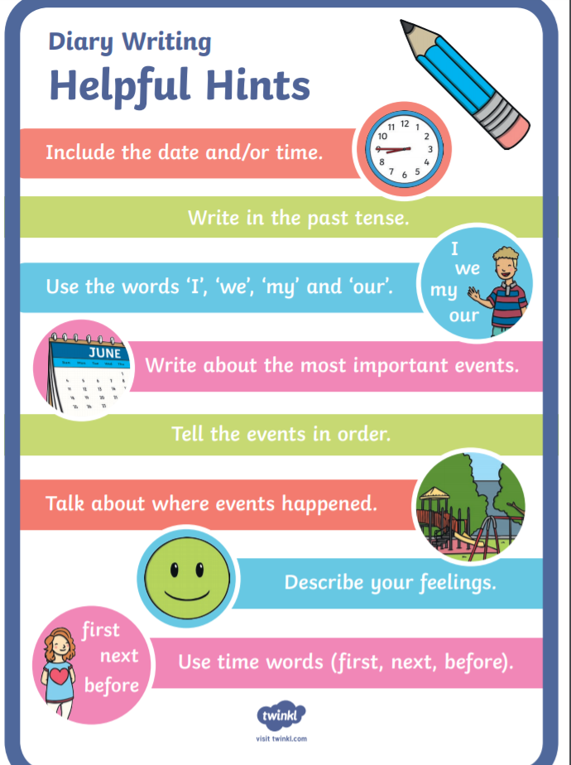
English Resources:
English Poem
Today I Had a Rotten Day
Today I had a rotten day.
As I was coming in from play
I accidentally stubbed my toes
and tripped and fell and whacked my nose.
I chipped a tooth. I cut my lip.
I scraped my knee. I hurt my hip.
I pulled my shoulder, tweaked my ear,
and got a bruise upon my rear.
I banged my elbow, barked my shin.
A welt is forming on my chin.
My pencil poked me in the thigh.
I got an eyelash in my eye.
I sprained my back. I wrenched my neck.
I’m feeling like a total wreck.
So that’s the last time I refuse
when teacher says to tie my shoes.

Gaeilge Resources:
Irish song: Óró Sé do Bheatha ‘Bhaile
Oro, se do bheatha 'bhaile!
Oro, se do bheatha 'bhaile!
Oro, se do bheatha 'bhaile!
Anois ar theacht an tsamhraidh
Se do bheatha a bhean ba leanmhar!
B'e ar gcreach tu bheith i ngeibhinn
Do dhuiche bhrea i seilbh meirleach
'S tu diolta leis na Ghallaibh
Oro, se do bheatha 'bhaile!
Oro, se do bheatha 'bhaile!
Oro, se do bheatha 'bhaile!
Anois ar theacht an tsamhraidh
Ta Grainne Mhaol ag teacht thar saile
Oglaigh armtha lei mar gharda
Gaeil iad fein 's ni Gaill na Spainnigh
'S cuirfid siad ruaig ar Ghallaibh
Oro, se do bheatha 'bhaile!
Oro, se do bheatha 'bhaile!
Oro, se do bheatha 'bhaile!
Anois ar theacht an tsamhraidh
A bhui le Ri na bhfeart go bhfeiceam
Muna mbeam beo 'na dhiaidh ach seachtain
Grainne Mhaol agus mile gaiscioch
Ag fogairt fain ar Ghallaibh

Geography Resources:
Questions to answer about the video clip on Arranmore Island:
- What business does Jerry Early run on the island?
- How far away is Arranmore Island from the mainland by boat?
- How long would the boat journey take on a good day?
- Name some of the activities Jerry Early suggests people could do if they visited Arranmore Island?
- What is Arranmore Island as Gaeilge? (It’s on a sign in the video)
- Is Jerry positive about the future of the island? Explain your answer.
- Would you like to visit Arranmore Island? Give a reason for your answer.

Map and Aerial Photograph of Arranmore Island:
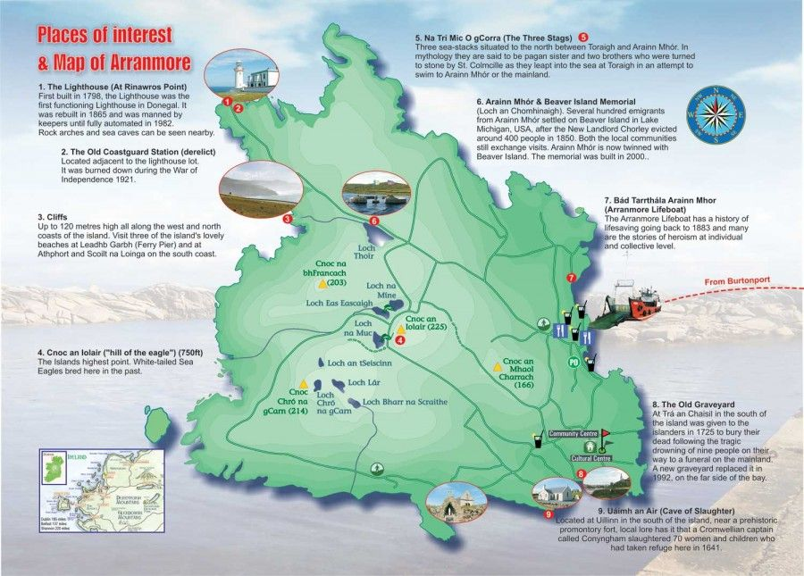
Questions to answer orally based on the map:
- Identify and name the lakes on the map.
- Identify and name the hills on the map.
- When was the lighthouse built?
- Identify and name the island’s highest point. How tall is the highest point?

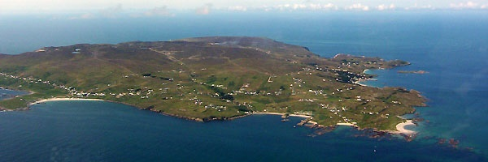
Tourist Brochure Template:
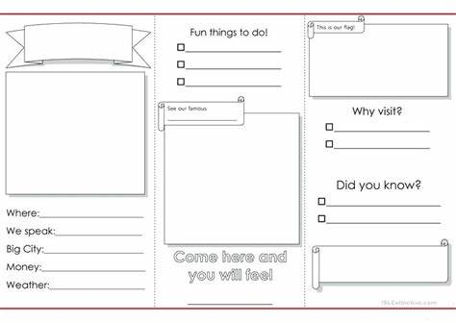

Maths answers for self-correction:
Page 123
- 54÷3=18 or 3 |54_ 2 a. 50÷2=25 c or 2 |50_ b. 36÷2=18 or 2|36 c. 54÷3= 18 or 3|54 d. 75÷3= 25 or 3|75
18 25 c 18 18 25 c
Page 124
1 a. 15 b. 27 c. 16 d. 24 e. 13 f.15 g. 15 h. 18 i.12 j. 14 k. 12 l. 12
2a. 26 b. 25 c. 14 d. 24 e. 17 f. 13 g. 13 h. 15 i. 13 j. 14 k. 12 l. 12
3a. 28 r 1 b. 26 r 1 c. 18 r 3 d. 24 r 2 e. 14 r 3 f. 12 r 1 g. 13 r 2 h. 14 r 4 i. 13 r 3 j. 12 r 3 k. 11 r 5 l. 11 r 2
4a. 32 c b. 1 c
5a. 10 b. 4
Page 125
1.13, 4 2. 12, 4 3. 18, 3
Who fell off the wall? HD (Humpty Dumpty)
a)27 b) 24 c)17 d) 23 e)19 f)16 g)14 h)12 i) 13 r 2 j) 15 r 2 k)12 r 3 l)11 r 5 m) 19 r 1 n)16 r 3 o) 13 r 1
Page 126
5 a. 188 b. 400 + 300= 700 Answer 692 c. 30 Answer 27 d. 200-80=120 Answer 112 e. 60 Answer 51 f. 40 x6= 240 Answer 222
g. 9 Answer 9 r 6 h. 70 + 10 = 7 Answer 7 r 3
Page 127
Across
1.40 2.36 3. 31 4. 268 5. 250 7. 24 9. 78 10. 32 11. 75 12. 22 13. 38 14. 50
Down
1.48 2. 348 3. 345 5.240 6. 92 8. 92 9. 78 10. 348 11. 721 13. 39

Page 121
Orange: 5 x 6 = (2 x 6) + (3 x 6)= 30, Blue: 7 x 5 = (4x5) + (3x5)= 35, Green: 6 x 2= (3x2) + (3x2)= 12,
Red: 9x4= (6x4) + (3x4) = 36, Pink: 8 x 3= (5x3) + (3x3)= 24, Brown: 9 x 8= (7x8) + (2x8)= 72,
Black: 10 x 9= (6x9) + (4x9) = 90, Purple: 8 x 6 = (6x6) + (2x6)= 48 Navy: 5 x 4= (4x4) + (1x4)= 20

Dear 3rd Class,
I hope you and your families are keeping well. I do hope you enjoyed the Easter holidays. The weather has been so nice and warm outside so I hope you are getting outside to play in the garden. Remember to help out at home as much as you can. Here is some work to keep you busy during the week. There is a lot of work here for you to complete. Do not worry if you do not get it all finished. Just do your best Boys and girls, you are living through history at the moment! That is why I think it would be a fantastic idea for you to keep a diary so that you can look back at this time in years to come. You will be able to tell people what life was like during Covid-19. Write about what you are doing every day and how you are feeling right now.
I miss you all and I would really love to see what you have been up to for the past few weeks. If you or your parents/guardians would like to send some pictures of any work you have completed, I would be delighted to see it. You can send it to my email address – mstierney@scoilchoca.ie .
Stay safe,
Ms. Tierney
SEN/EAL work Teachers: Ms. Curran & Ms. McCabe
Note: SEN teachers have added work on to the teachers’ plan. Children can decide to do this work instead of something the teacher has assigned. It is not extra work. Also, we would be delighted if you could email on a picture of something that your child has done and is proud of, so we can see their lovely work again!
EAL - Monthly theme: Animals | ORAL: Name as many wild animals as you can. Describe their appearance. For example, what does a giraffe look like?  WRITE: Find pictures of the wild animals and write their names underneath.
Speech and Language | Conversation Starters – Continue with these, one per day, this is a fun activity to do with someone at home.  Continue with activities from Speech & Language therapist pack.
Literacy A & B | SNIP programme – the next session. 3 pages per week. Please read the bl/cl/fl/gl/pl/sl blends lists 3 times each from below link:  http://www.theschoolhouse.us/lessons/lesson56.html  Please keep up the reading, every day!
Toe by Toe | Next SNIP session (17)..... 3 pages for the week.  Please read and ask an adult to read with you.
SEN Individuals | https://www.twinkl.ie/resource/coronavirus-social-situation-t-s-2548770 ( Social story)  Write Reader – Continue with Models of Cars, if started.  Fry’s Words: Continue with the list you are on.  Cloze Sheet –Number 2./ Conversation Starter daily.

We are watching RTE Home School Hub @ 11am each day, and it is really interesting, full of general knowledge. It is well worth watching!
PLEASE email us, we miss you all! mscurran@scoilchoca.ie / msmcabe@scoilchoca.ie ..............Ms. Curran is working, this week!

Contact SEN Teachers: mscurran@scoilchoca.ie / msmccabe@scoilchoca.ie

