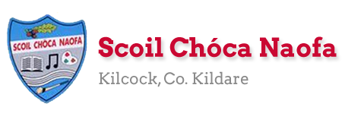
Work for First Class Class : Monday 20th April 2020
Monday | English:  Maths:  Irish:  P.E:  Other:
Tuesday | English:  Maths:  Irish:  P.E:  Other:
Wednesday | English:  Maths:  Irish:  P.E:  Other:
Thursday | English:  Maths:  Irish:  P.E:  Other:
Friday | English:  Maths:  Irish:  P.E:  Other:

SEN/EAL work
Teacher: Ms. Sheil
Note: SEN teachers have added work on to the teachers’ plan. Children can decide to do this work instead of something the teacher has assigned. It is not extra work. Also, we would be delighted if you could email on a picture of something that your child has done and is proud of so we can see their lovely work again! Also, try to watch the School Hub daily on RTE at 11.00 am...it is very good!
Literacy | Wordbuilding Workbook.  Complete one page for the week.It should take 5 mins per day.  Read the next page of words...try to read without having to sound them out.  Write one sentence per day using one of the words from the reading page.
Numeracy | If I gave you a maths workbook try to complete a half a page per day....If you run out of work ask your mum/dad to email me and I will send you some more.....
Contact SEN Teacher: mssheil@scoilchoca.ie

SEN Teacher 2
EAL | Theme: People who help us  - Set up Twinkl Account- membership is free  - Copy the following link into the internet browser- https://www.twinkl.ie/resource/roi-t-25992-people-who-help-us-colouring-pages  - Click the green download button  - Pick one of the jobs and show this to your child.  - Talk about the person and what they do. Do they know anyone who does this job?  - Ask them to colour in (if you can print the page out) or to draw the person and write something about the job beside the picture.  Please send me your picture via email if you can!!

Contact SEN Teacher: msnidhalaigh@scoilchoca.ie

Useful Websites for this week: ( For Self – directed Learning)
Contact Teacher: MsDunne@ScoilChoca.ie MsGrimes@ScoilChoca.ie

