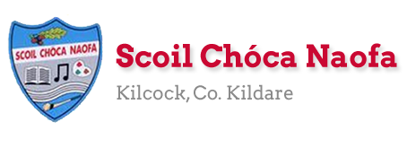
Work for Senior Infants Class : Week of Monday 27th April 2020
Monday | English: Skills Book pg 99 substituting sounds.  Maths: Planet maths pg 86 – o clock.  Irish: Sa Bhaile: New words: ballaí – walls, fuinneog – window, carr – car, liathróid - ball  P.E: Go outside and collect 5 smooth stones.  Other: Stay Safe Programme (see booklet). http://www.staysafe.ie/teachers_dlssp.htm – Topic 1 - Recap types of feelings and feeling safe and unsafe. Complete Tell 5 worksheet by discussing 5 people you would tell if you felt unsafe.
Tuesday | English: Phonics – practice the sh, th, ch sounds. Identify and write words into copy.  Maths: Discussion of words morning, afternoon, evening, night. Children write words and draw one thing they usually do at each time of day.  Irish: Sa Bhaile. New words: cófra – cupboard, talamh – ground, simléar - chimney  P.E: Do 5 jumping jacks, 5 bunny hops, 5 sausage rolls. Repeat 5 times!  Art: Paint your stones (see images below). Make one stone for a friend including some nice words about your friend. Make another stone for someone in your family.
Wednesday | English: Skills book pg. 101 – ‘h’ sound game.  Maths: Planet Maths – pg 87.  Irish: Dathanna – dearg – red, buí – yellow, glas – green, gorm – blue, dubh – black, donn – brown, ban-dearg – pink, corcra – purple, bán – white, oráiste - orange  P.E: Make animal movements - hop like a bunny, jump like a frog, crawl like a crab, fly like a bird etc  Other: Unlocking SESE: Pg. 58 – What is a well?
Thursday | English: Phonics https://www.phonicsbloom.com/uk/game/list/phonics-games-phase-2  Practice phase 2 phonics games with children (focusing on individual sounds)  Maths: Online telling the time game https://www.sheppardsoftware.com/mathgames/earlymath/on_time_game1.htm  Irish: Bua Na Cainte pg.40 Cé hé sin? Sin é ……. Cé hí sin? Sin í….(who is he/she? He/she is…) Daidí – Daddy, Mamaí – Mammy, an buachail – the boy, an cailín – the girl.  SESE: Unlocking SESE: Pg 59 – Parts of a plant.  Other: Stay Safe Programme (see booklet). http://www.staysafe.ie/teachers_dlssp.htm – Topic 2 - lesson 1 – Friendship.  Worksheet 5 – I show friendship when ….
Friday | English: Sight words https://sightwords.com/sight-words/flash-cards/#1up Use this site to access sight word flashcards. Practice next 10 from kindergarten set. Extension activity could be to call out word and child will write down.  Maths: Introduce children to words ‘on, beside, between, under’. Practice hiding items and explaining where they are. Planet maths pg 88.  P.E: Hip hop dance video https://www.loom.com/share/6b2f26e0a69546e6a0142e80144e499f  Other: What do plants need to grow?  Can you look after your own plant for the weekend? Send us a picture of your plant and how you are looking after it.

Useful Websites for this week: (supplemental work – if needed)
- Reading books: https://www.oxfordowl.co.uk/for-home/find-a-book/library-page/?view=image&query=&type=book&age_group=Age+5-6&level=&level_select=&book_type=&series=#
- Tricky words songs: https://www.youtube.com/watch?v=TvMyssfAUx0
- Extra phonics games: http://www.literactive.com/Download/live.asp?swf=story_files/slides_US.swf
- Contact Teacher: msbyrne@scoilchoca.ie msmeehan@scoilchoca.ie
- Contact support teacher: msnidhalaigh@scoilchoca.ie

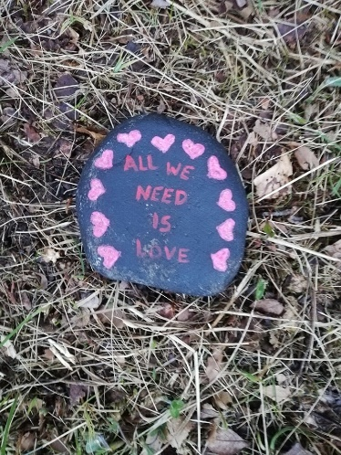
Painting Stones (ideas)
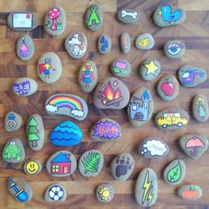
Children who attend EAL.
EAL work
Note: SEN teachers have added work on to the teachers’ plan. Children can decide to do this work instead of something the teacher has assigned. It is not extra work. Also, we would be delighted if you could email on a picture of something that your child has done and is proud of so we can see their lovely work again!
Teacher: Ms Tone / Ms Clancy/Ms Wilson
EAL | EAL theme – People Who Help Us  - Name the people who help us in our community, e.g. lollipop lady, policeman, nurse.  - Can you describe their uniform? Do they wear a hat?  - Who would use a hose? Who would use a pot and spoon?  Who would use a needle? Who would drive a tractor?  - Draw a picture of someone who helps you in the community.  Write a sentence about them if you can.

Contact SEN Teacher: mstone@scoilchoca.ie
mswilson@scoilchoca.ie

