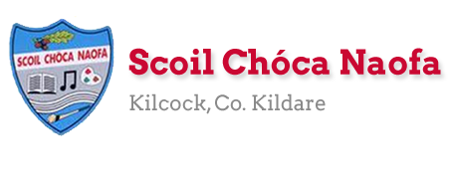
Work for Second Class : Monday 20th April 2020
We hope you are all keeping well during this time. We have outlined some activities which you can carry out daily. Extra activities, images showing the Gaeilge website and a message from Ms. Wilson are all contained on this document. Please do not feel pressure to complete everything. Also, we would be delighted if you could email on a picture of something that your child has done and is proud of so we can see their lovely work again! Feel free to contact us if you have any questions.
Kind regards, Ms. Carr and Ms. O’ Grady
mscarr@scoilchoca.ie msogrady@scoilchoca.ie
Monday | English: Read at Home pg. 105  Word Wizard p. 79 Snakes and Ladders  Maths: Master Your Maths- Week 27 Monday.  Skip counting- count in 6s https://www.youtube.com/watch?v=xpbc-1a7lMo  Gaeilge: Website: https://www.seideansi.ie/naionain-mhora.php  ‘An maith leat?’ Scéal – ‘Click Léigh seo’ (see image below)  P.E: Joe Wicks on YouTube or https://rtejr.rte.ie/10at10/  Other: SESE (Geography): We will be learning about the Earth this week. Write 5 facts about oceans.
Tuesday | English: Read at Home pg. 106  Word Wizard p. 80 Comprehension  Maths: Master Your Maths- Week 27 Tuesday.  Skip counting- count in 7s https://www.youtube.com/watch?v=1GUuH79G3Gw  Gaeilge: Website https://www.seideansi.ie/naionain-mhora.php  ‘An maith leat?’ Click ‘Roghnaigh an focal’  P.E: Using whatever materials you have at home play the game Cowboys and Robbers or make up your version of the game.  Other: SESE (Geography): Can you name all the continents?
Wednesday | English: Read at Home pg. 107  Word Wizard p.81 A & B  Maths: Master Your Maths- Week 27 Wednesday.  Skip counting- count in 8s https://www.youtube.com/watch?v=3SwaOvWD-PY  Gaeilge: Website https://www.seideansi.ie/naionain-mhora.php  ‘An maith leat?’ Click ‘Déan abairtí’  P.E: Joe Wicks on YouTube or https://rtejr.rte.ie/10at10/  Other: SESE (Geography): Write 5 facts about mountains in Ireland.
Thursday | English: Read at Home pg. 108  Word Wizard p.81 C  Maths: Master Your Maths- Week 27 Thursday.  Skip counting- count in 9s https://www.youtube.com/watch?v=c0Nj3GIA6TY  Gaeilge: Website https://www.seideansi.ie/naionain-mhora.php  ‘Fluich Báite’ – Scéal – Click ‘Léigh seo’  P.E: Go outside for a walk or run or cycle  Other: (Art) How to draw sea creatures https://www.youtube.com/watch?v=33yTQxC7nRE
Friday | English: Word Wizard p.83 Plurals  Think about a game you played this week. Write the steps involved in playing the game.  Maths: Master Your Maths- Week 27 Test.  Skip counting- count in 11s https://www.youtube.com/watch?v=kjvEHA3vYH8  Gaeilge: Website https://www.seideansi.ie/naionain-mhora.php  ‘Fluich Báite’ Click ‘Roghnaigh an focal’  P.E: Joe Wicks on YouTube or https://rtejr.rte.ie/10at10/  Other: Grab a timer. Can you meditate for 5 minutes.  Practice your prayers.

Extra activities if required including useful websites (For Self – directed Learning)
- RTE are providing a fun learning programme from 11-12 daily from Monday 30th onwards. Watch out for it @ https://www.rte.ie/learn/
Maths- Focus on Place Value
- Cracking Maths P. 127 https://www.youtube.com/watch?v=EVnrsoyfRFU
Note: Ones and Units are the same thing. https://www.youtube.com/watch?v=m6cxpRXaeSw
- Cracking Maths P.128 https://www.youtube.com/watch?v=T77vIZ8-m74
- Cracking Maths P.129
- Cracking Maths P.131
English
- Continue Handwriting book
- Time Capsule writing activity – write a letter to yourself about what’s happening at the moment. Keep it safe so you can open it and read it when we come back to school.
Gaeilge
Practice oral language questions
- Cén rang ina bhfuil tú?
- Cá bhfuil tú i do chónaí?
- Conas atá an aimsir inniu? Example - Tá an ghrian ag taitneamh agus tá sé te.
- Cad is ainm don múinteoir? Example – Ms Carr/Ms O’ Grady is ainm di.
- An bhfuil peata agat? Example. Tá/Níl madra/cat agam
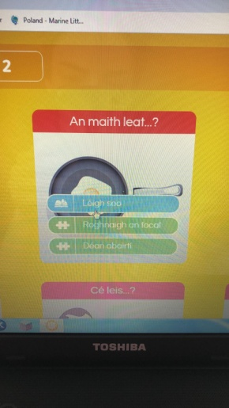 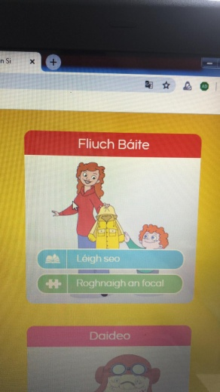 Images outlining where Irish activities are on website.
EAL work
Teacher: Ms. Wilson
Note: SEN teachers have added work on to the teachers’ plan. Children can decide to do this work instead of something the teacher has assigned. It is not extra work. Also, we would be delighted if you could email on a picture of something that your child has done and is proud of so we can see their lovely work again!
EAL 2nd Class | Theme : Wild Animals  Before Easter you researched a wild animal of your choice. I uploaded a template to the school website to guide your research.  This week I would like you to write a report about this wild animal. Mention the animal’s habitat, what the animal eats, names of male, female and young animal, predators and interesting facts about the animal. The following websites might help you.  https://www.dublinzoo.ie/animals/our-animals/  https://packs.eb.co.uk/science?grade=KS2---KS1&tag=2710&query=  Keep the report short and include a picture or drawing of the animal. Use your own words. Don’t copy directly from the website. I would be delighted if you could send me on a picture of the report when it is finished.
Contact SEN Teacher: mswilson@scoilchoca.ie

