Dear 4th class,
I hope you and your family are keeping well. I have typed up the below work for you to follow if your family wishes to do so. You can start this work next Monday and we will then have our Easter holidays (2 weeks). When the holidays are over, I will send you another document like this for you to follow. If you don’t get to complete all of this work that is ok. I understand that families are busy at this time and they are only suggested activities.
All written activities can be taken down in your copy. All maths activities can be taken down in your maths copy or maths book. Remember to always date and title your work using a red pen and ruler. Continue to write in joint writing.
If you are unsure of any words in your Starlight comprehensions, please look up the meaning of the bold words in a dictionary.
Stay safe and God bless,
Ms Smith

Work for Ms. Smith’s 4th Class : Week 3 Starting 30.03.2020– Friday 03.04.20
Monday | English:  Read at Home pg 95  Starlight 13A ‘How are Comic Books Made?’ Complete A Comprehension: Fact Finding and B Comprehension: Read Between the lines in copy pg 149  Maths:  Maths Matters pg 103 in book  Complete Mathletics activities  Irish:  Leabhar Litrithe lch 23  P.E: PE with Joe Wicks  https://www.youtube.com/watch?v=Rz0go1pTda8  Other:  Watch the video of milking cows in the past and milking cows nowadays (see link below).  ‘From Grass to Glass’ Activity.  Look at the 8 stages of milk production and number them, sequencing in the correct order in your copy (see the link below).
Tuesday | English:  Read at Home pg 96  Starlight 13A ‘How are Comic Books Made?’ Complete C Vocabulary in copy pg 149  Maths:  Maths Matters pg 104 in book  Complete Mathlectics Activties  Irish:  Leabhar Lirtithe lch 24  P.E: PE with Joe Wicks  https://www.youtube.com/watch?v=6v-a_dpwhro  Other:  Create your own ‘From Grass to Glass’ poster (A4 page). Include lots of colour and pictures to make it fun to read.
Wednesday | English:  Read at Home pg 97  Starlight 13A ‘How are Comic Books Made?’ Complete D Vocabulary in copy pg 150  Maths:  Maths Matters pg 105 in book  Complete Mathletcis Activties  Irish:  Leabhar Litrithe lch 25  P.E: PE with Joe Wicks  https://www.youtube.com/watch?v=4wzoy_J3I_c  Other:  Home investigation Activity (see below for further guidance)  Watch the video of how butter was made in the past (see link below).
Thursday | English:  Read at Home pg 98  Starlight 13A ‘How are Comic Books Made?’ Complete E Grammar pg 150  Maths:  Maths Matters pg 106  Complete Mathlectics Activities  Irish:  Leabhar Litirthe lch 22  P.E: Active 8 minute workout with Joe Wicks  https://www.youtube.com/watch?v=uqLNxJe4L2I  Other:  Research the work of a dairy farmer. Write a list of questions you would like to ask a dairy farmer. (write the list of questions in your copy)
Friday | English:  Read at Home pg 99  Starlight 13A ‘How are Comic Books Made?’ Complete F Writing Skills pg 151  Maths:  Maths Matters pg 107  Complete Mathlectics Activties  Irish:  Leabhar Litrithe lch 21  P.E: 5 Minute Move with Joe Wicks  https://www.youtube.com/watch?v=d3LPrhI0v-w  Other:  Look at the 2 photos below and discuss the differences in harvesting for farmers.  Starlight 13A ‘How are Comic Books Made?’ Complete G Writing Genre. Choose one title on pg 151 and follow guidelines. Research and brainstorm ideas in your copy.

Monday:
‘From Grass to Glass Activity’ https://www.moocrew.ie/wp-content/uploads/2019/12/ActivitySheet5_Senior_A4_v1.pdf
Follow the link and read the stages. Write the 8 stages of milk production in your copy.
Wednesday:
Home Investigation Activity (you can write the answers in your copy):
- Look at dairy products in the fridge and identify where they were sourced from. For example, was anything sourced from a local farm?
- Does milk in their fridge carry the NDC ‘Farmed in the Republic of Ireland’ guarantee?
- Do you know a local dairy farmer? If yes, who? Where do they live?
- Record how many litres of milk each family member has for a week.

History: Compare the two pictures of a farmer harvesting/gathering crops.
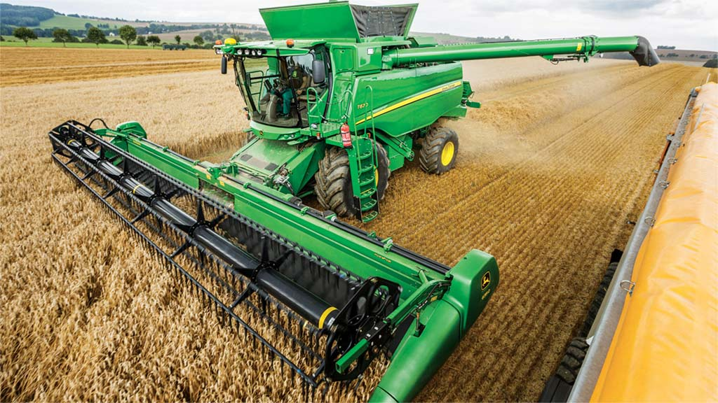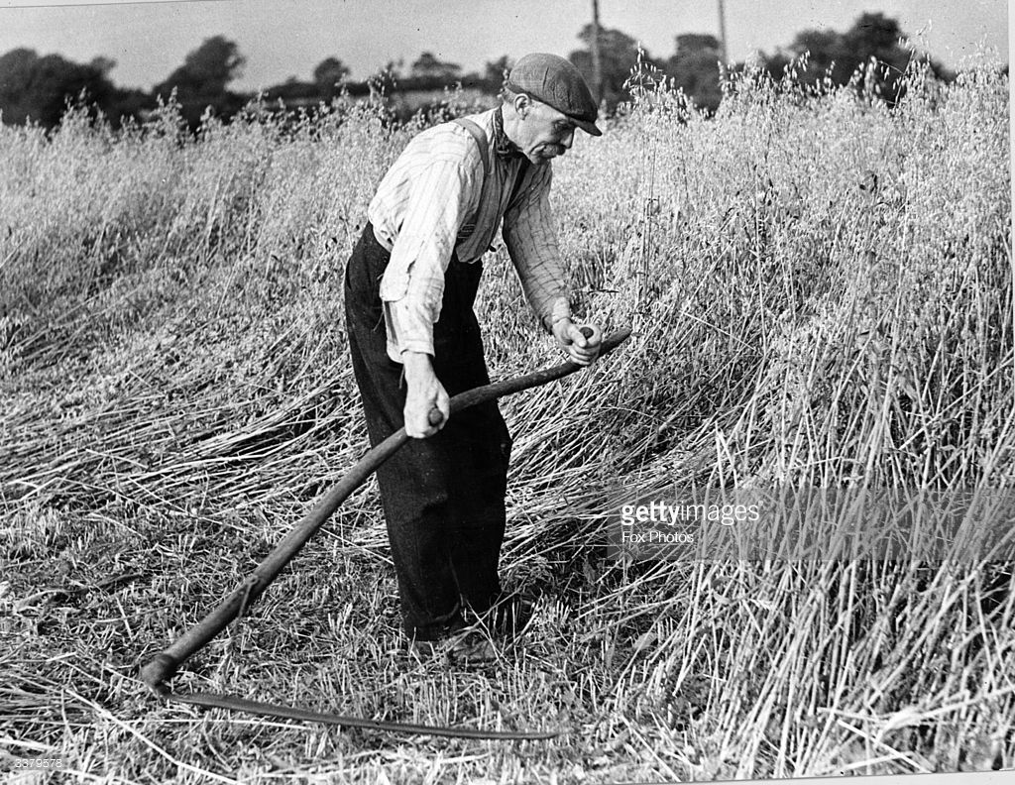
Questions:
- Which work do you think is easier? Why do you think that?
- What is the name of the tool the farmer in the first picture is using to harvest/gather crops?
- What is the name of the machine the farmer is using in the second picture to harvest/gather crops?

Useful web links for this week:
- RTE’s Home School Hub starting Monday 30th. If you miss it, you might be able to watch it back on RTE Player.
https://www.rte.ie/player/

- Look up MooCrew.ie (Click Resources and Senior) for more ideas around the topic of dairy farming.
https://www.moocrew.ie/senior/
https://www.moocrew.ie/wp-content/uploads/2019/12/Senior-Lesson-Plan-5.pdf

- Joe Wick’s Live Daily PE workouts YouTube
https://www.youtube.com/watch?v=K6r99N3kXME

- Maths: Tables revision games
https://www.topmarks.co.uk/maths-games/7-11-years/multiplication-and-division

- History: Food and Farming in the Past
http://www.askaboutireland.ie/learning-zone/primary-students/3rd-+-4th-class/history/the-history-of-food-and-f/about-farming/

- History: Churning butter
https://www.youtube.com/watch?v=dVt-6NJ71kQ

- History: Milking cows then and now video:
https://www.youtube.com/watch?v=26BwN7RoUXI

- History: Stages of milk production
https://www.moocrew.ie/wp-content/uploads/2019/12/ActivitySheet5_Senior_A4_v1.pdf

- Religion: Read the Easter story online:
https://www.topmarks.co.uk/easter/easterstory.aspx

- Religion/Art: Make an Easter Card: Here are some ideas: https://www.topmarks.co.uk/Easter/EasterCards.aspx

All work listed below is optional also.
Ms Wilson’s Literacy Group:
SNIP Literacy – One session per week.
Cloze Procedure – One cloze activity per week.
(Please contact Ms Wilson if you did not receive this work in school).

Ms Wilson’s EAL Group
Topic: People Who help Us / Occupations.
- Mind Map – List as many occupations as you can think of. Try to think of at least 15. Compare to the list on this PowerPoint. Did you think of more/less? https://www.twinkl.ie/resource/t4-s-47-jobs-powerpoint
- Research an occupation/job that interests you e.g. doctor, engineer, paramedic or shopkeeper. Think of the following headings when researching the occupation – Role, place of work, daily routine, skills needed, qualifications needed, equipment used. Next week you can write a short report on this occupation based on your research.

Ms Heffernan’s Maths Group:
mathsisfun.com covers lots of topics, tables practice and gives short quizzes and feedback.

Contact Teacher:
mssmith@scoilchoca.ie

mswilson@scoilchoca.ie

msheffernan@scoilchoca.ie

