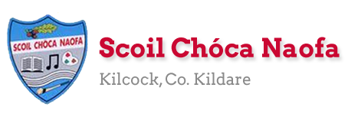
Work for Ms. Tierney’s 4th Class: Monday 30/03/20 – Friday 03/04/20
Monday | English:  Read at Home pg 95- Read & answer questions orally  Starlight 13A ‘How are Comic Books Made?’  Read page 148-150. Complete part A in your spare copy.  Look up any new words in your dictionary  Recite this week’s poem: I’m supposed to be in school  Maths:  Maths Matters pg 125, p 126 question 1 (Answers below for self-correction)  Make some Brain Juice (Recipe Below-Adult Supervision needed)  Complete Mathletics activities  Count up and down in multiples from 2-20, 3-30, 4-40  Irish:  Léigh Scuab Fiacal Danny: Read Irish Novel (1 pg)  Léigh an dán/Read the poem: Bia: Na Béilí  Imir cluichí ar Duolingo/Play games on Duolingo  P.E: PE with Joe Wicks on YouTube  Other: History  Write down what you know about food/farming in the past and what you would like to learn about it.  Read about Food and Farming in the Past.  Watch the video of how butter was made in the past.  Try churning your own butter in a jar with a tight lid on, using creamy milk and shaking it for a long time.
Tuesday | English:  Read at Home pg 96- Read & answer questions orally  Starlight 13A ‘How are Comic Books Made?’ Complete part B in your spare copy.  Look up new words in your dictionary.  Recite this week’s poem: I’m supposed to be in school  Maths:  Maths Matters pg 126 question 2, pg 127  Complete Mathletics Activties  Count up and down in multiples from 5-50, 6-60  Irish:  Léigh Scuab Fiacal Danny: Read Irish Novel (1 pg)  Léigh an dán: Read the poem: Bia: Na Béilí  Imir cluichí ar Duolingo/Play games on Duolingo  P.E: PE with Joe Wicks on YouTube  Other: History  Read about Food and Farming in the Past  Watch the video of milking cows in the past and milking cows nowadays.  Write a few sentences about how milking cows has changed over time.
Wednesday | English:  Read at Home pg 97- Read & answer questions orally  Starlight 13A ‘How are Comic Books Made?’ Complete part C and D in your spare copy  Recite this week’s poem.  Maths:  Maths Matters pg 128  Complete Mathletics Activties  Count up and down in multiplies from 7-70, 8-80  Irish:  Léigh Scuab Fiacal Danny: Read Irish Novel (1 pg)  Léigh an dán: Read the poem: Bia: Na Béilí  Imir cluichí ar Duolingo/Play games on Duolingo  P.E: PE with Joe Wicks on Youtube  Other: History  Read about Food and Farming in the Past  Look at the 2 photos below and discuss the differences in harvesting for farmers.  Write 3 questions you would like to ask a farmer from the past in your copy.
Thursday | English:  Read at Home pg 98- Read & answer questions orally  Starlight 13A ‘How are Comic Books Made?’  Design your own comic superhero character (animal/human/monster) and write 5 sentences describing your character. Remember your adjectives.  Recite this week’s poem.  Maths:  Maths Matters pg 129  Complete Mathletics Activities  Count up and down in multiples from 9-90, 10-100  Irish:  Léigh Scuab Fiacal Danny: Read Irish Novel (1 pg)  Léigh an dán: Read the poem: Bia: Na Béilí  Imir cluichí ar Duolingo/Play games on Duolingo  P.E: PE with Joe Wicks on YouTube  Other: History  ‘From Grass to Glass’ activity.  Look at the 8 stages of milk production.  Number them and sequence them in the correct order in your copy.
Friday | English:  Read at Home pg 99- Read & answer questions orally  Starlight 13A ‘How are Comic Books Made?’  Create a short comic strip about your superhero character.  Recite this week’s poem.  Maths:  Maths Matters pg 130  Complete Mathletics Activties  Count up and down in multiples from 11-110, 12-120  Irish:  Léigh Scuab Fiacal Danny: Read Irish Novel (1 pg)  Léigh an dán: Read the poem: Bia: Na Béilí  Imir cluichí ar Duolingo/Play games on Duolingo  P.E: PE with Joe Wicks on YouTube  Other: Religion/Art  Read the Easter story  Make an Easter card for someone you love

Useful websites for this week:
- Maths: https://www.mathletics.com/uk/
- Maths: Tables revision games- https://www.topmarks.co.uk/maths-games/7-11-years/multiplication-and-division
- Gaeilge: https://dinolingo.com/learn-irish-for-kids/
- PE: Joe Wicks’ Live Daily PE workouts: https://www.youtube.com/
- History: Food and Farming in the Past http://www.askaboutireland.ie/learning-zone/primary-students/3rd-+-4th-class/history/the-history-of-food-and-f/about-farming/
- History: Churning butter https://www.youtube.com/watch?v=dVt-6NJ71kQ
- History: Milking cows then and now video: https://www.youtube.com/watch?v=26BwN7RoUXI
- History: Stages of milk production https://www.moocrew.ie/wp-content/uploads/2019/12/ActivitySheet5_Senior_A4_v1.pdf
- Religion: Read the Easter story online: https://www.topmarks.co.uk/easter/easterstory.aspx
- Religion/Art: Make an Easter Card: Here are some ideas: https://www.topmarks.co.uk/Easter/EasterCards.aspx
- General: Twinkl: Worksheets/Powerpoints available: Free access if you use code CVDTWINKLHELPS
- RTE’s Home School Hub starting Monday 30th. Refer to picture below. If you miss it, you might be able to watch it back on RTE Player.
https://www.rte.ie/player/

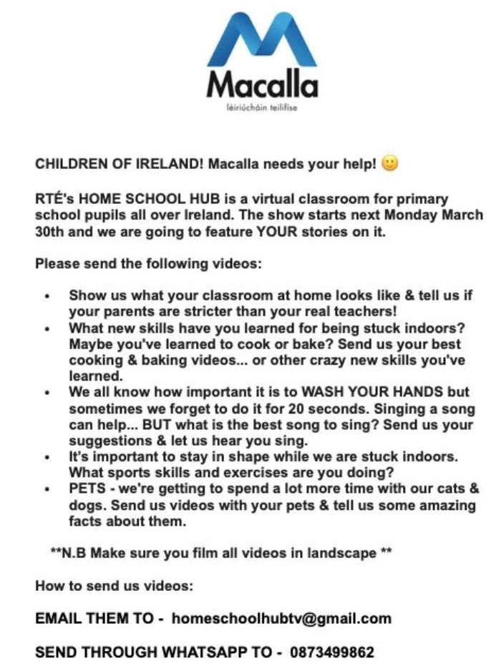

Other resources:
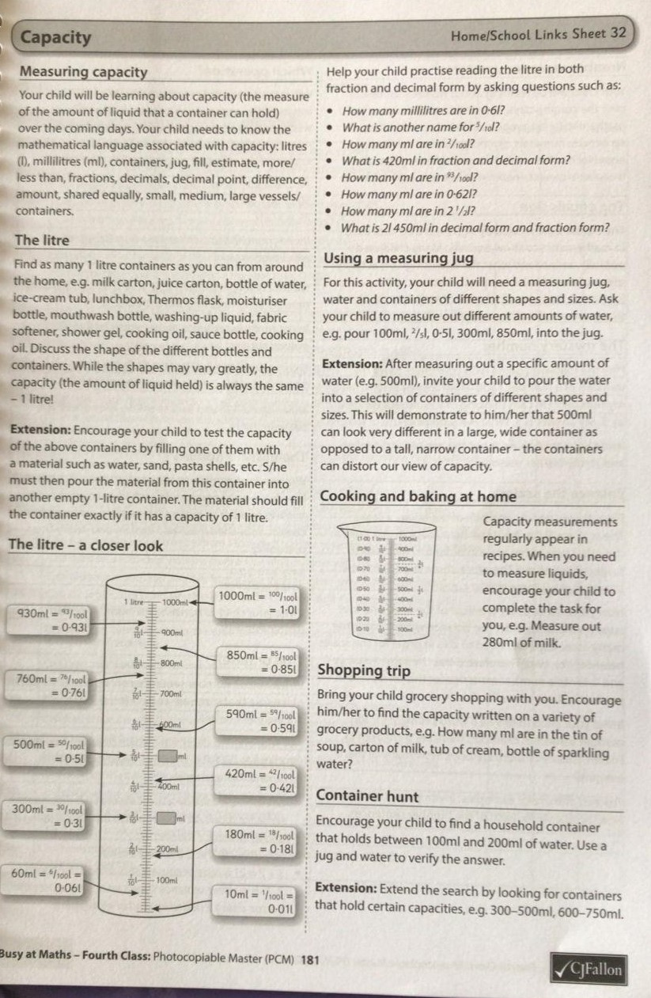
Information for parents on guiding their child with Capacity in maths

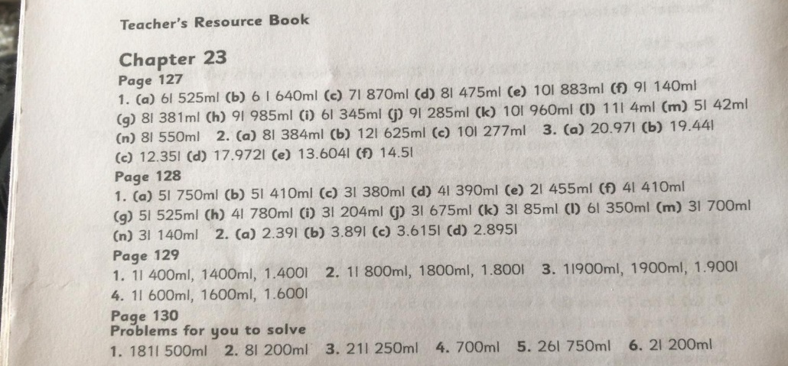
Maths Answer book for self-correction:

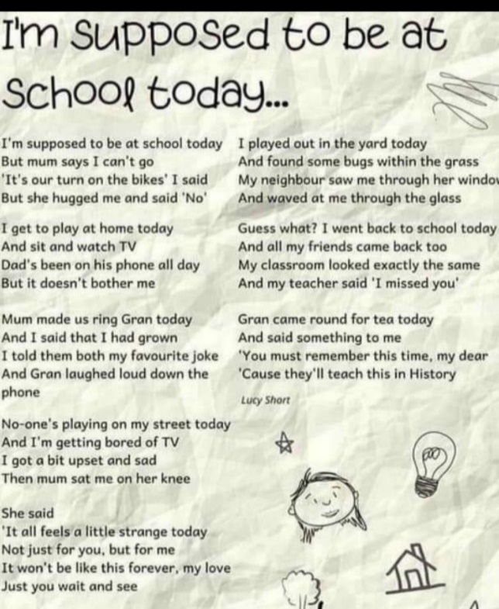
Dán: Gaeilge
Bia: Na Béilí
Is maith liom bricfeasta
tae agus tósta.
Is maith liom lón
Ceapaire ‘s deoch.
Is maith liom dinnéar
Prátaí rósta.
Is maith liom suipéar
‘s mé sa leaba go moch,

Recipe for Brain Juice:
Ingredients (Serves 2)
- 10 strawberries
- ½ litre orange juice
- 250 ml yoghurt
- 1 banana
Method:
- Measure ½ litre of orange juice in a measuring jug/other suitable container
- Measure 250 ml yoghurt
- Blend all ingredients in a blender until smooth.
Think and talk about:
- How much of the ingredients would be needed to make 4 smoothies?
- If 1 litre or orange juice is used, how many bananas would be needed?
- How many strawberries would be needed to make 1 smoothie?
- If 4 bananas were used, how many smoothies will this make?
- How much yoghurt would be needed if you used 2 litres of orange juice?
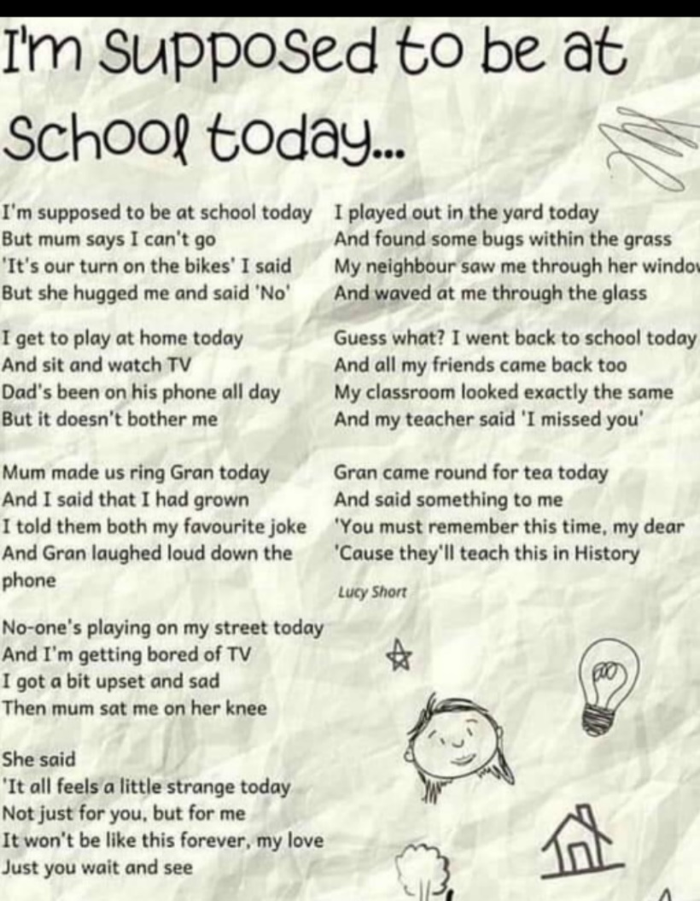

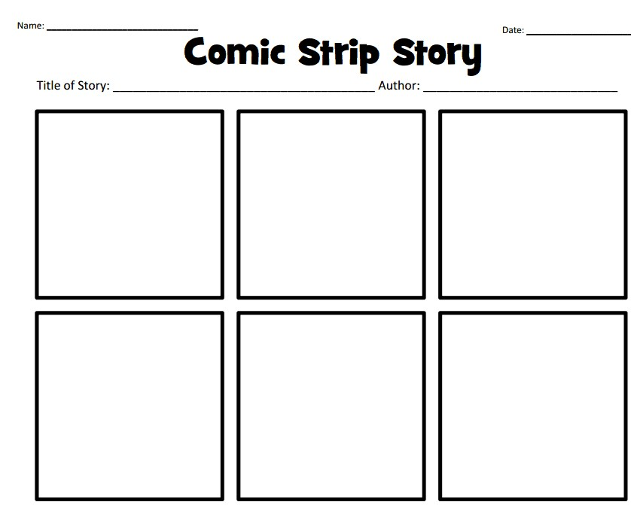

English: Comic Strip Template

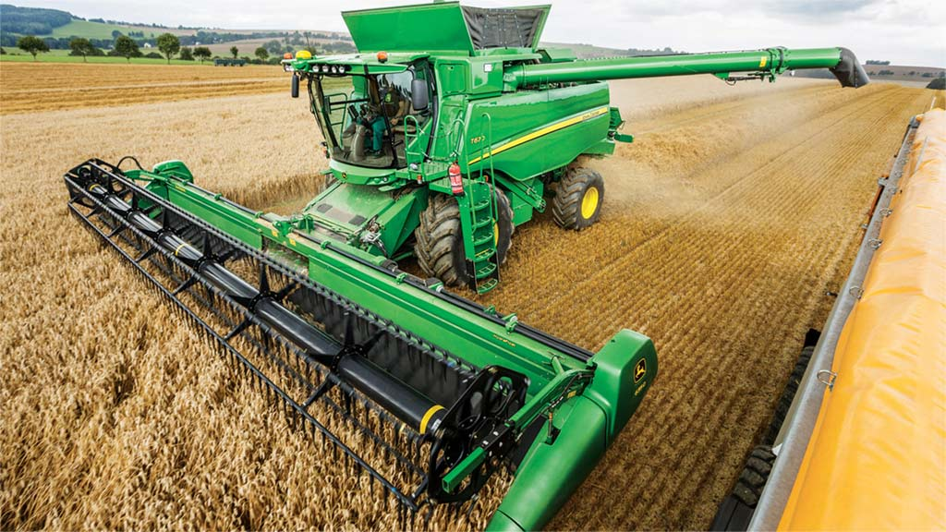
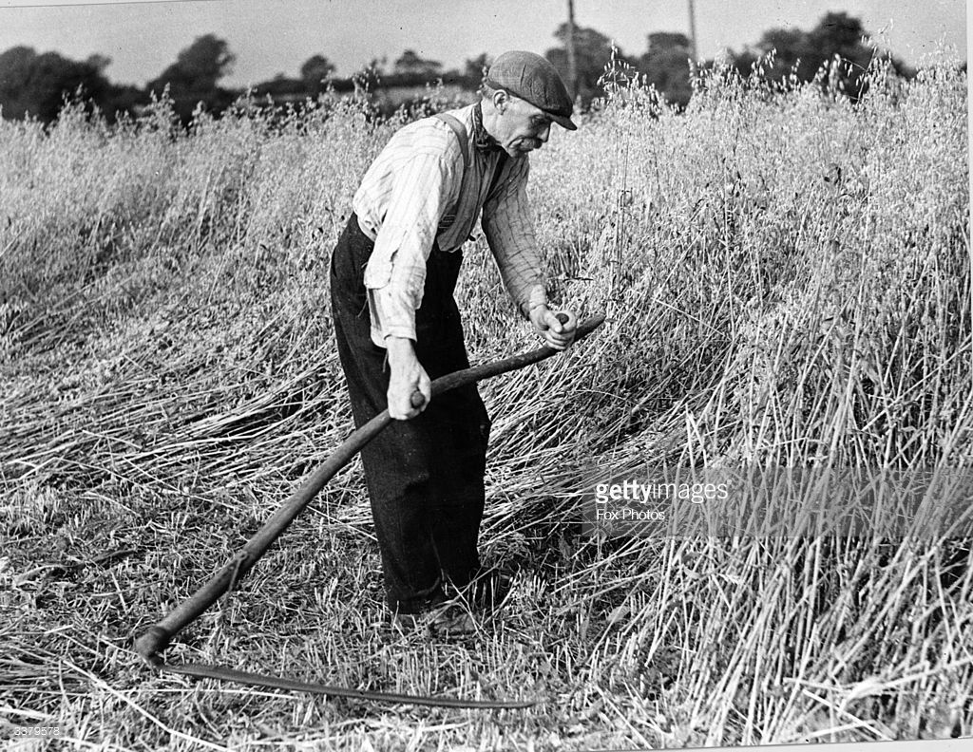
History: Compare the two pictures of a farmer harvesting/gathering crops.

Questions:
- Which work do you think is easier? Why do you think that?
- What is the name of the tool the farmer in the first picture is using to harvest/gather crops? (scythe)
- What is the name of the machine the farmer is using in the second picture to harvest/gather crops? (combine harvester)

Fun activities (optional)
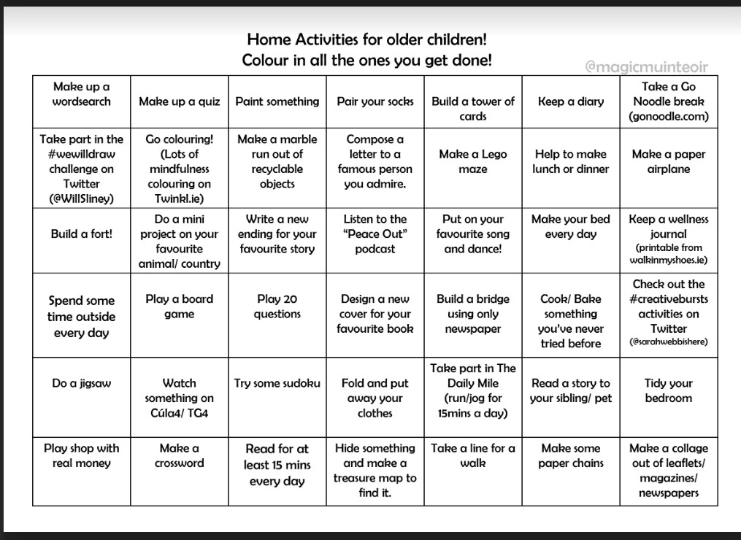

Ms. Heffernan’s Language Group:
Here is the link to a selection of folk and fairytales that you might like to listen to from Audible https://stories.audible.com/discovery/enterprise-discovery-21122352011?ref=adbl_ent_anon_ds_ds_dccs_sbtp-0-5
Alice’s Adventures in Wonderland https://stories.audible.com/pdp/B015D78L0U?ref=adbl_ent_anon_ds_pdp_pc_pg-1-cntr-0-2
The Wonderful Wizard of Oz https://stories.audible.com/pdp/B015D78L0U?ref=adbl_ent_anon_ds_pdp_pc_pg-1-cntr-0-2
The Secret Garden https://stories.audible.com/pdp/B002UZMRV8?ref=adbl_ent_anon_ds_pdp_pc_pg-1-cntr-0-43

Contact Teacher: mstierney@scoilchoca.ie

Dear 4th Class,
I hope you and your families are all keeping well and staying safe at this difficult time. I have given you some work that you might like to try this week. There is a lot of work here so don’t panic if you don’t get it all completed. Just try your best Enjoy your two weeks holidays at Easter. I hope to see you all soon.
Miss you all a lot,
Ms. Tierney

