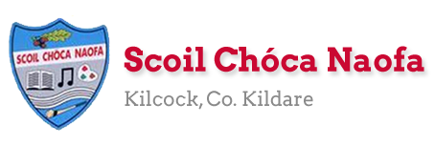
Work for Ms. Tierney’s 3rd Class: Monday 30/03/20 – Friday 03/04/20
Monday | English:  Read at Home pg 95- Read & answer questions orally  Starlight 13A ‘How are Comic Books Made?’  Read page 148-150. Complete part A in your spare copy.  Look up any new words in your dictionary.  Recite this week’s poem: I’m supposed to be in school.  Maths:  Maths Matters pg 117 (Answers at end of document)  Complete Mathletics activities  Count up and down in multiples 2-20, 3-30, 4-40  Irish:  Léigh sa Bhaile- Read the next page  Freagair na Ceisteanna/Answer the 5 questions at the bottom of the page in your spare copy.  Léigh an dán/Read the poem: Bia: Na Béilí  P.E: PE with Joe Wicks on YouTube  Other: History  Write down what you know about food/farming in the past and what you would like to learn about it.  Read about Food and Farming in the Past.  Watch the video of how butter was made in the past.  Try churning your own butter in a jar with a tight lid on, using creamy milk and shaking it for a long time.
Tuesday | English:  Read at Home pg 96- Read & answer questions orally  Starlight 13A ‘How are Comic Books Made?’ Complete part B in your spare copy.  Look up any new words in your dictionary.  Recite this week’s poem: I’m supposed to be in school  Maths:  Maths Matters pg 118 (Answers at end of document)  Complete Mathletics Activties  Count up and down in multiples from 5-50, 6-60  Irish:  Léigh sa Bhaile: Read the next page  Freagair na ceisteanna: Answer the 5 questions at the bottom of the page.  Léigh an dán: Read the poem: Bia: Na Béilí  P.E: PE with Joe Wicks on YouTube  Other: History  Read about Food and Farming in the Past  Watch the video of milking cows in the past and milking cows nowadays.  Write a few sentences about how milking cows has changed over time.
Wednesday | English:  Read at Home pg 97- Read & answer questions orally  Starlight 13A ‘How are Comic Books Made?’ Complete part C and D.  Recite this week’s poem.  Maths:  Maths Matters pg 119 (Answers at end of document)  Complete Mathletics Activties  Count up and down in multiplies from 7-70, 8-80  Irish:  Léigh sa Bhaile: Read the next page  Freagair na ceisteanna: Answer the 5 questions at the bottom of the page.  Léigh an dán: Read the poem: Bia: Na Béilí  P.E: PE with Joe Wicks on Youtube  Other: History  Read about Food and Farming in the Past  Look at the 2 photos below and discuss the differences in harvesting for farmers.  Write 3 questions you would like to ask a farmer from the past in your copy.
Thursday | English:  Read at Home pg 98- Read & answer questions orally  Starlight 13A ‘How are Comic Books Made?’  Design your own comic superhero character (animal/human/monster) and write 5 sentences describing your character. Remember your adjectives.  Recite this week’s poem.  Maths:  Maths Matters pg 120 (Answers at end of document)  Complete Mathletics Activities  Count up and down in multiples from 9-90, 10-100  Irish:  Léigh sa Bhaile: Read the next page  Freagair na ceisteanna: Answer the 5 questions at the bottom of the page  Léigh an dán: Read the poem: Bia: Na Béilí  P.E: PE with Joe Wicks on YouTube  Other: History  ‘From Grass to Glass’ activity.  Look at the 8 stages of milk production.  Number them and sequence them in the correct order in your copy.
Friday | English:  Read at Home pg 99- Read & answer questions orally  Starlight 13A ‘How are Comic Books Made?’  Create a short comic strip about your superhero character.  Recite this week’s poem.  Maths:  Maths Matters pg 121 (Answers at end of document)  Complete Mathletics Activties  Count up and down in multiples from 11-110, 12-120  Irish:  Léigh sa Bhaile: Read the next page  Freagair na ceisteanna: Answer the 5 questions at the bottom of the page  Léigh an dán: Read the poem: Bia: Na Béilí  P.E: PE with Joe Wicks on YouTube  Other: Religion/Art  Read the Easter story  Make an Easter card for someone you love

Useful websites for this week:
- Maths: Tutorial for multiplying a two-digit number by a one-digit number: https://www.youtube.com/watch?v=SfxULALs_u8
- Maths: https://www.mathletics.com/uk/
- Maths: Tables revision games- https://www.topmarks.co.uk/maths-games/7-11-years/multiplication-and-division
- PE: Joe Wicks’ Live Daily PE workouts: https://www.youtube.com/
- History: Food and Farming in the Past http://www.askaboutireland.ie/learning-zone/primary-students/3rd-+-4th-class/history/the-history-of-food-and-f/about-farming/
- History: Churning butter https://www.youtube.com/watch?v=dVt-6NJ71kQ
- History: Milking cows then and now video: https://www.youtube.com/watch?v=26BwN7RoUXI
- History: Stages of milk production https://www.moocrew.ie/wp-content/uploads/2019/12/ActivitySheet5_Senior_A4_v1.pdf
- Religion: Read the Easter story online: https://www.topmarks.co.uk/easter/easterstory.aspx
- Religion/Art: Make an Easter Card: Here are some ideas: https://www.topmarks.co.uk/Easter/EasterCards.aspx
- General: Twinkl: Worksheets/Powerpoints available: Free access if you use code CVDTWINKLHELPS
- RTE’s Home School Hub starting Monday 30th. If you miss it, you might be able to watch it back on RTE Player.
https://www.rte.ie/player/

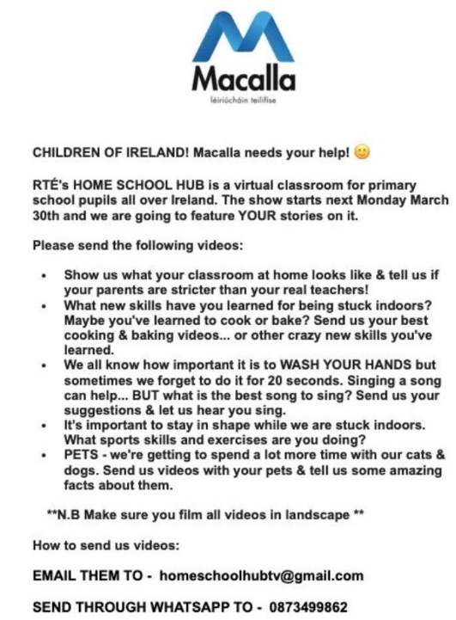

Other resources:

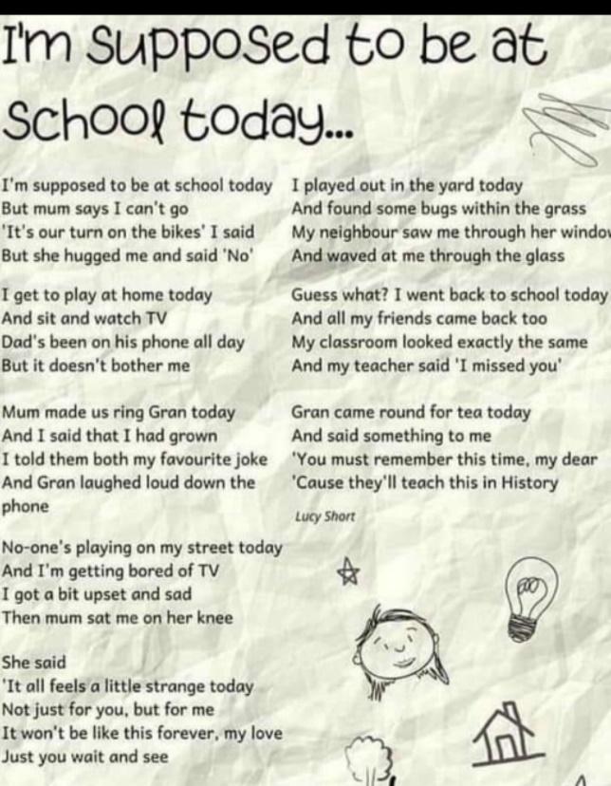
Dán: Gaeilge
Bia: Na Béilí
Is maith liom bricfeasta
tae agus tósta.
Is maith liom lón
Ceapaire ‘s deoch.
Is maith liom dinnéar
Prátaí rósta.
Is maith liom suipéar
‘s mé sa leaba go moch,

English: Comic Strip Template
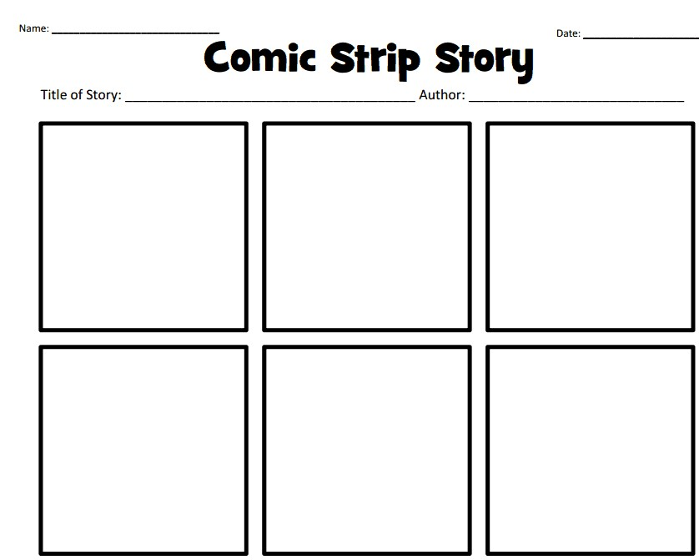

History: Compare the two pictures of a farmer harvesting/gathering crops.
Questions for discussion:
- Which work do you think is easier? Why do you think that?
- What is the name of the tool the farmer in the first picture is using to harvest/gather crops? (scythe)
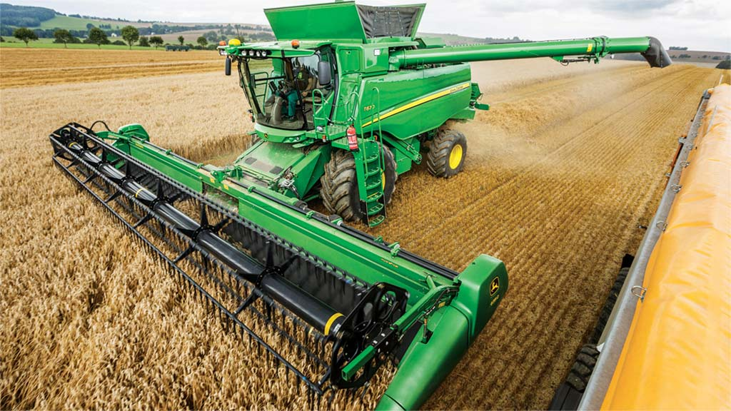
- What is the name of the machine the farmer is using in the second picture to harvest/gather crops? (combine harvester)
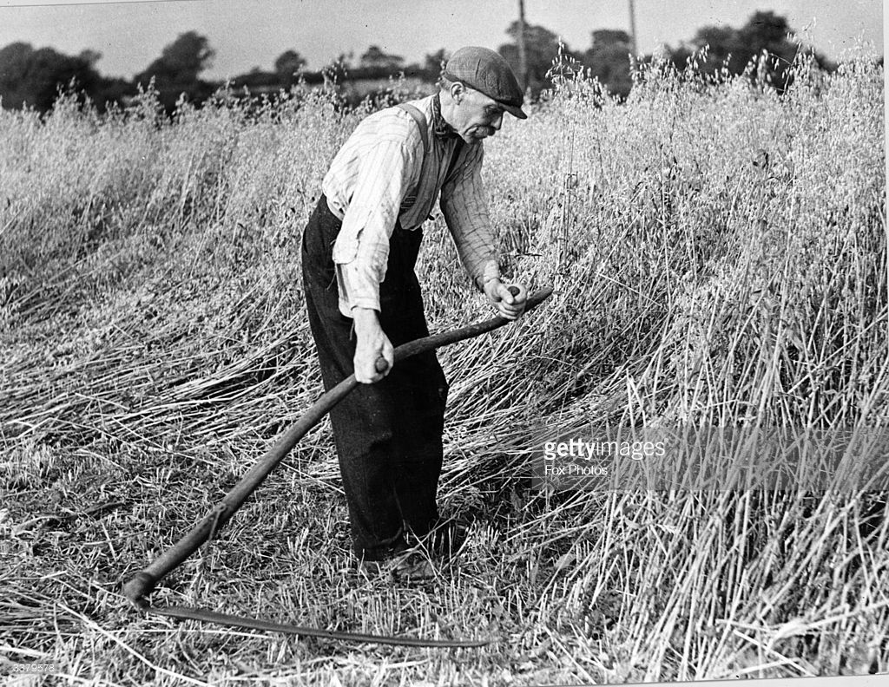
Fun activities (optional)
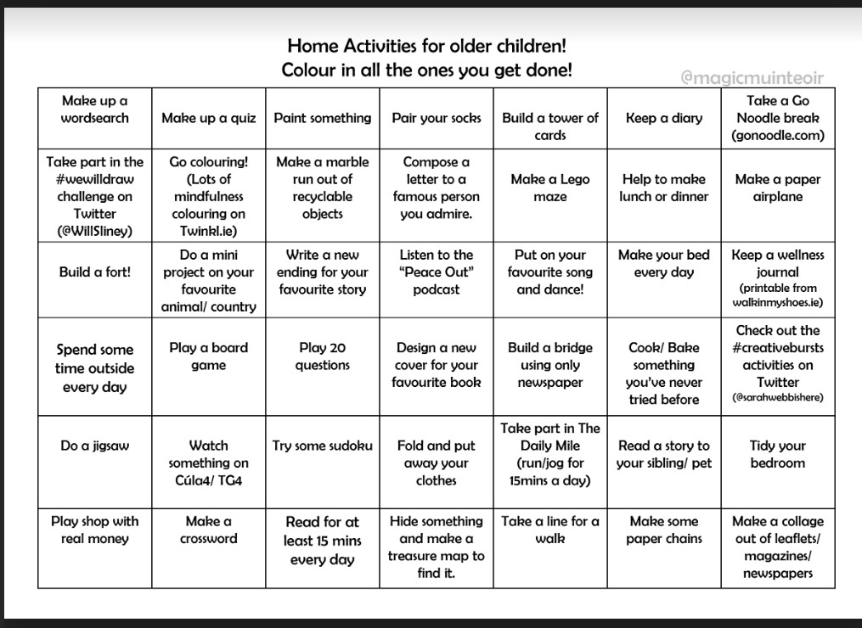

Maths answers for self-correction:
Page 117
- 120 2. 192 3. 180, 196, 185, 408 4 a. 216 4 b. 540
Page 118
1 a. 145 b. 290 2 a. 360 b. 480 c. 600 3 a. 114 b. 190 c. 266 4. 96 5. 159
Dominoes: 25 x 3= 75, 23 x 4= 92, 17x5= 85, 29x4= 116, 46x3= 138, 36x4= 144, 56 x 3 = 168, 38 x 3 = 114
Page 119
4 a. 6x9=54 b. 5 x 10 = 50 c. 4x10= 40 d. 8 x 4= 32 e. 2 x 8 = 16 f. 7x6=42 g. 5 x 6 = 30 h. 9 x 3= 27
5. 3x6=18 5 x 8= 8 x 5= 40 10 x 2= 2 x 10= 20 4 x 5 = 5 x 4 = 20 7 x 9= 9 x 7 = 63
Page 120
2 a. 20 3 a. 21 b. 7 c. 4 d. 3 e. 4, 3
5a. 7 b. 3 c. 2 d. 4
Page 121
Orange: 5 x 6 = (2 x 6) + (3 x 6)= 30, Blue: 7 x 5 = (4x5) + (3x5)= 35, Green: 6 x 2= (3x2) + (3x2)= 12,
Red: 9x4= (6x4) + (3x4) = 36, Pink: 8 x 3= (5x3) + (3x3)= 24, Brown: 9 x 8= (7x8) + (2x8)= 72,
Black: 10 x 9= (6x9) + (4x9) = 90, Purple: 8 x 6 = (6x6) + (2x6)= 48 Navy: 5 x 4= (4x4) + (1x4)= 20

Ms. Curran/Ms. McCabe’s EAL group
See Ms. Curran/Ms. McCabe’s document on website.

Ms. Curran/Ms. McCabe’s Literacy A group
See Ms. Curran/Ms. McCabe’s document on website.

Contact Teacher: mstierney@scoilchoca.ie

Dear 3rd Class,
I hope you and your families are all keeping well and staying safe at this difficult time. I have given you some work that you might like to try this week. There is a lot of work here so don’t panic if you don’t get it all completed. Just try your best Enjoy your two weeks holidays at Easter. I hope to see you all soon.
Miss you all a lot,
Ms. Tierney

