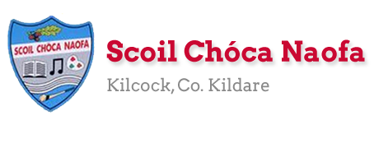
Work for Mr. Bracken’s 3rd Class: Monday 30/03/20 – Friday 03/04/20
Thought for the week comes from the poet Séamus Heaney – “If we can winter this one out, we can summer anywhere.”
Dear boys and girls & girls and boys,
I hope you and your family are well. This is very different, isn’t it?! The work below is for you to follow if your family wishes to do so. You can start this work next Monday. The Easter holidays (!) then begin and you won’t be getting pages like this for the Easter period (2 weeks). However, if there is any work you need to catch up on or you wish to complete it would be a good opportunity to do so. You will get another document like this to follow after the Easter break.
I understand that this seems like a lot of work. However, I certainly feel that having structure to your day at this time is very important. Spend an hour or so doing this work every day, if your family wishes to do so. Help out at home – vacuuming, emptying the dishwasher, whatever you can do to help. We all need to do our bit to help each other and you can show kindness to your family by doing these things.
I have sent spare copies home for you to complete your work in. Remember what I say in class all the time!
- Use a red pen
- Rule your page
- Include the date
- Use cursive writing
- Look back over your work
- Maybe ask someone to give you ‘Two Stars and a Wish’ or to tell you ‘What Worked Well’
Stay safe. Listen to your family. I miss my 3rd class a lot.
Mr. Bracken
P.S. you have earned all your letters for GOLDEN TIME
P.P.S. Because all sport was cancelled we can just assume that Kildare won the All Ireland and Manchester United won the Premier League ;)

Monday | English:  - Read at Home pg 100 – ‘William Tell’ - Read & answer questions orally  - Starlight 13A ‘How does the Human Eye Work?’  Read pages 146 - 148  Complete part A in your spare copy.  Find dictionary definitions for 3 new words from the text.  Write the definitions of these words and put the words into your own sentences.  - Recite this week’s poem: I’m supposed to be in school  Maths:  - Maths Matters pg 110  - Complete Mathletics activities  - Count up and down in multiples from 2-20, 3-30, 4-40  - Do page 1 of maths booklet (addition & subtraction)  Irish:  - Léigh sa Bhaile - Read the next page  - Freagair na Ceisteanna/Answer the 5 questions at the bottom of the page in your spare copy.  - Léigh an dán/Read the poem: Bia: Na Béilí  P.E: PE with Joe Wicks on YouTube  Other: History  Write down what you know about food/farming in the past and what you would like to learn about it. (KWL chart like we do on the whiteboard)  Read about Food and Farming in the Past.  Watch the video of how butter was made in the past.  Try churning your own butter in a jar with a tight lid on, using creamy milk and shaking it for a long time.
Tuesday | English:  - Read at Home pg 101- ‘Greenland’ - Read & answer questions orally  - Starlight 13A ‘How does the Human Eye Work?’ Complete part B in your spare copy.  Find dictionary definitions for 3 new words from the text.  Write the definitions of these words and put the words into your own sentences.  - Recite this week’s poem: I’m supposed to be in school  Maths:  - Maths Matters pg 111  - Complete Mathletics Activties  - Count up and down in multiples from 5-50, 6-60  - Maths booklet page 2 (multiplication & division)  Irish:  - Léigh sa Bhaile: Read the next page  Freagair na ceisteanna: Answer the 5 questions at the bottom of the page in your spare copy  - Léigh an dán: Read the poem: Bia: Na Béilí  - Watch a cartoon on TG4  P.E: PE with Joe Wicks on YouTube  Other: History  Read about Food and Farming in the Past  Watch the video of milking cows in the past and milking cows nowadays.  Write a few sentences about how milking cows has changed over time.
Wednesday | English:  - Read at Home pg 102 ‘Travelling’ - Read & answer questions orally  - Starlight 13A ‘How does the Human Eye Work?’ Complete parts C and D in your spare copy  Maths:  - Maths Matters pg 112  - Complete Mathletics Activties  - Count up and down in multiplies from 7-70, 8-80  - Maths booklet p. 3 (Subtraction – remember to rename - “if there’s more on the floor go next door, cross out the __ call it a __ and bring over your group of ten”).  Irish:  - Léigh sa Bhaile: Read the next page  - Freagair na ceisteanna: Answer the 5 questions at the bottom of the page in your spare copy  - Léigh an dán: Read the poem: Bia: Na Béilí  P.E: PE with Joe Wicks on Youtube  Other: History  Read about Food and Farming in the Past  Look at the 2 photos below and discuss the differences in harvesting for farmers.  Write 3 questions you would like to ask a farmer from the past in your copy.
Thursday | English:  - Read at Home pg 103 ‘Tyrannosaurus Rex’ - Read & answer questions orally  - Starlight 13A ‘How does the Human Eye Work?’  - Create your own human eye. Label your image and write 5 sentences describing how your eye works. Remember your adjectives.  Maths:  - Maths Matters pg 113  - Complete Mathletics Activities  - Count up and down in multiples from 9-90, 10-100  Irish:  - Léigh sa Bhaile: Read the next page  - Freagair na ceisteanna: Answer the 5 questions at the bottom of the page in your spare copy  - Léigh an dán: Read the poem: Bia: Na Béilí  P.E: PE with Joe Wicks on YouTube  Other: History  ‘From Grass to Glass’ activity.  Look at the 8 stages of milk production.  Number them and sequence them in the correct order in your copy.
Friday | English:  - Read at Home pg 99104 ‘Taj Mahal’ - Read & answer questions orally  - Starlight 13A ‘How does the Human Eye Work?’  - Finish the ‘L’ section of your KWL chart – in bullet points and without looking at the text , write down what you have learned about the human eye.  Maths:  - Maths Matters pg 114  - Complete Mathlectics Activties  - Count up and down in multiples from 11-110, 12-120  Irish:  - Léigh sa Bhaile: Read the next page  - Freagair na ceisteanna: Answer the 5 questions at the bottom of the page in your spare copy  - Léigh an dán: Read the poem: Bia: Na Béilí  P.E: PE with Joe Wicks on YouTube  Other: Religion/Art  Read the Easter story  Make an Easter card for someone you love
Useful websites for this week:
- Maths: Tutorial for analogue and digital time (Maths Matters) - https://www.youtube.com/watch?v=rnR5D9X1aFA
- Maths: https://www.mathletics.com/uk/
- Maths: Tables revision games- https://www.topmarks.co.uk/maths-games/7-11-years/multiplication-and-division
- PE: Joe Wicks’ Live Daily PE workouts: https://www.youtube.com/
- History: Food and Farming in the Past http://www.askaboutireland.ie/learning-zone/primary-students/3rd-+-4th-class/history/the-history-of-food-and-f/about-farming/
- History: Churning butter https://www.youtube.com/watch?v=dVt-6NJ71kQ
- History: Milking cows then and now video: https://www.youtube.com/watch?v=26BwN7RoUXI
- History: Stages of milk production https://www.moocrew.ie/wp-content/uploads/2019/12/ActivitySheet5_Senior_A4_v1.pdf
- Religion: Read the Easter story online: https://www.topmarks.co.uk/easter/easterstory.aspx
- Religion/Art: Make an Easter Card: Here are some ideas: https://www.topmarks.co.uk/Easter/EasterCards.aspx
- General: Twinkl: Worksheets/Powerpoints available: Free access if you use code CVDTWINKLHELPS
- RTE’s Home School Hub starting Monday 30th. Refer to picture below. If you miss it, you might be able to watch it back on RTE Player.
https://www.rte.ie/player/
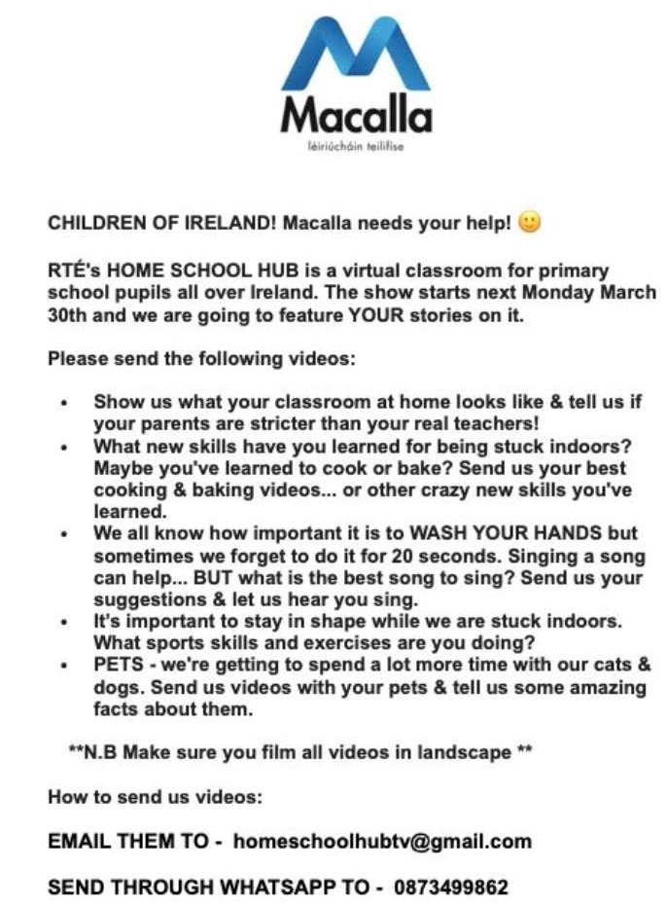
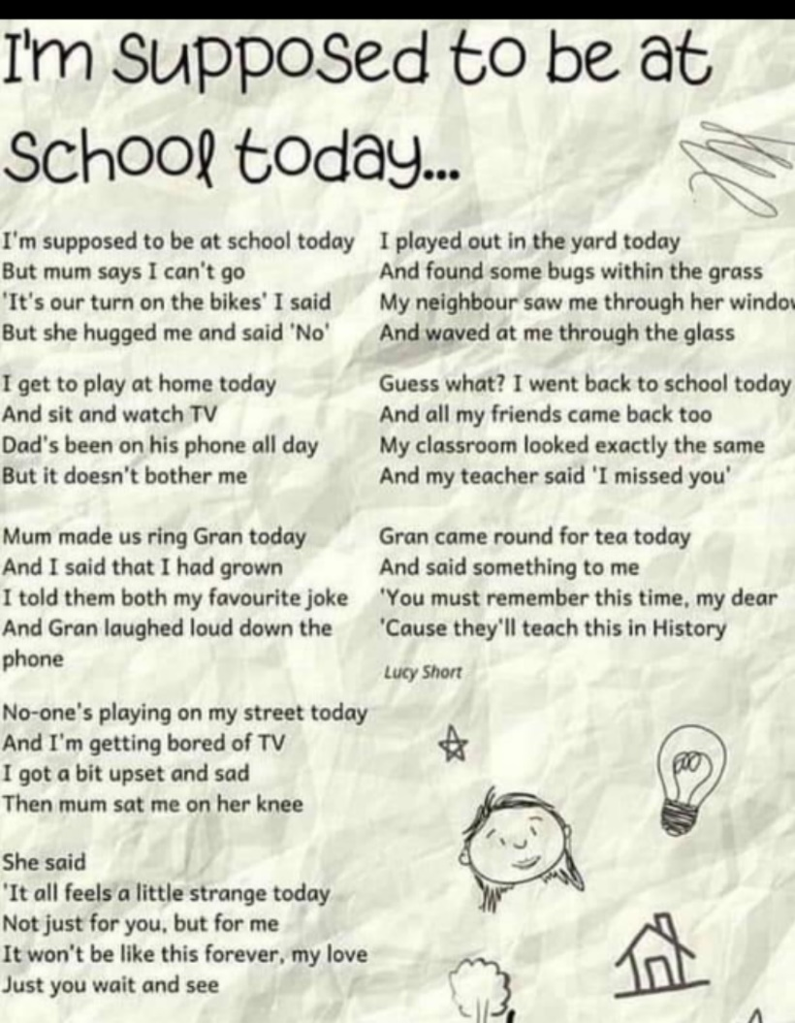
History: Compare the two pictures of a farmer harvesting/gathering crops.
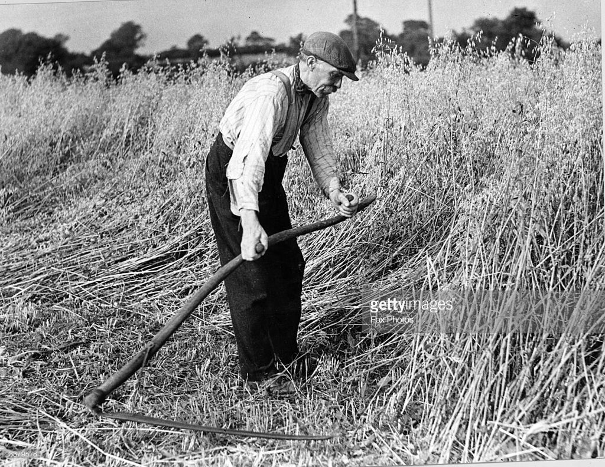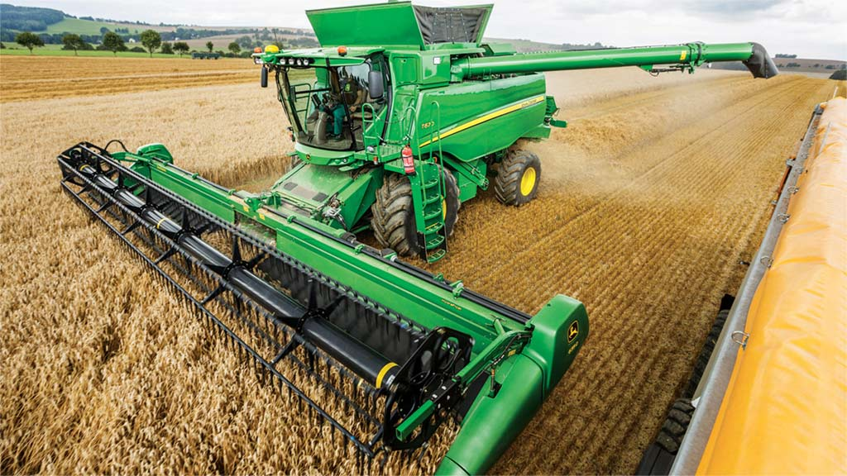

Questions:
- Which work do you think is easier? Why do you think that?
- What is the name of the tool the farmer in the first picture is using to harvest/gather crops? (scythe)
- What is the name of the machine the farmer is using in the second picture to harvest/gather crops? (combine harvester)

Ms. Curran/Ms. McCabe’s Literacy groups A & B and EAL
Go to their page on the school website

Contact Teacher: mrbracken@scoilchoca.ie

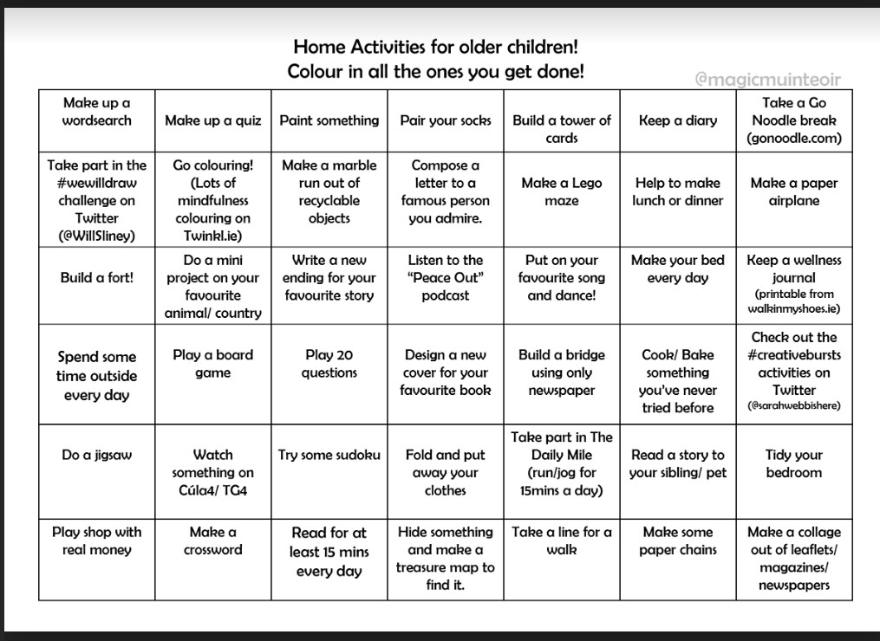
Fun activities (optional)

