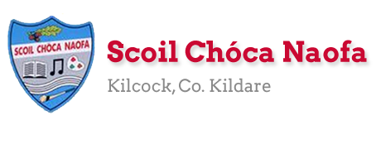
Work for SEN Mrs. Mc Cabe/Ms. Curran: Monday 30th March 2020
This week’s contact teacher is Mrs. Mc Cabe @ msmccabe@scoilchoca.ie but please feel free to contact either/both of us. Parents of individual children are invited to do so.
Literacy A & B | SNIP Programme one session per week as indicated (3 pages per week)  Practice initial blends on flashcards if given.
Speech& Language | Conversation Starters: Practice starting conversations using these to help – one per day.  Activities in Speech & Language Packs from therapist.
EAL  Monthly Theme  Animals | ORAL: Name as many farm animals as you can. What noise do they make? For Example ‘ a dog barks’  WRITE: Find pictures and write the animals’ names underneath.
Toe by Toe Individuals | Snip Session (3 pages per week)
SEN Individuals | Write Reader: Start an online story on Models of Cars or Dolphins/Sharks.  Conversation Starters: Practice starting conversations using these to help – one per day.  Fry’s Words: Practice reading 50 per day.  Cloze sheet one each week.
Useful Websites for this week: ( For Self – directed Learning) https://www.twinkl.ie/resource/us-t-2546349-all-about-farm-animals-powerpoint EAL
https://www.youtube.com/watch?v=WXgvvqn1Zng. Blends
www.theschoolhouse.us Blends
www.writereader.com to write a story
Contact Teachers: msmccabe@scoilchoca.ie mscurran@scoilchoca.ie

